Incidence/Prevalence Trend Report
Elevated AST (>40 IU/L) · KNHANES · 2007-2024 · survey-weighted

Figure. Incidence/prevalence trend
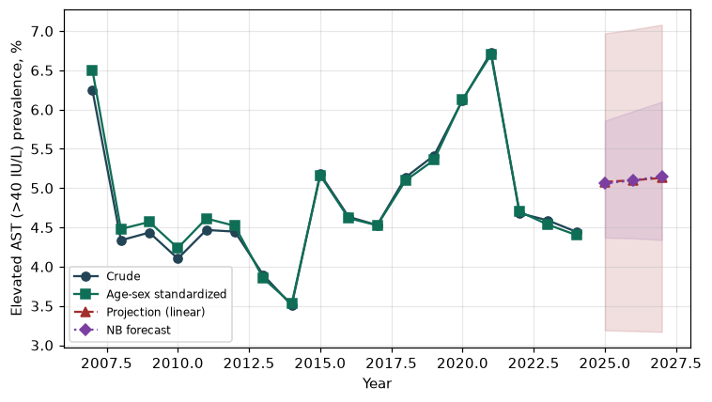

Counts by period
period | count
2007 | 175
2008 | 287
2009 | 308
2010 | 229
2011 | 246
2012 | 239
2013 | 194
2014 | 183
2015 | 255
2016 | 261
2017 | 251
2018 | 311
2019 | 335
2020 | 346
2021 | 351
2022 | 225
2023 | 256
2024 | 242

Crude and age-sex standardized rate (%)
year | crude | standardized
2007.00 | 6.25 | 6.50
2008.00 | 4.34 | 4.48
2009.00 | 4.43 | 4.57
2010.00 | 4.10 | 4.24
2011.00 | 4.47 | 4.61
2012.00 | 4.45 | 4.52
2013.00 | 3.89 | 3.85
2014.00 | 3.51 | 3.53
2015.00 | 5.18 | 5.16
2016.00 | 4.63 | 4.62
2017.00 | 4.53 | 4.53
2018.00 | 5.14 | 5.10
2019.00 | 5.42 | 5.36
2020.00 | 6.12 | 6.13
2021.00 | 6.73 | 6.70
2022.00 | 4.68 | 4.70
2023.00 | 4.59 | 4.53
2024.00 | 4.44 | 4.40

Projection (linear, standardized rate)
year | forecast | lo95 | hi95
2025.00 | 5.08 | 3.19 | 6.97
2026.00 | 5.10 | 3.18 | 7.02
2027.00 | 5.13 | 3.17 | 7.08

Stratified trend by sex (%)
year | men | women
2007.00 | 9.66 | 2.87
2008.00 | 6.39 | 2.29
2009.00 | 6.20 | 2.65
2010.00 | 5.99 | 2.21
2011.00 | 6.53 | 2.42
2012.00 | 5.99 | 2.88
2013.00 | 5.68 | 2.04
2014.00 | 5.12 | 1.87
2015.00 | 7.26 | 3.09
2016.00 | 6.26 | 2.99
2017.00 | 6.65 | 2.38
2018.00 | 7.03 | 3.23
2019.00 | 7.35 | 3.50
2020.00 | 8.84 | 3.42
2021.00 | 8.79 | 4.66
2022.00 | 6.20 | 3.17
2023.00 | 6.22 | 2.97
2024.00 | 6.00 | 2.88

Joinpoint regression — segment APC (%) with bootstrap 95% CI
segment | period | APC(%) | lo95 | hi95
1 | 2007-2008 | -31.11 | -31.11 | -31.11
2 | 2008-2024 | 1.26 | 0.27 | 2.98

Negative binomial (NB) forecast (%)
year | NB_forecast | lo95 | hi95
2025.00 | 5.06 | 4.37 | 5.86
2026.00 | 5.10 | 4.36 | 5.98
2027.00 | 5.15 | 4.34 | 6.10

Interpretation
The age-sex standardized prevalence of Elevated AST (>40 IU/L) showed an annual percent change of 1.26% (95% CI 0.27 to 2.98) in the latest segment.

