Incidence/Prevalence Trend Report
Hepatic steatosis · KNHANES · 2007-2024 · survey-weighted

Figure. Incidence/prevalence trend
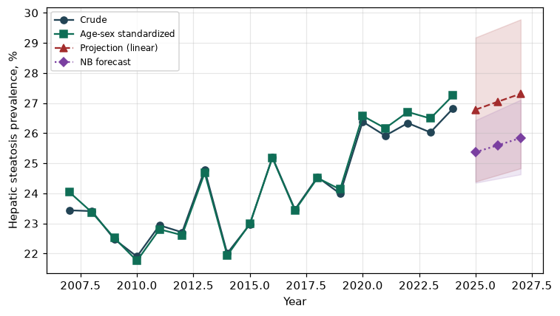

Counts by period
period | count
2007 | 680
2008 | 1450
2009 | 1558
2010 | 1195
2011 | 1255
2012 | 1160
2013 | 1235
2014 | 1069
2015 | 1198
2016 | 1463
2017 | 1356
2018 | 1397
2019 | 1401
2020 | 1440
2021 | 1321
2022 | 1233
2023 | 1366
2024 | 1433

Crude and age-sex standardized rate (%)
year | crude | standardized
2007.00 | 23.44 | 24.05
2008.00 | 23.41 | 23.37
2009.00 | 22.47 | 22.52
2010.00 | 21.90 | 21.76
2011.00 | 22.94 | 22.81
2012.00 | 22.70 | 22.61
2013.00 | 24.78 | 24.68
2014.00 | 22.01 | 21.94
2015.00 | 22.97 | 22.98
2016.00 | 25.20 | 25.18
2017.00 | 23.46 | 23.44
2018.00 | 24.54 | 24.51
2019.00 | 23.99 | 24.13
2020.00 | 26.38 | 26.57
2021.00 | 25.92 | 26.16
2022.00 | 26.34 | 26.71
2023.00 | 26.03 | 26.49
2024.00 | 26.82 | 27.25

Projection (linear, standardized rate)
year | forecast | lo95 | hi95
2025.00 | 26.78 | 24.39 | 29.18
2026.00 | 27.05 | 24.61 | 29.48
2027.00 | 27.31 | 24.83 | 29.78

Stratified trend by sex (%)
year | men | women
2007.00 | 23.64 | 23.23
2008.00 | 27.05 | 19.79
2009.00 | 26.45 | 18.46
2010.00 | 25.56 | 18.23
2011.00 | 25.70 | 20.21
2012.00 | 24.82 | 20.56
2013.00 | 27.88 | 21.58
2014.00 | 26.17 | 17.77
2015.00 | 26.32 | 19.61
2016.00 | 28.91 | 21.45
2017.00 | 27.42 | 19.47
2018.00 | 29.85 | 19.17
2019.00 | 28.97 | 19.04
2020.00 | 32.24 | 20.50
2021.00 | 30.92 | 20.86
2022.00 | 32.52 | 20.11
2023.00 | 30.70 | 21.33
2024.00 | 32.04 | 21.51

Joinpoint regression — segment APC (%) with bootstrap 95% CI
segment | period | APC(%) | lo95 | hi95
1 | 2007-2010 | -3.32 | -3.65 | -2.81
2 | 2010-2024 | 1.51 | 1.15 | 1.89

Negative binomial (NB) forecast (%)
year | NB_forecast | lo95 | hi95
2025.00 | 25.37 | 24.35 | 26.43
2026.00 | 25.60 | 24.49 | 26.77
2027.00 | 25.84 | 24.63 | 27.11

Interpretation
The age-sex standardized prevalence of Hepatic steatosis showed an annual percent change of 1.51% (95% CI 1.15 to 1.89) in the latest segment.

