Incidence/Prevalence Trend Report
High body fat (M>=25/F>=35%) · KNHANES · 2008-2011 · survey-weighted

Figure. Incidence/prevalence trend
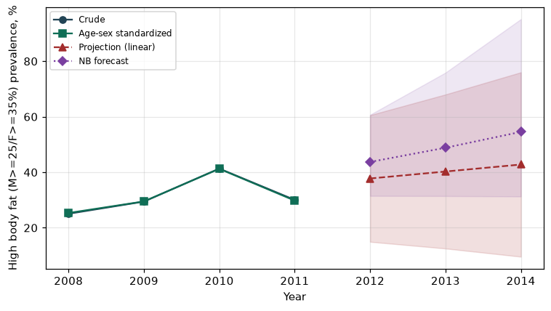

Counts by period
period | count
2008 | 929
2009 | 2105
2010 | 2526
2011 | 786

Crude and age-sex standardized rate (%)
year | crude | standardized
2008.00 | 25.05 | 25.34
2009.00 | 29.44 | 29.50
2010.00 | 41.33 | 41.25
2011.00 | 30.05 | 29.80

Projection (linear, standardized rate)
year | forecast | lo95 | hi95
2012.00 | 37.76 | 14.95 | 60.57
2013.00 | 40.27 | 12.53 | 68.02
2014.00 | 42.79 | 9.58 | 76.00

Stratified trend by sex (%)
year | men | women
2008.00 | 21.60 | 28.48
2009.00 | 26.26 | 32.57
2010.00 | 38.38 | 44.23
2011.00 | 24.74 | 35.03

Joinpoint regression — segment APC (%) with bootstrap 95% CI
segment | period | APC(%) | lo95 | hi95
1 | 2008-2011 | 8.57 | -27.75 | 39.85

Negative binomial (NB) forecast (%)
year | NB_forecast | lo95 | hi95
2012.00 | 43.72 | 31.48 | 60.71
2013.00 | 48.83 | 31.42 | 75.89
2014.00 | 54.55 | 31.27 | 95.16

Interpretation
The age-sex standardized prevalence of High body fat (M>=25/F>=35%) showed an annual percent change of 8.57% (95% CI -27.75 to 39.85) in the latest segment.
Note: only 4 time points were available. Adding more survey cycles stabilizes the trend and joinpoint estimates.

