Incidence/Prevalence Trend Report
High LDL cholesterol (>=160) · KNHANES · 2009-2024 · survey-weighted

Figure. Incidence/prevalence trend
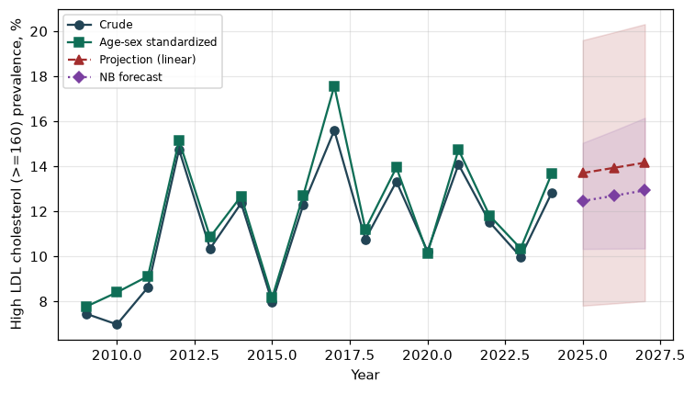

Counts by period
period | count
2009 | 139
2010 | 139
2011 | 188
2012 | 114
2013 | 83
2014 | 85
2015 | 418
2016 | 114
2017 | 129
2018 | 86
2019 | 109
2020 | 74
2021 | 83
2022 | 554
2023 | 556
2024 | 648

Crude and age-sex standardized rate (%)
year | crude | standardized
2009.00 | 7.45 | 7.76
2010.00 | 6.98 | 8.40
2011.00 | 8.63 | 9.12
2012.00 | 14.74 | 15.14
2013.00 | 10.34 | 10.86
2014.00 | 12.36 | 12.67
2015.00 | 7.96 | 8.17
2016.00 | 12.28 | 12.70
2017.00 | 15.59 | 17.56
2018.00 | 10.76 | 11.20
2019.00 | 13.32 | 13.95
2020.00 | 10.23 | 10.13
2021.00 | 14.08 | 14.74
2022.00 | 11.52 | 11.81
2023.00 | 9.98 | 10.35
2024.00 | 12.82 | 13.67

Projection (linear, standardized rate)
year | forecast | lo95 | hi95
2025.00 | 13.70 | 7.81 | 19.60
2026.00 | 13.93 | 7.91 | 19.95
2027.00 | 14.16 | 8.01 | 20.31

Stratified trend by sex (%)
year | men | women
2009.00 | 7.52 | 7.37
2010.00 | 7.59 | 6.20
2011.00 | 8.61 | 8.65
2012.00 | 12.71 | 18.49
2013.00 | 8.36 | 14.73
2014.00 | 11.60 | 14.57
2015.00 | 8.27 | 7.65
2016.00 | 11.31 | 14.25
2017.00 | 13.04 | 22.56
2018.00 | 10.62 | 11.09
2019.00 | 11.91 | 16.45
2020.00 | 9.73 | 11.55
2021.00 | 13.09 | 16.51
2022.00 | 11.60 | 11.44
2023.00 | 10.43 | 9.54
2024.00 | 14.34 | 11.29

Joinpoint regression — segment APC (%) with bootstrap 95% CI
segment | period | APC(%) | lo95 | hi95
1 | 2009-2012 | 23.21 | 8.24 | 66.06
2 | 2012-2024 | -0.03 | -2.49 | 3.00

Negative binomial (NB) forecast (%)
year | NB_forecast | lo95 | hi95
2025.00 | 12.46 | 10.33 | 15.04
2026.00 | 12.69 | 10.34 | 15.58
2027.00 | 12.93 | 10.35 | 16.15

Interpretation
The age-sex standardized prevalence of High LDL cholesterol (>=160) showed an annual percent change of -0.03% (95% CI -2.49 to 3.0) in the latest segment.

