Incidence/Prevalence Trend Report
High non-HDL cholesterol (>=190) · KNHANES · 2007-2024 · survey-weighted

Figure. Incidence/prevalence trend
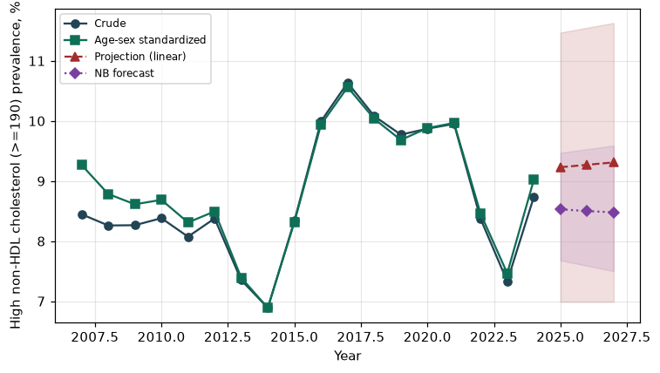

Counts by period
period | count
2007 | 264
2008 | 594
2009 | 607
2010 | 526
2011 | 510
2012 | 474
2013 | 399
2014 | 343
2015 | 446
2016 | 569
2017 | 624
2018 | 589
2019 | 603
2020 | 521
2021 | 500
2022 | 405
2023 | 408
2024 | 443

Crude and age-sex standardized rate (%)
year | crude | standardized
2007.00 | 8.45 | 9.27
2008.00 | 8.26 | 8.78
2009.00 | 8.26 | 8.61
2010.00 | 8.38 | 8.69
2011.00 | 8.07 | 8.31
2012.00 | 8.38 | 8.49
2013.00 | 7.35 | 7.39
2014.00 | 6.89 | 6.89
2015.00 | 8.34 | 8.32
2016.00 | 9.99 | 9.94
2017.00 | 10.64 | 10.56
2018.00 | 10.08 | 10.04
2019.00 | 9.77 | 9.68
2020.00 | 9.87 | 9.88
2021.00 | 9.95 | 9.97
2022.00 | 8.37 | 8.46
2023.00 | 7.33 | 7.47
2024.00 | 8.73 | 9.02

Projection (linear, standardized rate)
year | forecast | lo95 | hi95
2025.00 | 9.23 | 6.99 | 11.47
2026.00 | 9.27 | 6.99 | 11.55
2027.00 | 9.31 | 6.99 | 11.63

Stratified trend by sex (%)
year | men | women
2007.00 | 7.33 | 9.54
2008.00 | 8.74 | 7.78
2009.00 | 9.13 | 7.39
2010.00 | 9.51 | 7.26
2011.00 | 8.48 | 7.67
2012.00 | 8.45 | 8.30
2013.00 | 7.59 | 7.11
2014.00 | 8.05 | 5.72
2015.00 | 9.39 | 7.28
2016.00 | 10.70 | 9.28
2017.00 | 11.65 | 9.61
2018.00 | 11.41 | 8.74
2019.00 | 10.29 | 9.26
2020.00 | 11.91 | 7.84
2021.00 | 12.38 | 7.52
2022.00 | 9.71 | 7.04
2023.00 | 8.50 | 6.17
2024.00 | 10.83 | 6.62

Joinpoint regression — segment APC (%) with bootstrap 95% CI
segment | period | APC(%) | lo95 | hi95
1 | 2007-2015 | -2.45 | -4.33 | -0.81
2 | 2015-2024 | -1.44 | -4.58 | 1.17

Negative binomial (NB) forecast (%)
year | NB_forecast | lo95 | hi95
2025.00 | 8.53 | 7.68 | 9.47
2026.00 | 8.50 | 7.59 | 9.53
2027.00 | 8.48 | 7.50 | 9.59

Interpretation
The age-sex standardized prevalence of High non-HDL cholesterol (>=190) showed an annual percent change of -1.44% (95% CI -4.58 to 1.17) in the latest segment.

