Incidence/Prevalence Trend Report
Hypertension · KNHANES · 2007-2024 · survey-weighted

Figure. Incidence/prevalence trend
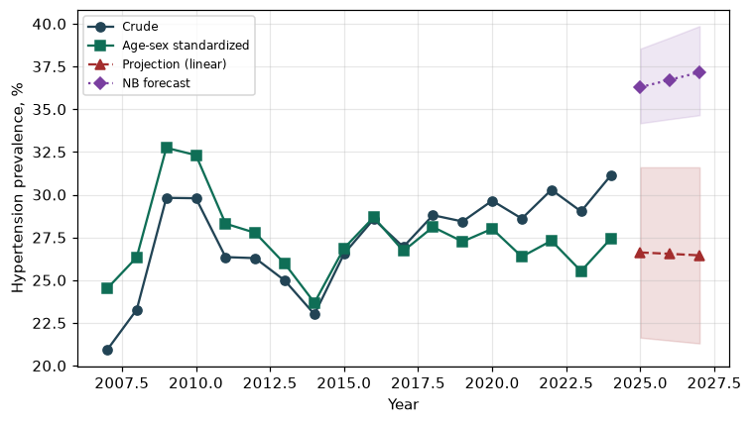

Counts by period
period | count
2007 | 772
2008 | 1858
2009 | 2492
2010 | 2144
2011 | 1972
2012 | 1917
2013 | 1660
2014 | 1598
2015 | 1815
2016 | 1998
2017 | 1978
2018 | 2063
2019 | 2079
2020 | 1985
2021 | 1946
2022 | 1839
2023 | 1996
2024 | 2158

Crude and age-sex standardized rate (%)
year | crude | standardized
2007.00 | 20.92 | 24.51
2008.00 | 23.27 | 26.34
2009.00 | 29.82 | 32.74
2010.00 | 29.79 | 32.31
2011.00 | 26.35 | 28.31
2012.00 | 26.29 | 27.77
2013.00 | 24.97 | 25.96
2014.00 | 23.00 | 23.68
2015.00 | 26.55 | 26.87
2016.00 | 28.57 | 28.68
2017.00 | 26.94 | 26.70
2018.00 | 28.80 | 28.11
2019.00 | 28.43 | 27.26
2020.00 | 29.65 | 28.01
2021.00 | 28.60 | 26.37
2022.00 | 30.29 | 27.31
2023.00 | 29.02 | 25.53
2024.00 | 31.12 | 27.42

Projection (linear, standardized rate)
year | forecast | lo95 | hi95
2025.00 | 26.62 | 21.64 | 31.60
2026.00 | 26.54 | 21.47 | 31.60
2027.00 | 26.45 | 21.30 | 31.60

Stratified trend by sex (%)
year | men | women
2007.00 | 21.89 | 19.96
2008.00 | 24.70 | 21.87
2009.00 | 34.84 | 24.90
2010.00 | 33.94 | 25.75
2011.00 | 29.66 | 23.11
2012.00 | 28.29 | 24.33
2013.00 | 27.88 | 22.13
2014.00 | 25.09 | 20.97
2015.00 | 29.25 | 23.91
2016.00 | 32.04 | 25.15
2017.00 | 30.45 | 23.48
2018.00 | 31.55 | 26.08
2019.00 | 29.81 | 27.07
2020.00 | 33.58 | 25.75
2021.00 | 30.45 | 26.75
2022.00 | 33.63 | 27.00
2023.00 | 31.00 | 27.07
2024.00 | 33.57 | 28.69

Joinpoint regression — segment APC (%) with bootstrap 95% CI
segment | period | APC(%) | lo95 | hi95
1 | 2007-2010 | 11.04 | -1.31 | 24.31
2 | 2010-2024 | -0.45 | -1.21 | 0.55

Negative binomial (NB) forecast (%)
year | NB_forecast | lo95 | hi95
2025.00 | 36.29 | 34.18 | 38.54
2026.00 | 36.72 | 34.42 | 39.19
2027.00 | 37.16 | 34.65 | 39.86

Interpretation
The age-sex standardized prevalence of Hypertension showed an annual percent change of -0.45% (95% CI -1.21 to 0.55) in the latest segment.

