Incidence/Prevalence Trend Report
Hypertriglyceridemia (NCEP TG>=150) · KNHANES · 2007-2024 · survey-weighted

Figure. Incidence/prevalence trend
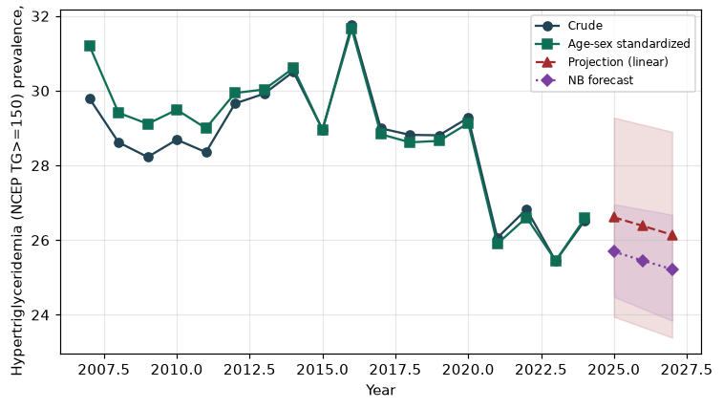

Counts by period
period | count
2007 | 821
2008 | 1811
2009 | 1971
2010 | 1627
2011 | 1640
2012 | 1550
2013 | 1489
2014 | 1437
2015 | 1459
2016 | 1751
2017 | 1652
2018 | 1651
2019 | 1672
2020 | 1574
2021 | 1335
2022 | 1281
2023 | 1322
2024 | 1377

Crude and age-sex standardized rate (%)
year | crude | standardized
2007.00 | 29.80 | 31.21
2008.00 | 28.62 | 29.41
2009.00 | 28.23 | 29.11
2010.00 | 28.69 | 29.49
2011.00 | 28.35 | 29.00
2012.00 | 29.66 | 29.94
2013.00 | 29.92 | 30.03
2014.00 | 30.51 | 30.60
2015.00 | 28.96 | 28.95
2016.00 | 31.75 | 31.66
2017.00 | 28.99 | 28.84
2018.00 | 28.82 | 28.62
2019.00 | 28.81 | 28.66
2020.00 | 29.28 | 29.13
2021.00 | 26.06 | 25.90
2022.00 | 26.83 | 26.61
2023.00 | 25.44 | 25.45
2024.00 | 26.52 | 26.58

Projection (linear, standardized rate)
year | forecast | lo95 | hi95
2025.00 | 26.61 | 23.95 | 29.28
2026.00 | 26.38 | 23.67 | 29.09
2027.00 | 26.14 | 23.39 | 28.90

Stratified trend by sex (%)
year | men | women
2007.00 | 36.59 | 23.20
2008.00 | 37.10 | 20.32
2009.00 | 36.13 | 20.30
2010.00 | 38.00 | 19.49
2011.00 | 36.69 | 20.17
2012.00 | 36.57 | 22.69
2013.00 | 37.71 | 21.93
2014.00 | 41.70 | 19.21
2015.00 | 38.35 | 19.50
2016.00 | 40.88 | 22.56
2017.00 | 38.83 | 19.04
2018.00 | 38.60 | 19.04
2019.00 | 37.32 | 20.45
2020.00 | 39.09 | 19.57
2021.00 | 34.31 | 17.86
2022.00 | 36.33 | 17.42
2023.00 | 34.36 | 16.70
2024.00 | 36.61 | 16.43

Joinpoint regression — segment APC (%) with bootstrap 95% CI
segment | period | APC(%) | lo95 | hi95
1 | 2007-2017 | -0.01 | -0.62 | 0.96
2 | 2017-2024 | -1.77 | -3.08 | -1.10

Negative binomial (NB) forecast (%)
year | NB_forecast | lo95 | hi95
2025.00 | 25.69 | 24.48 | 26.96
2026.00 | 25.45 | 24.16 | 26.82
2027.00 | 25.22 | 23.84 | 26.68

Interpretation
The age-sex standardized prevalence of Hypertriglyceridemia (NCEP TG>=150) showed an annual percent change of -1.77% (95% CI -3.08 to -1.1) in the latest segment.

