Incidence/Prevalence Trend Report
Insulin resistance (HOMA-IR>=2.5) · KNHANES · 2007-2021 · survey-weighted

Figure. Incidence/prevalence trend
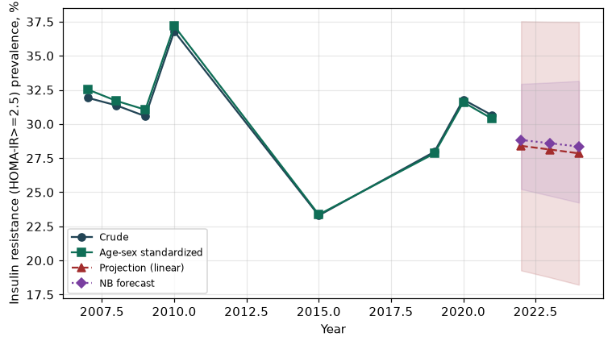

Counts by period
period | count
2007 | 933
2008 | 1986
2009 | 2120
2010 | 2107
2015 | 1205
2019 | 1660
2020 | 1765
2021 | 1633

Crude and age-sex standardized rate (%)
year | crude | standardized
2007.00 | 31.92 | 32.54
2008.00 | 31.36 | 31.69
2009.00 | 30.57 | 31.05
2010.00 | 36.79 | 37.18
2015.00 | 23.30 | 23.36
2019.00 | 27.96 | 27.84
2020.00 | 31.79 | 31.60
2021.00 | 30.64 | 30.38

Projection (linear, standardized rate)
year | forecast | lo95 | hi95
2022.00 | 28.40 | 19.27 | 37.53
2023.00 | 28.13 | 18.76 | 37.49
2024.00 | 27.85 | 18.22 | 37.48

Stratified trend by sex (%)
year | men | women
2007.00 | 32.91 | 30.95
2008.00 | 30.84 | 31.88
2009.00 | 32.45 | 28.68
2010.00 | 39.45 | 34.17
2015.00 | 25.65 | 20.93
2019.00 | 31.44 | 24.55
2020.00 | 36.75 | 26.88
2021.00 | 34.18 | 27.12

Joinpoint regression — segment APC (%) with bootstrap 95% CI
segment | period | APC(%) | lo95 | hi95
1 | 2007-2015 | -4.07 | -6.85 | 8.31
2 | 2015-2021 | 5.00 | -3.84 | 13.49

Negative binomial (NB) forecast (%)
year | NB_forecast | lo95 | hi95
2022.00 | 28.83 | 25.23 | 32.94
2023.00 | 28.59 | 24.74 | 33.04
2024.00 | 28.35 | 24.24 | 33.15

Interpretation
The age-sex standardized prevalence of Insulin resistance (HOMA-IR>=2.5) showed an annual percent change of 5.0% (95% CI -3.84 to 13.49) in the latest segment.

