Incidence/Prevalence Trend Report
Leukocytosis (WBC>11) · KNHANES · 2007-2024 · survey-weighted

Figure. Incidence/prevalence trend
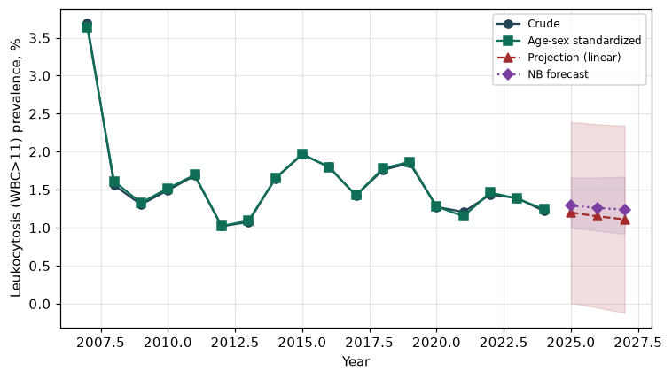

Counts by period
period | count
2007 | 104
2008 | 105
2009 | 85
2010 | 81
2011 | 92
2012 | 54
2013 | 56
2014 | 76
2015 | 106
2016 | 106
2017 | 93
2018 | 92
2019 | 108
2020 | 83
2021 | 70
2022 | 74
2023 | 81
2024 | 64

Crude and age-sex standardized rate (%)
year | crude | standardized
2007.00 | 3.69 | 3.64
2008.00 | 1.56 | 1.61
2009.00 | 1.30 | 1.33
2010.00 | 1.49 | 1.52
2011.00 | 1.69 | 1.70
2012.00 | 1.02 | 1.02
2013.00 | 1.08 | 1.09
2014.00 | 1.65 | 1.65
2015.00 | 1.96 | 1.97
2016.00 | 1.80 | 1.79
2017.00 | 1.42 | 1.43
2018.00 | 1.76 | 1.78
2019.00 | 1.85 | 1.87
2020.00 | 1.27 | 1.28
2021.00 | 1.21 | 1.15
2022.00 | 1.44 | 1.46
2023.00 | 1.39 | 1.38
2024.00 | 1.22 | 1.24

Projection (linear, standardized rate)
year | forecast | lo95 | hi95
2025.00 | 1.20 | 0.01 | 2.39
2026.00 | 1.15 | -0.05 | 2.36
2027.00 | 1.11 | -0.12 | 2.34

Stratified trend by sex (%)
year | men | women
2007.00 | 4.65 | 2.73
2008.00 | 2.30 | 0.82
2009.00 | 1.85 | 0.75
2010.00 | 2.13 | 0.86
2011.00 | 1.88 | 1.49
2012.00 | 1.49 | 0.54
2013.00 | 1.34 | 0.80
2014.00 | 2.45 | 0.83
2015.00 | 2.59 | 1.33
2016.00 | 1.97 | 1.63
2017.00 | 1.74 | 1.11
2018.00 | 2.48 | 1.03
2019.00 | 2.52 | 1.19
2020.00 | 1.92 | 0.63
2021.00 | 1.21 | 1.21
2022.00 | 1.57 | 1.30
2023.00 | 1.95 | 0.83
2024.00 | 1.64 | 0.79

Joinpoint regression — segment APC (%) with bootstrap 95% CI
segment | period | APC(%) | lo95 | hi95
1 | 2007-2008 | -55.71 | -55.71 | -55.71
2 | 2008-2024 | -0.40 | -1.84 | 1.39

Negative binomial (NB) forecast (%)
year | NB_forecast | lo95 | hi95
2025.00 | 1.29 | 1.00 | 1.66
2026.00 | 1.26 | 0.96 | 1.66
2027.00 | 1.24 | 0.92 | 1.67

Interpretation
The age-sex standardized prevalence of Leukocytosis (WBC>11) showed an annual percent change of -0.4% (95% CI -1.84 to 1.39) in the latest segment.

