Incidence/Prevalence Trend Report
Low HDL cholesterol · KNHANES · 2007-2024 · survey-weighted

Figure. Incidence/prevalence trend
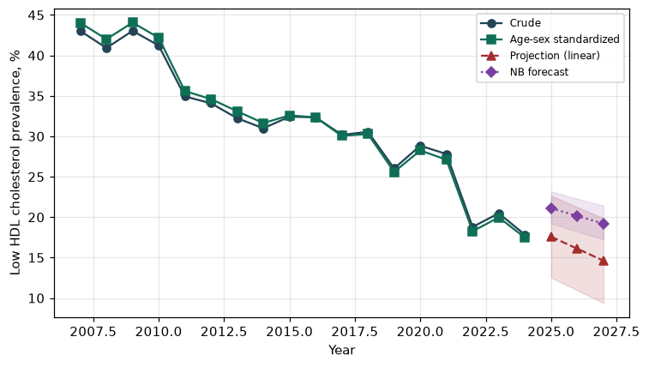

Counts by period
period | count
2007 | 1381
2008 | 3013
2009 | 3283
2010 | 2567
2011 | 2210
2012 | 2094
2013 | 1766
2014 | 1680
2015 | 1859
2016 | 2045
2017 | 1916
2018 | 1981
2019 | 1697
2020 | 1788
2021 | 1642
2022 | 1042
2023 | 1204
2024 | 1061

Crude and age-sex standardized rate (%)
year | crude | standardized
2007.00 | 43.04 | 44.04
2008.00 | 40.92 | 42.01
2009.00 | 43.04 | 44.06
2010.00 | 41.22 | 42.19
2011.00 | 34.93 | 35.59
2012.00 | 34.08 | 34.60
2013.00 | 32.24 | 33.10
2014.00 | 30.99 | 31.63
2015.00 | 32.42 | 32.59
2016.00 | 32.35 | 32.34
2017.00 | 30.18 | 30.05
2018.00 | 30.55 | 30.28
2019.00 | 26.03 | 25.59
2020.00 | 28.84 | 28.25
2021.00 | 27.81 | 27.10
2022.00 | 18.79 | 18.26
2023.00 | 20.48 | 19.97
2024.00 | 17.83 | 17.48

Projection (linear, standardized rate)
year | forecast | lo95 | hi95
2025.00 | 17.58 | 12.52 | 22.64
2026.00 | 16.10 | 10.96 | 21.24
2027.00 | 14.62 | 9.39 | 19.86

Stratified trend by sex (%)
year | men | women
2007.00 | 31.21 | 54.59
2008.00 | 32.16 | 49.63
2009.00 | 33.81 | 52.35
2010.00 | 34.10 | 48.36
2011.00 | 26.94 | 42.85
2012.00 | 23.73 | 44.60
2013.00 | 24.09 | 40.66
2014.00 | 23.51 | 38.61
2015.00 | 26.50 | 38.37
2016.00 | 27.14 | 37.62
2017.00 | 24.89 | 35.51
2018.00 | 24.49 | 36.66
2019.00 | 21.30 | 30.71
2020.00 | 24.24 | 33.41
2021.00 | 22.76 | 32.85
2022.00 | 17.68 | 19.90
2023.00 | 18.69 | 22.26
2024.00 | 16.12 | 19.55

Joinpoint regression — segment APC (%) with bootstrap 95% CI
segment | period | APC(%) | lo95 | hi95
1 | 2007-2020 | -3.81 | -4.55 | -3.09
2 | 2020-2024 | -11.89 | -19.60 | -0.80

Negative binomial (NB) forecast (%)
year | NB_forecast | lo95 | hi95
2025.00 | 21.12 | 19.24 | 23.18
2026.00 | 20.14 | 18.21 | 22.27
2027.00 | 19.21 | 17.24 | 21.41

Interpretation
The age-sex standardized prevalence of Low HDL cholesterol showed an annual percent change of -11.89% (95% CI -19.6 to -0.8) in the latest segment.

