Incidence/Prevalence Trend Report
Low muscle mass (low ASMI, AWGS cut) · KNHANES · 2008-2011 · survey-weighted

Figure. Incidence/prevalence trend
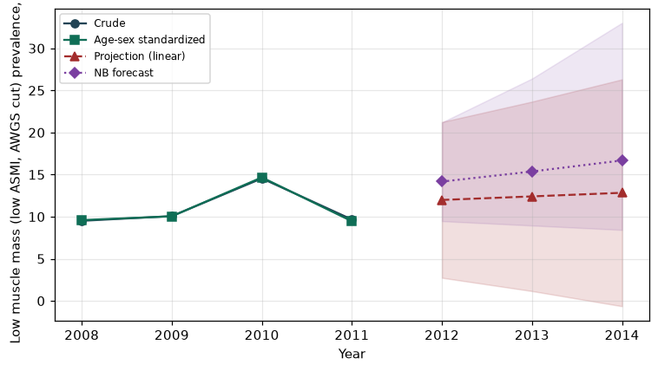

Counts by period
period | count
2008 | 332
2009 | 739
2010 | 901
2011 | 251

Crude and age-sex standardized rate (%)
year | crude | standardized
2008.00 | 9.51 | 9.59
2009.00 | 10.07 | 10.05
2010.00 | 14.55 | 14.67
2011.00 | 9.67 | 9.46

Projection (linear, standardized rate)
year | forecast | lo95 | hi95
2012.00 | 11.99 | 2.74 | 21.25
2013.00 | 12.41 | 1.16 | 23.67
2014.00 | 12.84 | -0.64 | 26.31

Stratified trend by sex (%)
year | men | women
2008.00 | 8.61 | 10.40
2009.00 | 9.14 | 10.98
2010.00 | 11.82 | 17.24
2011.00 | 8.50 | 10.75

Joinpoint regression — segment APC (%) with bootstrap 95% CI
segment | period | APC(%) | lo95 | hi95
1 | 2008-2011 | 3.41 | -35.54 | 46.02

Negative binomial (NB) forecast (%)
year | NB_forecast | lo95 | hi95
2012.00 | 14.17 | 9.47 | 21.20
2013.00 | 15.37 | 8.95 | 26.41
2014.00 | 16.68 | 8.43 | 33.03

Interpretation
The age-sex standardized prevalence of Low muscle mass (low ASMI, AWGS cut) showed an annual percent change of 3.41% (95% CI -35.54 to 46.02) in the latest segment.
Note: only 4 time points were available. Adding more survey cycles stabilizes the trend and joinpoint estimates.

