Incidence/Prevalence Trend Report
MASLD · KNHANES · 2007-2024 · survey-weighted

Figure. Incidence/prevalence trend
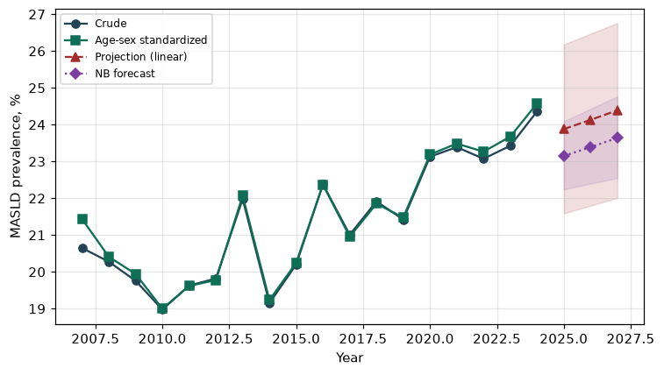

Counts by period
period | count
2007 | 603
2008 | 1287
2009 | 1395
2010 | 1047
2011 | 1096
2012 | 1011
2013 | 1050
2014 | 900
2015 | 1049
2016 | 1296
2017 | 1221
2018 | 1251
2019 | 1247
2020 | 1278
2021 | 1200
2022 | 1095
2023 | 1230
2024 | 1293

Crude and age-sex standardized rate (%)
year | crude | standardized
2007.00 | 20.65 | 21.43
2008.00 | 20.28 | 20.41
2009.00 | 19.76 | 19.94
2010.00 | 18.98 | 19.00
2011.00 | 19.63 | 19.62
2012.00 | 19.82 | 19.78
2013.00 | 21.98 | 22.07
2014.00 | 19.15 | 19.24
2015.00 | 20.20 | 20.25
2016.00 | 22.38 | 22.37
2017.00 | 21.01 | 20.95
2018.00 | 21.91 | 21.85
2019.00 | 21.42 | 21.48
2020.00 | 23.13 | 23.19
2021.00 | 23.39 | 23.49
2022.00 | 23.07 | 23.27
2023.00 | 23.43 | 23.67
2024.00 | 24.36 | 24.58

Projection (linear, standardized rate)
year | forecast | lo95 | hi95
2025.00 | 23.88 | 21.59 | 26.18
2026.00 | 24.13 | 21.80 | 26.47
2027.00 | 24.39 | 22.01 | 26.76

Stratified trend by sex (%)
year | men | women
2007.00 | 19.45 | 21.83
2008.00 | 21.42 | 19.13
2009.00 | 21.56 | 17.94
2010.00 | 20.55 | 17.40
2011.00 | 19.27 | 19.98
2012.00 | 19.95 | 19.69
2013.00 | 23.93 | 20.02
2014.00 | 21.73 | 16.60
2015.00 | 21.76 | 18.64
2016.00 | 24.02 | 20.73
2017.00 | 23.42 | 18.57
2018.00 | 25.22 | 18.56
2019.00 | 24.68 | 18.20
2020.00 | 26.53 | 19.72
2021.00 | 26.58 | 20.15
2022.00 | 27.01 | 19.10
2023.00 | 26.73 | 20.10
2024.00 | 28.02 | 20.63

Joinpoint regression — segment APC (%) with bootstrap 95% CI
segment | period | APC(%) | lo95 | hi95
1 | 2007-2010 | -3.78 | -4.79 | -2.27
2 | 2010-2024 | 1.67 | 1.24 | 2.04

Negative binomial (NB) forecast (%)
year | NB_forecast | lo95 | hi95
2025.00 | 23.15 | 22.24 | 24.09
2026.00 | 23.39 | 22.40 | 24.43
2027.00 | 23.64 | 22.55 | 24.77

Interpretation
The age-sex standardized prevalence of MASLD showed an annual percent change of 1.67% (95% CI 1.24 to 2.04) in the latest segment.

