Incidence/Prevalence Trend Report
Metabolic syndrome · KNHANES · 2007-2024 · survey-weighted

Figure. Incidence/prevalence trend
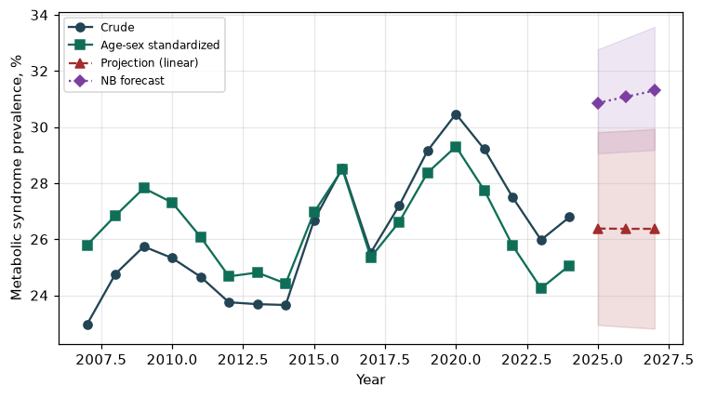

Counts by period
period | count
2007 | 729
2008 | 1747
2009 | 1959
2010 | 1576
2011 | 1590
2012 | 1434
2013 | 1286
2014 | 1254
2015 | 1527
2016 | 1746
2017 | 1630
2018 | 1720
2019 | 1836
2020 | 1818
2021 | 1694
2022 | 1386
2023 | 1505
2024 | 1518

Crude and age-sex standardized rate (%)
year | crude | standardized
2007.00 | 22.96 | 25.79
2008.00 | 24.76 | 26.84
2009.00 | 25.74 | 27.82
2010.00 | 25.33 | 27.31
2011.00 | 24.66 | 26.08
2012.00 | 23.75 | 24.67
2013.00 | 23.68 | 24.81
2014.00 | 23.65 | 24.42
2015.00 | 26.67 | 26.96
2016.00 | 28.54 | 28.50
2017.00 | 25.52 | 25.36
2018.00 | 27.20 | 26.61
2019.00 | 29.15 | 28.37
2020.00 | 30.47 | 29.30
2021.00 | 29.21 | 27.75
2022.00 | 27.49 | 25.77
2023.00 | 25.97 | 24.25
2024.00 | 26.79 | 25.06

Projection (linear, standardized rate)
year | forecast | lo95 | hi95
2025.00 | 26.38 | 22.94 | 29.82
2026.00 | 26.37 | 22.87 | 29.87
2027.00 | 26.37 | 22.81 | 29.93

Stratified trend by sex (%)
year | men | women
2007.00 | 23.86 | 22.09
2008.00 | 26.52 | 23.03
2009.00 | 28.57 | 22.89
2010.00 | 29.07 | 21.63
2011.00 | 28.06 | 21.32
2012.00 | 24.53 | 22.96
2013.00 | 26.30 | 21.00
2014.00 | 28.65 | 18.62
2015.00 | 30.35 | 22.99
2016.00 | 32.49 | 24.59
2017.00 | 30.34 | 20.65
2018.00 | 31.46 | 22.93
2019.00 | 33.56 | 24.82
2020.00 | 37.24 | 23.71
2021.00 | 33.64 | 24.75
2022.00 | 34.92 | 20.08
2023.00 | 31.28 | 20.78
2024.00 | 33.73 | 19.85

Joinpoint regression — segment APC (%) with bootstrap 95% CI
segment | period | APC(%) | lo95 | hi95
1 | 2007-2019 | 0.19 | -0.62 | 0.94
2 | 2019-2024 | -3.54 | -6.28 | -1.86

Negative binomial (NB) forecast (%)
year | NB_forecast | lo95 | hi95
2025.00 | 30.86 | 29.06 | 32.77
2026.00 | 31.08 | 29.12 | 33.17
2027.00 | 31.30 | 29.18 | 33.57

Interpretation
The age-sex standardized prevalence of Metabolic syndrome showed an annual percent change of -3.54% (95% CI -6.28 to -1.86) in the latest segment.

