Incidence/Prevalence Trend Report
Obesity (KSSO >=25 / WHO >=30, country-specific) · KNHANES · 2007-2024 · survey-weighted

Figure. Incidence/prevalence trend
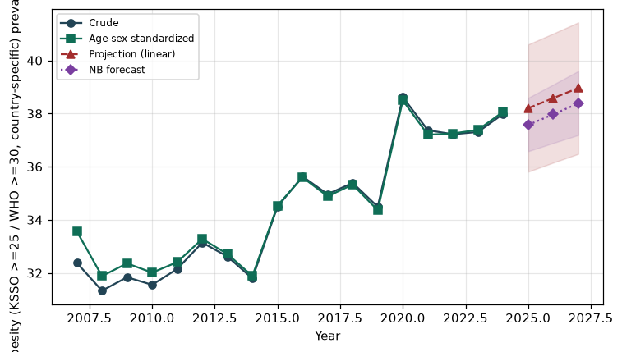

Counts by period
period | count
2007 | 963
2008 | 2118
2009 | 2372
2010 | 1954
2011 | 1966
2012 | 1892
2013 | 1859
2014 | 1774
2015 | 1941
2016 | 2134
2017 | 2147
2018 | 2143
2019 | 2118
2020 | 2194
2021 | 2023
2022 | 1859
2023 | 2067
2024 | 2158

Crude and age-sex standardized rate (%)
year | crude | standardized
2007.00 | 32.38 | 33.56
2008.00 | 31.33 | 31.88
2009.00 | 31.84 | 32.36
2010.00 | 31.55 | 32.01
2011.00 | 32.15 | 32.40
2012.00 | 33.14 | 33.28
2013.00 | 32.62 | 32.71
2014.00 | 31.79 | 31.88
2015.00 | 34.49 | 34.53
2016.00 | 35.63 | 35.60
2017.00 | 34.96 | 34.88
2018.00 | 35.39 | 35.32
2019.00 | 34.49 | 34.36
2020.00 | 38.62 | 38.49
2021.00 | 37.37 | 37.20
2022.00 | 37.22 | 37.25
2023.00 | 37.31 | 37.39
2024.00 | 37.98 | 38.07

Projection (linear, standardized rate)
year | forecast | lo95 | hi95
2025.00 | 38.20 | 35.81 | 40.60
2026.00 | 38.58 | 36.15 | 41.01
2027.00 | 38.96 | 36.48 | 41.43

Stratified trend by sex (%)
year | men | women
2007.00 | 36.67 | 28.15
2008.00 | 36.13 | 26.63
2009.00 | 36.00 | 27.75
2010.00 | 36.63 | 26.61
2011.00 | 35.41 | 28.95
2012.00 | 36.23 | 30.11
2013.00 | 37.87 | 27.46
2014.00 | 37.97 | 25.73
2015.00 | 39.97 | 29.13
2016.00 | 41.75 | 29.59
2017.00 | 41.38 | 28.62
2018.00 | 42.31 | 28.53
2019.00 | 41.48 | 27.55
2020.00 | 47.18 | 30.03
2021.00 | 44.84 | 29.87
2022.00 | 46.01 | 28.48
2023.00 | 44.16 | 30.44
2024.00 | 47.11 | 28.85

Joinpoint regression — segment APC (%) with bootstrap 95% CI
segment | period | APC(%) | lo95 | hi95
1 | 2007-2010 | -1.26 | -5.00 | 1.50
2 | 2010-2024 | 1.33 | 1.12 | 1.62

Negative binomial (NB) forecast (%)
year | NB_forecast | lo95 | hi95
2025.00 | 37.57 | 36.58 | 38.59
2026.00 | 37.97 | 36.89 | 39.09
2027.00 | 38.38 | 37.19 | 39.60

Interpretation
The age-sex standardized prevalence of Obesity (KSSO >=25 / WHO >=30, country-specific) showed an annual percent change of 1.33% (95% CI 1.12 to 1.62) in the latest segment.

