Incidence/Prevalence Trend Report
Osteoporosis (T-score<=-2.5, age>=50) · KNHANES · 2008-2011 · survey-weighted

Figure. Incidence/prevalence trend
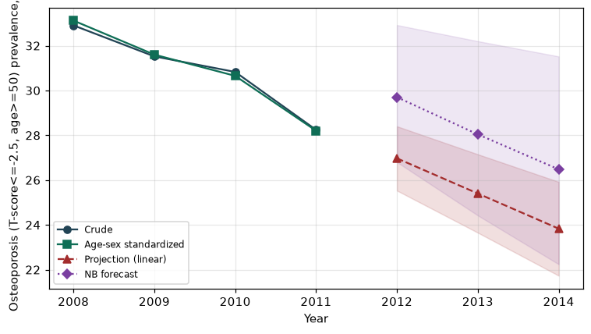

Counts by period
period | count
2008 | 622
2009 | 1225
2010 | 1014
2011 | 406

Crude and age-sex standardized rate (%)
year | crude | standardized
2008.00 | 32.91 | 33.12
2009.00 | 31.52 | 31.60
2010.00 | 30.83 | 30.65
2011.00 | 28.24 | 28.20

Projection (linear, standardized rate)
year | forecast | lo95 | hi95
2012.00 | 26.97 | 25.53 | 28.40
2013.00 | 25.40 | 23.65 | 27.15
2014.00 | 23.83 | 21.73 | 25.92

Stratified trend by sex (%)
year | men | women
2008.00 | 13.04 | 49.84
2009.00 | 13.56 | 47.04
2010.00 | 13.51 | 45.49
2011.00 | 12.37 | 41.97

Joinpoint regression — segment APC (%) with bootstrap 95% CI
segment | period | APC(%) | lo95 | hi95
1 | 2008-2011 | -5 | -7.99 | -3

Negative binomial (NB) forecast (%)
year | NB_forecast | lo95 | hi95
2012.00 | 29.70 | 26.80 | 32.92
2013.00 | 28.04 | 24.42 | 32.20
2014.00 | 26.48 | 22.24 | 31.52

Interpretation
The age-sex standardized prevalence of Osteoporosis (T-score<=-2.5, age>=50) showed an annual percent change of -5% (95% CI -7.99 to -3) in the latest segment.
Note: only 4 time points were available. Adding more survey cycles stabilizes the trend and joinpoint estimates.

