Incidence/Prevalence Trend Report
Overweight (KSSO >=23 / WHO >=25, country-specific) · KNHANES · 2007-2024 · survey-weighted

Figure. Incidence/prevalence trend
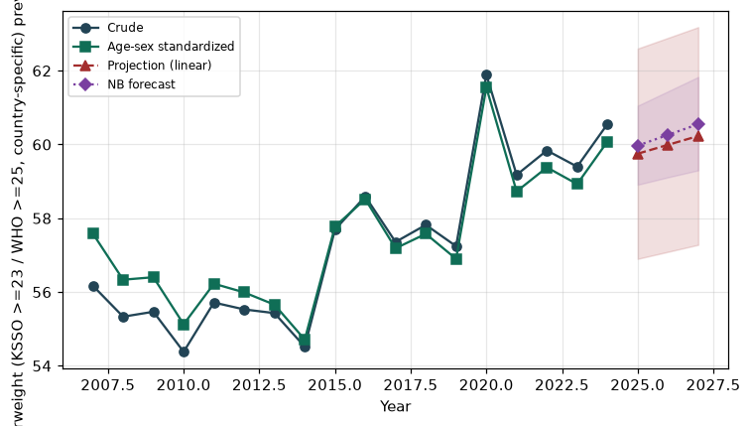

Counts by period
period | count
2007 | 1695
2008 | 3730
2009 | 4133
2010 | 3388
2011 | 3386
2012 | 3326
2013 | 3182
2014 | 3084
2015 | 3257
2016 | 3539
2017 | 3535
2018 | 3551
2019 | 3553
2020 | 3520
2021 | 3296
2022 | 3030
2023 | 3357
2024 | 3488

Crude and age-sex standardized rate (%)
year | crude | standardized
2007.00 | 56.17 | 57.59
2008.00 | 55.33 | 56.33
2009.00 | 55.47 | 56.40
2010.00 | 54.38 | 55.13
2011.00 | 55.72 | 56.23
2012.00 | 55.53 | 55.99
2013.00 | 55.43 | 55.66
2014.00 | 54.52 | 54.71
2015.00 | 57.69 | 57.78
2016.00 | 58.59 | 58.52
2017.00 | 57.36 | 57.18
2018.00 | 57.82 | 57.58
2019.00 | 57.24 | 56.90
2020.00 | 61.89 | 61.55
2021.00 | 59.18 | 58.73
2022.00 | 59.84 | 59.38
2023.00 | 59.40 | 58.93
2024.00 | 60.55 | 60.08

Projection (linear, standardized rate)
year | forecast | lo95 | hi95
2025.00 | 59.75 | 56.90 | 62.60
2026.00 | 59.99 | 57.09 | 62.89
2027.00 | 60.23 | 57.28 | 63.18

Stratified trend by sex (%)
year | men | women
2007.00 | 63.61 | 48.85
2008.00 | 62.86 | 47.96
2009.00 | 61.71 | 49.34
2010.00 | 61.51 | 47.44
2011.00 | 62.03 | 49.53
2012.00 | 61.05 | 50.12
2013.00 | 63.06 | 47.93
2014.00 | 62.96 | 46.24
2015.00 | 66.00 | 49.57
2016.00 | 67.03 | 50.26
2017.00 | 66.74 | 48.07
2018.00 | 67.87 | 47.85
2019.00 | 67.60 | 46.97
2020.00 | 73.85 | 49.91
2021.00 | 70.36 | 47.94
2022.00 | 69.77 | 49.96
2023.00 | 69.18 | 49.60
2024.00 | 72.42 | 48.68

Joinpoint regression — segment APC (%) with bootstrap 95% CI
segment | period | APC(%) | lo95 | hi95
1 | 2007-2010 | -1.29 | -2.26 | 0.12
2 | 2010-2024 | 0.61 | 0.46 | 0.82

Negative binomial (NB) forecast (%)
year | NB_forecast | lo95 | hi95
2025.00 | 59.97 | 58.91 | 61.05
2026.00 | 60.26 | 59.11 | 61.44
2027.00 | 60.55 | 59.30 | 61.83

Interpretation
The age-sex standardized prevalence of Overweight (KSSO >=23 / WHO >=25, country-specific) showed an annual percent change of 0.61% (95% CI 0.46 to 0.82) in the latest segment.

