Incidence/Prevalence Trend Report
Prediabetes · KNHANES · 2007-2024 · survey-weighted

Figure. Incidence/prevalence trend
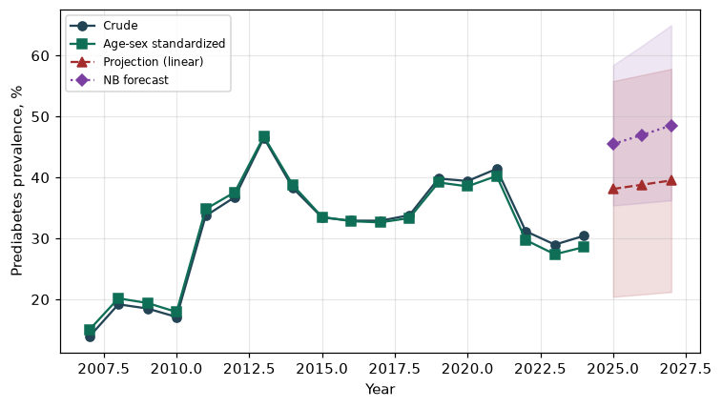

Counts by period
period | count
2007 | 461
2008 | 1297
2009 | 1309
2010 | 1054
2011 | 2211
2012 | 2221
2013 | 2508
2014 | 2033
2015 | 1900
2016 | 2070
2017 | 2116
2018 | 2198
2019 | 2577
2020 | 2383
2021 | 2427
2022 | 1695
2023 | 1776
2024 | 1895

Crude and age-sex standardized rate (%)
year | crude | standardized
2007.00 | 13.86 | 14.99
2008.00 | 19.18 | 20.16
2009.00 | 18.50 | 19.40
2010.00 | 17.10 | 17.93
2011.00 | 33.70 | 34.81
2012.00 | 36.77 | 37.58
2013.00 | 46.48 | 46.72
2014.00 | 38.23 | 38.72
2015.00 | 33.43 | 33.53
2016.00 | 32.91 | 32.82
2017.00 | 32.90 | 32.63
2018.00 | 33.80 | 33.34
2019.00 | 39.82 | 39.18
2020.00 | 39.42 | 38.54
2021.00 | 41.41 | 40.25
2022.00 | 31.17 | 29.72
2023.00 | 28.98 | 27.39
2024.00 | 30.42 | 28.58

Projection (linear, standardized rate)
year | forecast | lo95 | hi95
2025.00 | 38.11 | 20.41 | 55.80
2026.00 | 38.81 | 20.82 | 56.80
2027.00 | 39.51 | 21.20 | 57.81

Stratified trend by sex (%)
year | men | women
2007.00 | 16.67 | 11.07
2008.00 | 22.62 | 15.82
2009.00 | 21.61 | 15.37
2010.00 | 20.60 | 13.64
2011.00 | 36.07 | 31.35
2012.00 | 38.58 | 34.94
2013.00 | 48.96 | 43.93
2014.00 | 41.40 | 35.03
2015.00 | 37.50 | 29.35
2016.00 | 36.06 | 29.74
2017.00 | 35.62 | 30.16
2018.00 | 36.19 | 31.40
2019.00 | 41.75 | 37.89
2020.00 | 42.36 | 36.48
2021.00 | 41.78 | 41.03
2022.00 | 35.28 | 27.07
2023.00 | 31.61 | 26.36
2024.00 | 32.91 | 27.91

Joinpoint regression — segment APC (%) with bootstrap 95% CI
segment | period | APC(%) | lo95 | hi95
1 | 2007-2013 | 20.59 | 11.20 | 31.82
2 | 2013-2024 | -2.65 | -4.13 | 0.20

Negative binomial (NB) forecast (%)
year | NB_forecast | lo95 | hi95
2025.00 | 45.48 | 35.40 | 58.43
2026.00 | 46.98 | 35.82 | 61.61
2027.00 | 48.53 | 36.24 | 64.99

Interpretation
The age-sex standardized prevalence of Prediabetes showed an annual percent change of -2.65% (95% CI -4.13 to 0.2) in the latest segment.

