Incidence/Prevalence Trend Report
Vitamin D deficiency (<20 ng/mL) · KNHANES · 2008-2014 · survey-weighted

Figure. Incidence/prevalence trend
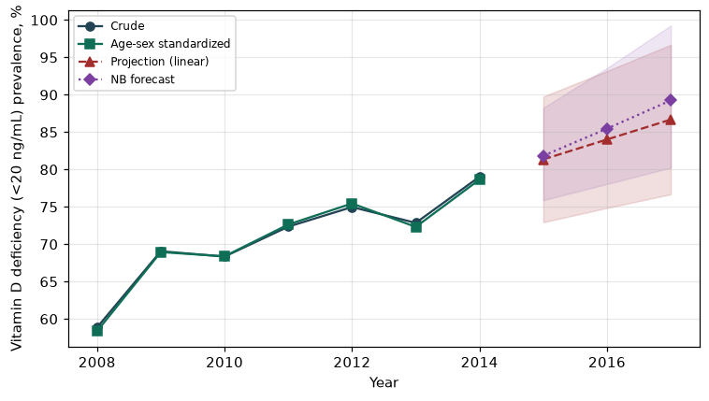

Counts by period
period | count
2008 | 3320
2009 | 4671
2010 | 3965
2011 | 4155
2012 | 4102
2013 | 1394
2014 | 1522

Crude and age-sex standardized rate (%)
year | crude | standardized
2008.00 | 58.86 | 58.37
2009.00 | 69.06 | 68.95
2010.00 | 68.35 | 68.38
2011.00 | 72.35 | 72.64
2012.00 | 74.98 | 75.45
2013.00 | 72.86 | 72.32
2014.00 | 79.04 | 78.66

Projection (linear, standardized rate)
year | forecast | lo95 | hi95
2015.00 | 81.35 | 72.94 | 89.76
2016.00 | 84.02 | 74.86 | 93.18
2017.00 | 86.68 | 76.68 | 96.69

Stratified trend by sex (%)
year | men | women
2008.00 | 50.01 | 67.88
2009.00 | 62.63 | 75.55
2010.00 | 61.47 | 75.24
2011.00 | 66.73 | 77.93
2012.00 | 69.99 | 80.04
2013.00 | 69.60 | 77.27
2014.00 | 75.85 | 83.24

Joinpoint regression — segment APC (%) with bootstrap 95% CI
segment | period | APC(%) | lo95 | hi95
1 | 2008-2009 | 18.13 | 18.13 | 18.13
2 | 2009-2014 | 2.50 | 1.03 | 3.72

Negative binomial (NB) forecast (%)
year | NB_forecast | lo95 | hi95
2015.00 | 81.84 | 75.89 | 88.26
2016.00 | 85.47 | 78.06 | 93.58
2017.00 | 89.25 | 80.25 | 99.26

Interpretation
The age-sex standardized prevalence of Vitamin D deficiency (<20 ng/mL) showed an annual percent change of 2.5% (95% CI 1.03 to 3.72) in the latest segment.

