Machine Learning Prediction Model Report
Outcome: Abdominal obesity · NHANES · 3 models compared · tuning, full metrics, threshold, SHAP, PDP
[ML] outcome = abdominal_obesity

Data summary
Item | Value
N | 6000
Outcome prevalence (%) | 57.6
Features | 46
Models compared | 3
Train/test | 4200/1800 (70/30 stratified)
Auto-excluded leakage | None

Hyperparameter search space
Model | Search space
LogisticRegression | {'C': [0.01, 0.1, 1, 10], 'penalty': ['l1', 'l2']}
HistGradientBoosting | {'learning_rate': [0.03, 0.1], 'max_iter': [200, 400], 'max_depth': [3, 6, None]}
XGBoost | {'n_estimators': [300, 500], 'max_depth': [3, 5], 'learning_rate': [0.03, 0.1], 'subsample': [0.8, 1.0]}

Tuning results — best parameters and CV auROC
model | CV_auROC | best_params
LogisticRegression | 0.8185 | {'penalty': 'l1', 'C': 0.1}
HistGradientBoosting | 0.8226 | {'max_iter': 400, 'max_depth': 3, 'learning_rate': 0.03}
XGBoost | 0.826 | {'subsample': 0.8, 'n_estimators': 500, 'max_depth': 3, 'learning_rate': 0.03}

Full performance metrics (test set)
model | TP | TN | FP | FN | sensitivity | specificity | PPV | NPV | accuracy | balanced_accuracy | f1 | MCC | kappa | auROC | auPRC | logloss | brier | combined
XGBoost | 824 | 518 | 245 | 213 | 0.7946 | 0.6789 | 0.7708 | 0.7086 | 0.7456 | 0.7367 | 0.7825 | 0.4765 | 0.4761 | 0.825 | 0.8652 | 0.5029 | 0.1682 | 0.8451
HistGradientBoosting | 831 | 517 | 246 | 206 | 0.8014 | 0.6776 | 0.7716 | 0.7151 | 0.7489 | 0.7395 | 0.7862 | 0.4828 | 0.4823 | 0.8242 | 0.8641 | 0.5039 | 0.1684 | 0.8441
LogisticRegression | 826 | 521 | 242 | 211 | 0.7965 | 0.6828 | 0.7734 | 0.7117 | 0.7483 | 0.7397 | 0.7848 | 0.4822 | 0.4819 | 0.8284 | 0.853 | 0.5159 | 0.1663 | 0.8407

ROC · Precision-Recall
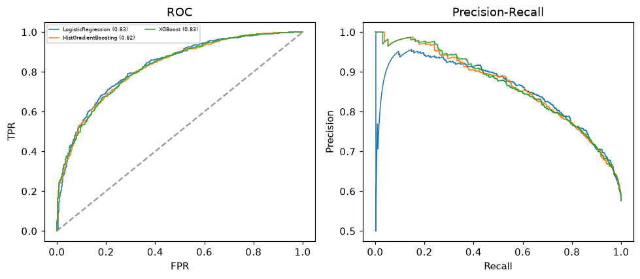

Selected final model — XGBoost (combined=0.8451)
Among 3 candidate models, XGBoost achieved the highest combined score, with an area under the receiver operating characteristic curve of 0.825 and area under the precision-recall curve of 0.8652.

Threshold analysis (0.1-0.9)
threshold | TP | TN | FP | FN | sensitivity | specificity | PPV | NPV | f1 | accuracy
0.1 | 1030.0 | 85.0 | 678.0 | 7.0 | 0.993 | 0.111 | 0.603 | 0.924 | 0.75 | 0.619
0.2 | 1009.0 | 209.0 | 554.0 | 28.0 | 0.973 | 0.274 | 0.646 | 0.882 | 0.776 | 0.677
0.3 | 958.0 | 334.0 | 429.0 | 79.0 | 0.924 | 0.438 | 0.691 | 0.809 | 0.79 | 0.718
0.4 | 903.0 | 431.0 | 332.0 | 134.0 | 0.871 | 0.565 | 0.731 | 0.763 | 0.795 | 0.741
0.5 | 824.0 | 518.0 | 245.0 | 213.0 | 0.795 | 0.679 | 0.771 | 0.709 | 0.783 | 0.746
0.6 | 729.0 | 588.0 | 175.0 | 308.0 | 0.703 | 0.771 | 0.806 | 0.656 | 0.751 | 0.732
0.7 | 618.0 | 655.0 | 108.0 | 419.0 | 0.596 | 0.858 | 0.851 | 0.61 | 0.701 | 0.707
0.8 | 464.0 | 708.0 | 55.0 | 573.0 | 0.447 | 0.928 | 0.894 | 0.553 | 0.596 | 0.651
0.9 | 246.0 | 757.0 | 6.0 | 791.0 | 0.237 | 0.992 | 0.976 | 0.489 | 0.382 | 0.557

Calibration
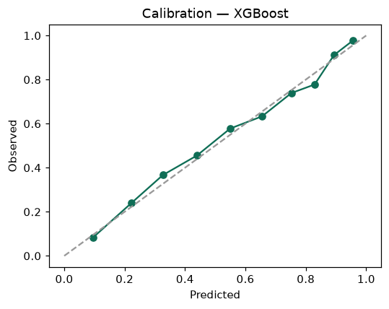

SHAP feature contributions
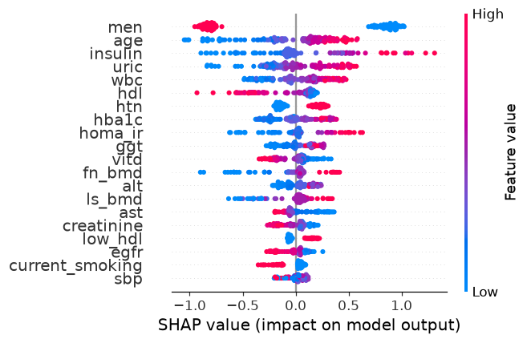

Partial dependence (PDP)
