Machine Learning Prediction Model Report
Outcome: Advanced liver fibrosis (FIB-4>2.67) · NHANES · 3 models compared · tuning, full metrics, threshold, SHAP, PDP
[ML] outcome = adv_fibrosis

Data summary
Item | Value
N | 6000
Outcome prevalence (%) | 4.2
Features | 55
Models compared | 3
Train/test | 4200/1800 (70/30 stratified)
Auto-excluded leakage | None

Hyperparameter search space
Model | Search space
LogisticRegression | {'C': [0.01, 0.1, 1, 10], 'penalty': ['l1', 'l2']}
HistGradientBoosting | {'learning_rate': [0.03, 0.1], 'max_iter': [200, 400], 'max_depth': [3, 6, None]}
XGBoost | {'n_estimators': [300, 500], 'max_depth': [3, 5], 'learning_rate': [0.03, 0.1], 'subsample': [0.8, 1.0]}

Tuning results — best parameters and CV auROC
model | CV_auROC | best_params
LogisticRegression | 0.8745 | {'penalty': 'l1', 'C': 1}
HistGradientBoosting | 0.8574 | {'max_iter': 200, 'max_depth': 6, 'learning_rate': 0.03}
XGBoost | 0.8674 | {'subsample': 0.8, 'n_estimators': 300, 'max_depth': 5, 'learning_rate': 0.03}

Full performance metrics (test set)
model | TP | TN | FP | FN | sensitivity | specificity | PPV | NPV | accuracy | balanced_accuracy | f1 | MCC | kappa | auROC | auPRC | logloss | brier | combined
XGBoost | 8 | 1719 | 5 | 68 | 0.1053 | 0.9971 | 0.6154 | 0.9619 | 0.9594 | 0.5512 | 0.1798 | 0.2431 | 0.1695 | 0.88 | 0.3507 | 0.131 | 0.0335 | 0.6153
HistGradientBoosting | 7 | 1720 | 4 | 69 | 0.0921 | 0.9977 | 0.6364 | 0.9614 | 0.9594 | 0.5449 | 0.1609 | 0.2317 | 0.1519 | 0.8747 | 0.329 | 0.1328 | 0.034 | 0.6018
LogisticRegression | 7 | 1715 | 9 | 69 | 0.0921 | 0.9948 | 0.4375 | 0.9613 | 0.9567 | 0.5434 | 0.1522 | 0.1861 | 0.1395 | 0.8841 | 0.3117 | 0.1273 | 0.034 | 0.5979

ROC · Precision-Recall
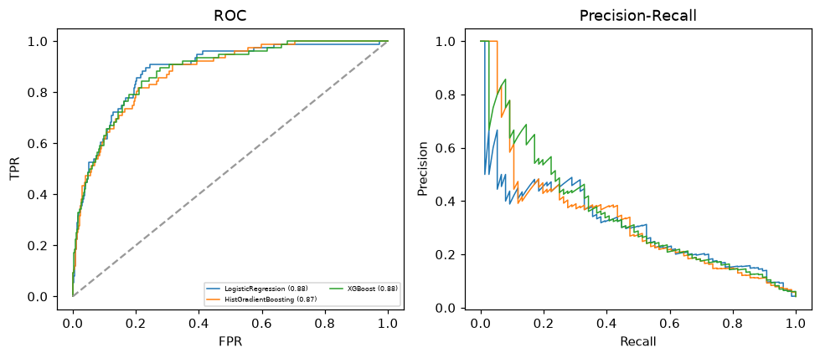

Selected final model — XGBoost (combined=0.6153)
Among 3 candidate models, XGBoost achieved the highest combined score, with an area under the receiver operating characteristic curve of 0.88 and area under the precision-recall curve of 0.3507.

Threshold analysis (0.1-0.9)
threshold | TP | TN | FP | FN | sensitivity | specificity | PPV | NPV | f1 | accuracy
0.1 | 37.0 | 1632.0 | 92.0 | 39.0 | 0.487 | 0.947 | 0.287 | 0.977 | 0.361 | 0.927
0.2 | 26.0 | 1688.0 | 36.0 | 50.0 | 0.342 | 0.979 | 0.419 | 0.971 | 0.377 | 0.952
0.3 | 19.0 | 1702.0 | 22.0 | 57.0 | 0.25 | 0.987 | 0.463 | 0.968 | 0.325 | 0.956
0.4 | 15.0 | 1712.0 | 12.0 | 61.0 | 0.197 | 0.993 | 0.556 | 0.966 | 0.291 | 0.959
0.5 | 8.0 | 1719.0 | 5.0 | 68.0 | 0.105 | 0.997 | 0.615 | 0.962 | 0.18 | 0.959
0.6 | 6.0 | 1723.0 | 1.0 | 70.0 | 0.079 | 0.999 | 0.857 | 0.961 | 0.145 | 0.961
0.7 | 4.0 | 1723.0 | 1.0 | 72.0 | 0.053 | 0.999 | 0.8 | 0.96 | 0.099 | 0.959
0.8 | 2.0 | 1723.0 | 1.0 | 74.0 | 0.026 | 0.999 | 0.667 | 0.959 | 0.051 | 0.958
0.9 | 1.0 | 1724.0 | 0.0 | 75.0 | 0.013 | 1.0 | 1.0 | 0.958 | 0.026 | 0.958

Calibration
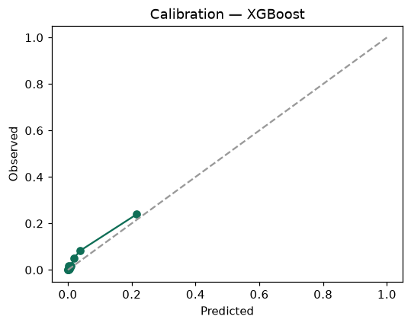

SHAP feature contributions
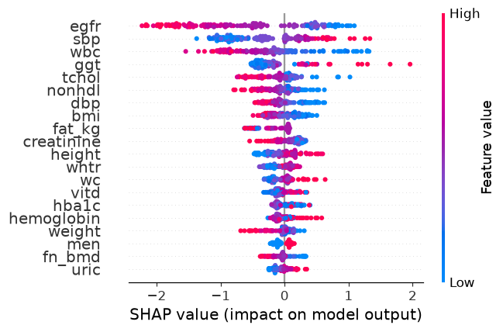

Partial dependence (PDP)
