Machine Learning Prediction Model Report
Outcome: Anemia (WHO) · NHANES · 3 models compared · tuning, full metrics, threshold, SHAP, PDP
[ML] outcome = anemia

Data summary
Item | Value
N | 6000
Outcome prevalence (%) | 10.7
Features | 60
Models compared | 3
Train/test | 4200/1800 (70/30 stratified)
Auto-excluded leakage | None

Hyperparameter search space
Model | Search space
LogisticRegression | {'C': [0.01, 0.1, 1, 10], 'penalty': ['l1', 'l2']}
HistGradientBoosting | {'learning_rate': [0.03, 0.1], 'max_iter': [200, 400], 'max_depth': [3, 6, None]}
XGBoost | {'n_estimators': [300, 500], 'max_depth': [3, 5], 'learning_rate': [0.03, 0.1], 'subsample': [0.8, 1.0]}

Tuning results — best parameters and CV auROC
model | CV_auROC | best_params
LogisticRegression | 0.7595 | {'penalty': 'l1', 'C': 0.1}
HistGradientBoosting | 0.7695 | {'max_iter': 200, 'max_depth': None, 'learning_rate': 0.03}
XGBoost | 0.7808 | {'subsample': 0.8, 'n_estimators': 500, 'max_depth': 3, 'learning_rate': 0.03}

Full performance metrics (test set)
model | TP | TN | FP | FN | sensitivity | specificity | PPV | NPV | accuracy | balanced_accuracy | f1 | MCC | kappa | auROC | auPRC | logloss | brier | combined
XGBoost | 26 | 1585 | 23 | 166 | 0.1354 | 0.9857 | 0.5306 | 0.9052 | 0.895 | 0.5606 | 0.2158 | 0.2297 | 0.1802 | 0.8061 | 0.3638 | 0.2771 | 0.0811 | 0.585
HistGradientBoosting | 23 | 1586 | 22 | 169 | 0.1198 | 0.9863 | 0.5111 | 0.9037 | 0.8939 | 0.5531 | 0.1941 | 0.2098 | 0.1601 | 0.7802 | 0.3219 | 0.2956 | 0.0849 | 0.551
LogisticRegression | 10 | 1601 | 7 | 182 | 0.0521 | 0.9956 | 0.5882 | 0.8979 | 0.895 | 0.5239 | 0.0957 | 0.1523 | 0.0797 | 0.7477 | 0.2994 | 0.3038 | 0.086 | 0.5235

ROC · Precision-Recall
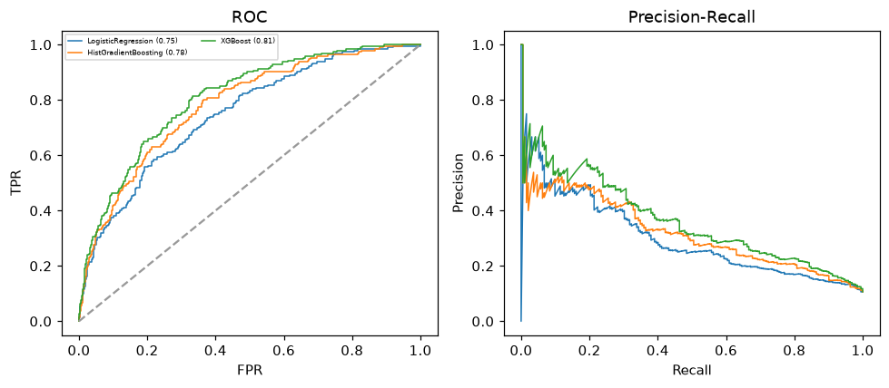

Selected final model — XGBoost (combined=0.585)
Among 3 candidate models, XGBoost achieved the highest combined score, with an area under the receiver operating characteristic curve of 0.8061 and area under the precision-recall curve of 0.3638.

Threshold analysis (0.1-0.9)
threshold | TP | TN | FP | FN | sensitivity | specificity | PPV | NPV | f1 | accuracy
0.1 | 134.0 | 1198.0 | 410.0 | 58.0 | 0.698 | 0.745 | 0.246 | 0.954 | 0.364 | 0.74
0.2 | 89.0 | 1449.0 | 159.0 | 103.0 | 0.464 | 0.901 | 0.359 | 0.934 | 0.405 | 0.854
0.3 | 59.0 | 1534.0 | 74.0 | 133.0 | 0.307 | 0.954 | 0.444 | 0.92 | 0.363 | 0.885
0.4 | 43.0 | 1572.0 | 36.0 | 149.0 | 0.224 | 0.978 | 0.544 | 0.913 | 0.317 | 0.897
0.5 | 26.0 | 1585.0 | 23.0 | 166.0 | 0.135 | 0.986 | 0.531 | 0.905 | 0.216 | 0.895
0.6 | 15.0 | 1597.0 | 11.0 | 177.0 | 0.078 | 0.993 | 0.577 | 0.9 | 0.138 | 0.896
0.7 | 8.0 | 1604.0 | 4.0 | 184.0 | 0.042 | 0.998 | 0.667 | 0.897 | 0.078 | 0.896
0.8 | 2.0 | 1606.0 | 2.0 | 190.0 | 0.01 | 0.999 | 0.5 | 0.894 | 0.02 | 0.893
0.9 | 0.0 | 1608.0 | 0.0 | 192.0 | 0.0 | 1.0 | nan | 0.893 | 0.0 | 0.893

Calibration
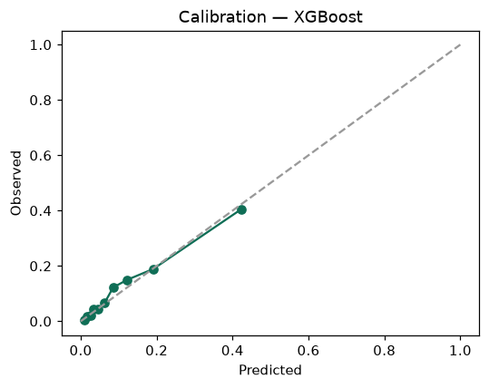

SHAP feature contributions
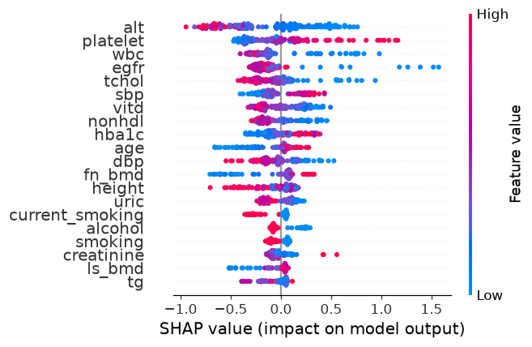

Partial dependence (PDP)
