Machine Learning Prediction Model Report
Outcome: Atherogenic dyslipidemia (high TG + low HDL) · NHANES · 3 models compared · tuning, full metrics, threshold, SHAP, PDP
[ML] outcome = atherogenic_dyslipidemia

Data summary
Item | Value
N | 6000
Outcome prevalence (%) | 13.1
Features | 55
Models compared | 3
Train/test | 4200/1800 (70/30 stratified)
Auto-excluded leakage | None

Hyperparameter search space
Model | Search space
LogisticRegression | {'C': [0.01, 0.1, 1, 10], 'penalty': ['l1', 'l2']}
HistGradientBoosting | {'learning_rate': [0.03, 0.1], 'max_iter': [200, 400], 'max_depth': [3, 6, None]}
XGBoost | {'n_estimators': [300, 500], 'max_depth': [3, 5], 'learning_rate': [0.03, 0.1], 'subsample': [0.8, 1.0]}

Tuning results — best parameters and CV auROC
model | CV_auROC | best_params
LogisticRegression | 0.806 | {'penalty': 'l1', 'C': 0.1}
HistGradientBoosting | 0.8008 | {'max_iter': 200, 'max_depth': None, 'learning_rate': 0.03}
XGBoost | 0.8104 | {'subsample': 0.8, 'n_estimators': 500, 'max_depth': 3, 'learning_rate': 0.03}

Full performance metrics (test set)
model | TP | TN | FP | FN | sensitivity | specificity | PPV | NPV | accuracy | balanced_accuracy | f1 | MCC | kappa | auROC | auPRC | logloss | brier | combined
HistGradientBoosting | 28 | 1540 | 25 | 207 | 0.1191 | 0.984 | 0.5283 | 0.8815 | 0.8711 | 0.5516 | 0.1944 | 0.2056 | 0.1538 | 0.7983 | 0.3891 | 0.3234 | 0.0966 | 0.5937
XGBoost | 30 | 1543 | 22 | 205 | 0.1277 | 0.9859 | 0.5769 | 0.8827 | 0.8739 | 0.5568 | 0.2091 | 0.2285 | 0.1698 | 0.7984 | 0.387 | 0.3186 | 0.0961 | 0.5927
LogisticRegression | 15 | 1551 | 14 | 220 | 0.0638 | 0.9911 | 0.5172 | 0.8758 | 0.87 | 0.5274 | 0.1136 | 0.1469 | 0.0875 | 0.7877 | 0.363 | 0.3237 | 0.0981 | 0.5754

ROC · Precision-Recall
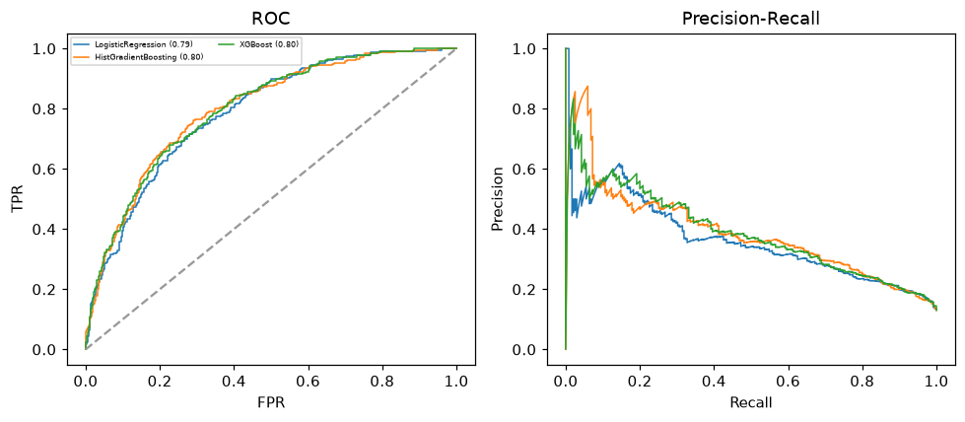

Selected final model — HistGradientBoosting (combined=0.5937)
Among 3 candidate models, HistGradientBoosting achieved the highest combined score, with an area under the receiver operating characteristic curve of 0.7983 and area under the precision-recall curve of 0.3891.

Threshold analysis (0.1-0.9)
threshold | TP | TN | FP | FN | sensitivity | specificity | PPV | NPV | f1 | accuracy
0.1 | 176.0 | 1115.0 | 450.0 | 59.0 | 0.749 | 0.712 | 0.281 | 0.95 | 0.409 | 0.717
0.2 | 125.0 | 1340.0 | 225.0 | 110.0 | 0.532 | 0.856 | 0.357 | 0.924 | 0.427 | 0.814
0.3 | 81.0 | 1454.0 | 111.0 | 154.0 | 0.345 | 0.929 | 0.422 | 0.904 | 0.379 | 0.853
0.4 | 54.0 | 1508.0 | 57.0 | 181.0 | 0.23 | 0.964 | 0.486 | 0.893 | 0.312 | 0.868
0.5 | 28.0 | 1540.0 | 25.0 | 207.0 | 0.119 | 0.984 | 0.528 | 0.882 | 0.194 | 0.871
0.6 | 17.0 | 1556.0 | 9.0 | 218.0 | 0.072 | 0.994 | 0.654 | 0.877 | 0.13 | 0.874
0.7 | 7.0 | 1563.0 | 2.0 | 228.0 | 0.03 | 0.999 | 0.778 | 0.873 | 0.057 | 0.872
0.8 | 2.0 | 1564.0 | 1.0 | 233.0 | 0.009 | 0.999 | 0.667 | 0.87 | 0.017 | 0.87
0.9 | 0.0 | 1564.0 | 1.0 | 235.0 | 0.0 | 0.999 | 0.0 | 0.869 | 0.0 | 0.869

Calibration
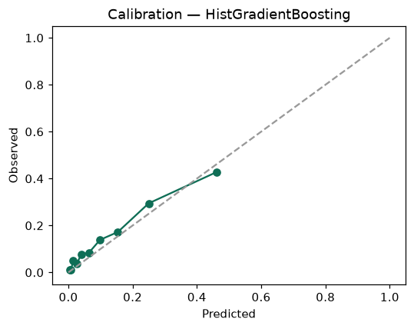

SHAP feature contributions
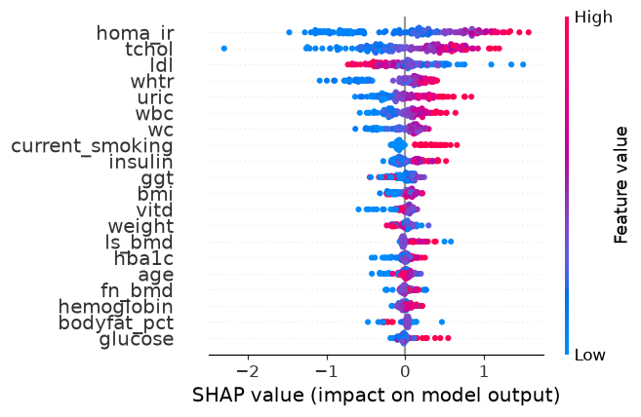

Partial dependence (PDP)
