Machine Learning Prediction Model Report
Outcome: Chronic kidney disease (KDIGO: eGFR<60 or ACR>=30) · NHANES · 3 models compared · tuning, full metrics, threshold, SHAP, PDP
[ML] outcome = ckd

Data summary
Item | Value
N | 6000
Outcome prevalence (%) | 16.8
Features | 57
Models compared | 3
Train/test | 4200/1800 (70/30 stratified)
Auto-excluded leakage | None

Hyperparameter search space
Model | Search space
LogisticRegression | {'C': [0.01, 0.1, 1, 10], 'penalty': ['l1', 'l2']}
HistGradientBoosting | {'learning_rate': [0.03, 0.1], 'max_iter': [200, 400], 'max_depth': [3, 6, None]}
XGBoost | {'n_estimators': [300, 500], 'max_depth': [3, 5], 'learning_rate': [0.03, 0.1], 'subsample': [0.8, 1.0]}

Tuning results — best parameters and CV auROC
model | CV_auROC | best_params
LogisticRegression | 0.7874 | {'penalty': 'l1', 'C': 0.1}
HistGradientBoosting | 0.7823 | {'max_iter': 400, 'max_depth': 3, 'learning_rate': 0.03}
XGBoost | 0.7899 | {'subsample': 1.0, 'n_estimators': 300, 'max_depth': 3, 'learning_rate': 0.03}

Full performance metrics (test set)
model | TP | TN | FP | FN | sensitivity | specificity | PPV | NPV | accuracy | balanced_accuracy | f1 | MCC | kappa | auROC | auPRC | logloss | brier | combined
LogisticRegression | 85 | 1465 | 34 | 216 | 0.2824 | 0.9773 | 0.7143 | 0.8715 | 0.8611 | 0.6299 | 0.4048 | 0.39 | 0.3425 | 0.8079 | 0.543 | 0.3523 | 0.1066 | 0.6754
XGBoost | 80 | 1471 | 28 | 221 | 0.2658 | 0.9813 | 0.7407 | 0.8694 | 0.8617 | 0.6236 | 0.3912 | 0.3883 | 0.3322 | 0.8074 | 0.5422 | 0.3518 | 0.1065 | 0.6748
HistGradientBoosting | 85 | 1469 | 30 | 216 | 0.2824 | 0.98 | 0.7391 | 0.8718 | 0.8633 | 0.6312 | 0.4087 | 0.4004 | 0.3484 | 0.8025 | 0.546 | 0.3537 | 0.1067 | 0.6742

ROC · Precision-Recall
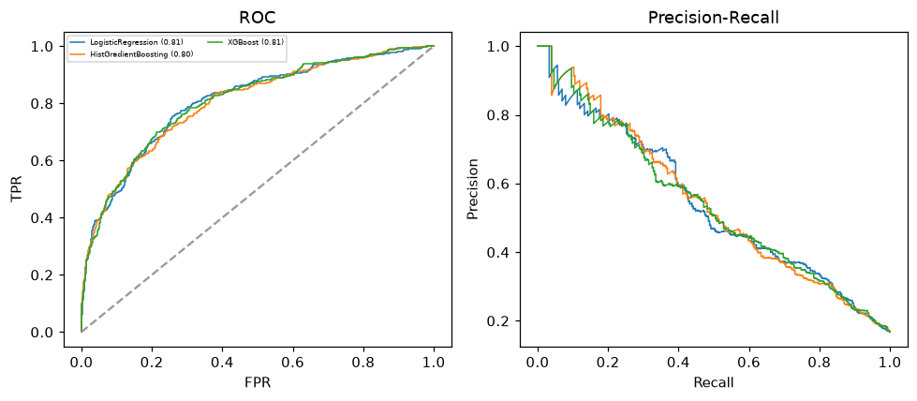

Selected final model — LogisticRegression (combined=0.6754)
Among 3 candidate models, LogisticRegression achieved the highest combined score, with an area under the receiver operating characteristic curve of 0.8079 and area under the precision-recall curve of 0.543.

Threshold analysis (0.1-0.9)
threshold | TP | TN | FP | FN | sensitivity | specificity | PPV | NPV | f1 | accuracy
0.1 | 256.0 | 853.0 | 646.0 | 45.0 | 0.85 | 0.569 | 0.284 | 0.95 | 0.426 | 0.616
0.2 | 203.0 | 1183.0 | 316.0 | 98.0 | 0.674 | 0.789 | 0.391 | 0.923 | 0.495 | 0.77
0.3 | 152.0 | 1322.0 | 177.0 | 149.0 | 0.505 | 0.882 | 0.462 | 0.899 | 0.483 | 0.819
0.4 | 122.0 | 1415.0 | 84.0 | 179.0 | 0.405 | 0.944 | 0.592 | 0.888 | 0.481 | 0.854
0.5 | 85.0 | 1465.0 | 34.0 | 216.0 | 0.282 | 0.977 | 0.714 | 0.872 | 0.405 | 0.861
0.6 | 53.0 | 1485.0 | 14.0 | 248.0 | 0.176 | 0.991 | 0.791 | 0.857 | 0.288 | 0.854
0.7 | 29.0 | 1494.0 | 5.0 | 272.0 | 0.096 | 0.997 | 0.853 | 0.846 | 0.173 | 0.846
0.8 | 14.0 | 1498.0 | 1.0 | 287.0 | 0.047 | 0.999 | 0.933 | 0.839 | 0.089 | 0.84
0.9 | 2.0 | 1499.0 | 0.0 | 299.0 | 0.007 | 1.0 | 1.0 | 0.834 | 0.013 | 0.834

Calibration
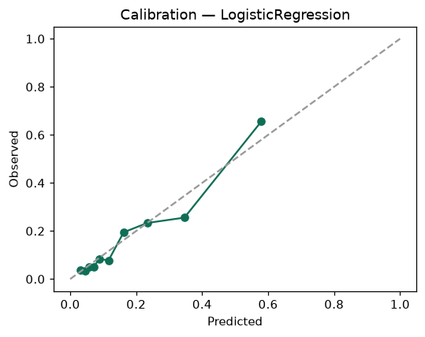

SHAP feature contributions
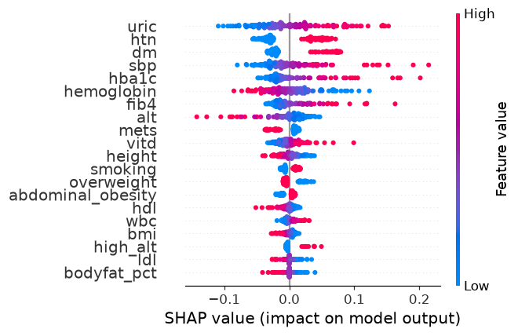

Partial dependence (PDP)
