Machine Learning Prediction Model Report
Outcome: Dyslipidemia (KSoLA composite) · NHANES · 3 models compared · tuning, full metrics, threshold, SHAP, PDP
[ML] outcome = dyslipidemia

Data summary
Item | Value
N | 6000
Outcome prevalence (%) | 55.6
Features | 52
Models compared | 3
Train/test | 4200/1800 (70/30 stratified)
Auto-excluded leakage | None

Hyperparameter search space
Model | Search space
LogisticRegression | {'C': [0.01, 0.1, 1, 10], 'penalty': ['l1', 'l2']}
HistGradientBoosting | {'learning_rate': [0.03, 0.1], 'max_iter': [200, 400], 'max_depth': [3, 6, None]}
XGBoost | {'n_estimators': [300, 500], 'max_depth': [3, 5], 'learning_rate': [0.03, 0.1], 'subsample': [0.8, 1.0]}

Tuning results — best parameters and CV auROC
model | CV_auROC | best_params
LogisticRegression | 0.7048 | {'penalty': 'l2', 'C': 0.01}
HistGradientBoosting | 0.7075 | {'max_iter': 400, 'max_depth': 3, 'learning_rate': 0.03}
XGBoost | 0.7137 | {'subsample': 0.8, 'n_estimators': 300, 'max_depth': 5, 'learning_rate': 0.03}

Full performance metrics (test set)
model | TP | TN | FP | FN | sensitivity | specificity | PPV | NPV | accuracy | balanced_accuracy | f1 | MCC | kappa | auROC | auPRC | logloss | brier | combined
HistGradientBoosting | 812 | 409 | 390 | 189 | 0.8112 | 0.5119 | 0.6755 | 0.6839 | 0.6783 | 0.6615 | 0.7372 | 0.3408 | 0.3315 | 0.7402 | 0.7741 | 0.5944 | 0.2042 | 0.7571
XGBoost | 801 | 429 | 370 | 200 | 0.8002 | 0.5369 | 0.684 | 0.682 | 0.6833 | 0.6686 | 0.7376 | 0.3513 | 0.3445 | 0.7415 | 0.7707 | 0.5959 | 0.2042 | 0.7561
LogisticRegression | 793 | 430 | 369 | 208 | 0.7922 | 0.5382 | 0.6824 | 0.674 | 0.6794 | 0.6652 | 0.7332 | 0.3432 | 0.3372 | 0.7308 | 0.7482 | 0.601 | 0.2068 | 0.7395

ROC · Precision-Recall
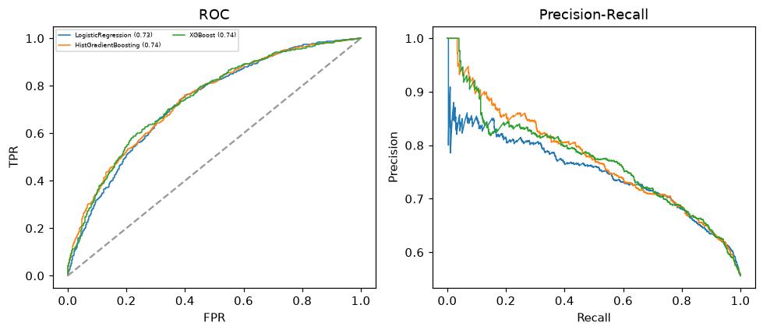

Selected final model — HistGradientBoosting (combined=0.7571)
Among 3 candidate models, HistGradientBoosting achieved the highest combined score, with an area under the receiver operating characteristic curve of 0.7402 and area under the precision-recall curve of 0.7741.

Threshold analysis (0.1-0.9)
threshold | TP | TN | FP | FN | sensitivity | specificity | PPV | NPV | f1 | accuracy
0.1 | 996.0 | 33.0 | 766.0 | 5.0 | 0.995 | 0.041 | 0.565 | 0.868 | 0.721 | 0.572
0.2 | 977.0 | 121.0 | 678.0 | 24.0 | 0.976 | 0.151 | 0.59 | 0.834 | 0.736 | 0.61
0.3 | 952.0 | 205.0 | 594.0 | 49.0 | 0.951 | 0.257 | 0.616 | 0.807 | 0.748 | 0.643
0.4 | 900.0 | 292.0 | 507.0 | 101.0 | 0.899 | 0.365 | 0.64 | 0.743 | 0.748 | 0.662
0.5 | 812.0 | 409.0 | 390.0 | 189.0 | 0.811 | 0.512 | 0.676 | 0.684 | 0.737 | 0.678
0.6 | 599.0 | 586.0 | 213.0 | 402.0 | 0.598 | 0.733 | 0.738 | 0.593 | 0.661 | 0.658
0.7 | 359.0 | 713.0 | 86.0 | 642.0 | 0.359 | 0.892 | 0.807 | 0.526 | 0.497 | 0.596
0.8 | 151.0 | 780.0 | 19.0 | 850.0 | 0.151 | 0.976 | 0.888 | 0.479 | 0.258 | 0.517
0.9 | 23.0 | 799.0 | 0.0 | 978.0 | 0.023 | 1.0 | 1.0 | 0.45 | 0.045 | 0.457

Calibration
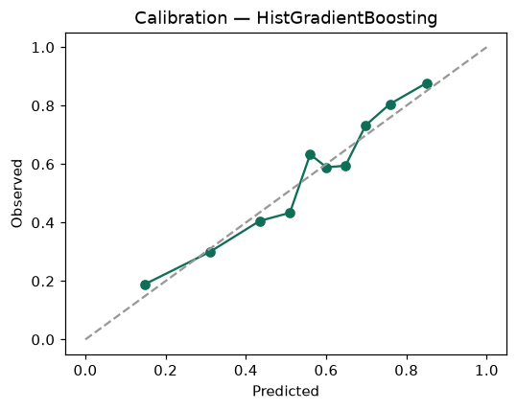

SHAP feature contributions
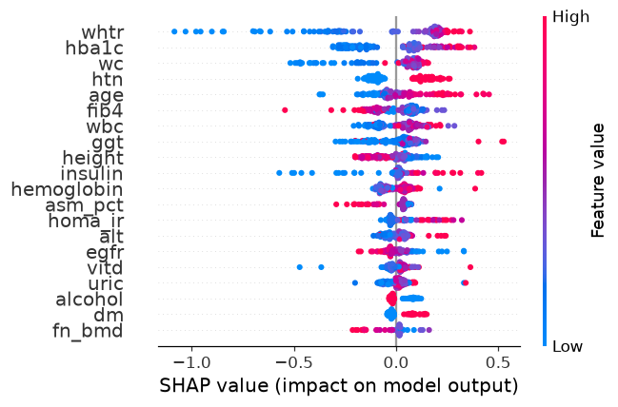

Partial dependence (PDP)
