Machine Learning Prediction Model Report
Outcome: Elevated AST (>40 IU/L) · NHANES · 3 models compared · tuning, full metrics, threshold, SHAP, PDP
[ML] outcome = high_ast

Data summary
Item | Value
N | 6000
Outcome prevalence (%) | 5.9
Features | 57
Models compared | 3
Train/test | 4200/1800 (70/30 stratified)
Auto-excluded leakage | None

Hyperparameter search space
Model | Search space
LogisticRegression | {'C': [0.01, 0.1, 1, 10], 'penalty': ['l1', 'l2']}
HistGradientBoosting | {'learning_rate': [0.03, 0.1], 'max_iter': [200, 400], 'max_depth': [3, 6, None]}
XGBoost | {'n_estimators': [300, 500], 'max_depth': [3, 5], 'learning_rate': [0.03, 0.1], 'subsample': [0.8, 1.0]}

Tuning results — best parameters and CV auROC
model | CV_auROC | best_params
LogisticRegression | 0.8254 | {'penalty': 'l1', 'C': 0.01}
HistGradientBoosting | 0.8293 | {'max_iter': 400, 'max_depth': 3, 'learning_rate': 0.03}
XGBoost | 0.8336 | {'subsample': 1.0, 'n_estimators': 300, 'max_depth': 3, 'learning_rate': 0.03}

Full performance metrics (test set)
model | TP | TN | FP | FN | sensitivity | specificity | PPV | NPV | accuracy | balanced_accuracy | f1 | MCC | kappa | auROC | auPRC | logloss | brier | combined
LogisticRegression | 14 | 1692 | 2 | 92 | 0.1321 | 0.9988 | 0.875 | 0.9484 | 0.9478 | 0.5654 | 0.2295 | 0.3283 | 0.2174 | 0.8792 | 0.4112 | 0.1926 | 0.0471 | 0.6452
XGBoost | 7 | 1682 | 12 | 99 | 0.066 | 0.9929 | 0.3684 | 0.9444 | 0.9383 | 0.5295 | 0.112 | 0.1358 | 0.0958 | 0.8647 | 0.3088 | 0.17 | 0.0473 | 0.5868
HistGradientBoosting | 8 | 1682 | 12 | 98 | 0.0755 | 0.9929 | 0.4 | 0.9449 | 0.9389 | 0.5342 | 0.127 | 0.1536 | 0.1104 | 0.8567 | 0.2998 | 0.1738 | 0.0484 | 0.5782

ROC · Precision-Recall
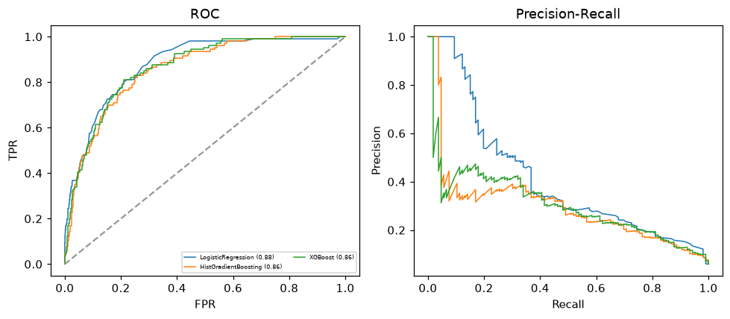

Selected final model — LogisticRegression (combined=0.6452)
Among 3 candidate models, LogisticRegression achieved the highest combined score, with an area under the receiver operating characteristic curve of 0.8792 and area under the precision-recall curve of 0.4112.

Threshold analysis (0.1-0.9)
threshold | TP | TN | FP | FN | sensitivity | specificity | PPV | NPV | f1 | accuracy
0.1 | 52.0 | 1566.0 | 128.0 | 54.0 | 0.491 | 0.924 | 0.289 | 0.967 | 0.364 | 0.899
0.2 | 24.0 | 1675.0 | 19.0 | 82.0 | 0.226 | 0.989 | 0.558 | 0.953 | 0.322 | 0.944
0.3 | 17.0 | 1689.0 | 5.0 | 89.0 | 0.16 | 0.997 | 0.773 | 0.95 | 0.266 | 0.948
0.4 | 14.0 | 1691.0 | 3.0 | 92.0 | 0.132 | 0.998 | 0.824 | 0.948 | 0.228 | 0.947
0.5 | 14.0 | 1692.0 | 2.0 | 92.0 | 0.132 | 0.999 | 0.875 | 0.948 | 0.23 | 0.948
0.6 | 10.0 | 1693.0 | 1.0 | 96.0 | 0.094 | 0.999 | 0.909 | 0.946 | 0.171 | 0.946
0.7 | 9.0 | 1694.0 | 0.0 | 97.0 | 0.085 | 1.0 | 1.0 | 0.946 | 0.157 | 0.946
0.8 | 4.0 | 1694.0 | 0.0 | 102.0 | 0.038 | 1.0 | 1.0 | 0.943 | 0.073 | 0.943
0.9 | 2.0 | 1694.0 | 0.0 | 104.0 | 0.019 | 1.0 | 1.0 | 0.942 | 0.037 | 0.942

Calibration
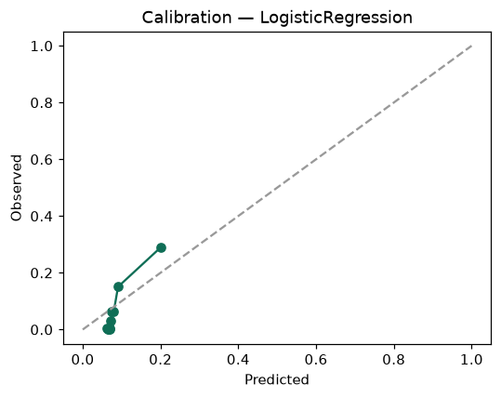

SHAP feature contributions
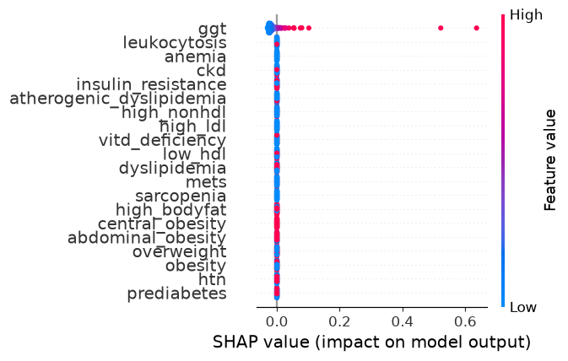

Partial dependence (PDP)
