Machine Learning Prediction Model Report
Outcome: Hepatic steatosis · NHANES · 3 models compared · tuning, full metrics, threshold, SHAP, PDP
[ML] outcome = steatosis

Data summary
Item | Value
N | 4869
Outcome prevalence (%) | 59.6
Features | 31
Models compared | 3
Train/test | 3408/1461 (70/30 stratified)
Auto-excluded leakage | None

Hyperparameter search space
Model | Search space
LogisticRegression | {'C': [0.01, 0.1, 1, 10], 'penalty': ['l1', 'l2']}
HistGradientBoosting | {'learning_rate': [0.03, 0.1], 'max_iter': [200, 400], 'max_depth': [3, 6, None]}
XGBoost | {'n_estimators': [300, 500], 'max_depth': [3, 5], 'learning_rate': [0.03, 0.1], 'subsample': [0.8, 1.0]}

Tuning results — best parameters and CV auROC
model | CV_auROC | best_params
LogisticRegression | 0.8199 | {'penalty': 'l2', 'C': 1}
HistGradientBoosting | 0.8107 | {'max_iter': 400, 'max_depth': 3, 'learning_rate': 0.03}
XGBoost | 0.8146 | {'subsample': 0.8, 'n_estimators': 500, 'max_depth': 3, 'learning_rate': 0.03}

Full performance metrics (test set)
model | TP | TN | FP | FN | sensitivity | specificity | PPV | NPV | accuracy | balanced_accuracy | f1 | MCC | kappa | auROC | auPRC | logloss | brier | combined
XGBoost | 753 | 372 | 218 | 118 | 0.8645 | 0.6305 | 0.7755 | 0.7592 | 0.77 | 0.7475 | 0.8176 | 0.5145 | 0.5089 | 0.8415 | 0.8767 | 0.4761 | 0.1562 | 0.8591
HistGradientBoosting | 751 | 377 | 213 | 120 | 0.8622 | 0.639 | 0.779 | 0.7586 | 0.7721 | 0.7506 | 0.8185 | 0.5191 | 0.5143 | 0.8384 | 0.8722 | 0.4817 | 0.1579 | 0.8553
LogisticRegression | 753 | 366 | 224 | 118 | 0.8645 | 0.6203 | 0.7707 | 0.7562 | 0.7659 | 0.7424 | 0.8149 | 0.5055 | 0.4993 | 0.8318 | 0.8685 | 0.4896 | 0.161 | 0.8501

ROC · Precision-Recall
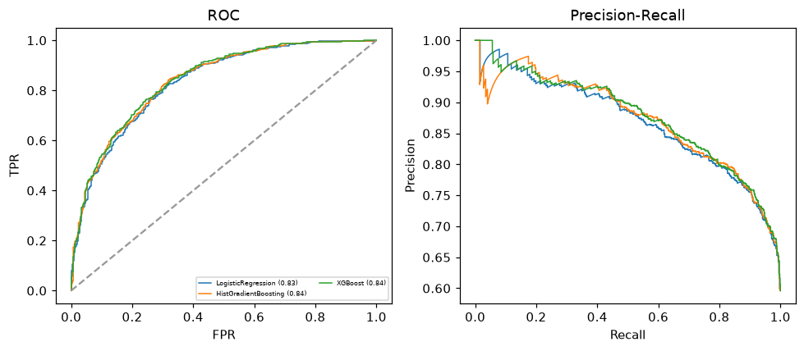

Selected final model — XGBoost (combined=0.8591)
Among 3 candidate models, XGBoost achieved the highest combined score, with an area under the receiver operating characteristic curve of 0.8415 and area under the precision-recall curve of 0.8767.

Threshold analysis (0.1-0.9)
threshold | TP | TN | FP | FN | sensitivity | specificity | PPV | NPV | f1 | accuracy
0.1 | 867.0 | 109.0 | 481.0 | 4.0 | 0.995 | 0.185 | 0.643 | 0.965 | 0.781 | 0.668
0.2 | 851.0 | 196.0 | 394.0 | 20.0 | 0.977 | 0.332 | 0.684 | 0.907 | 0.804 | 0.717
0.3 | 827.0 | 257.0 | 333.0 | 44.0 | 0.949 | 0.436 | 0.713 | 0.854 | 0.814 | 0.742
0.4 | 803.0 | 312.0 | 278.0 | 68.0 | 0.922 | 0.529 | 0.743 | 0.821 | 0.823 | 0.763
0.5 | 753.0 | 372.0 | 218.0 | 118.0 | 0.865 | 0.631 | 0.775 | 0.759 | 0.818 | 0.77
0.6 | 683.0 | 426.0 | 164.0 | 188.0 | 0.784 | 0.722 | 0.806 | 0.694 | 0.795 | 0.759
0.7 | 583.0 | 485.0 | 105.0 | 288.0 | 0.669 | 0.822 | 0.847 | 0.627 | 0.748 | 0.731
0.8 | 445.0 | 538.0 | 52.0 | 426.0 | 0.511 | 0.912 | 0.895 | 0.558 | 0.651 | 0.673
0.9 | 219.0 | 574.0 | 16.0 | 652.0 | 0.251 | 0.973 | 0.932 | 0.468 | 0.396 | 0.543

Calibration
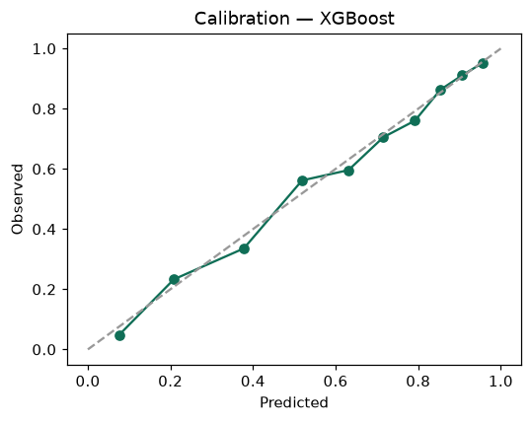

SHAP feature contributions
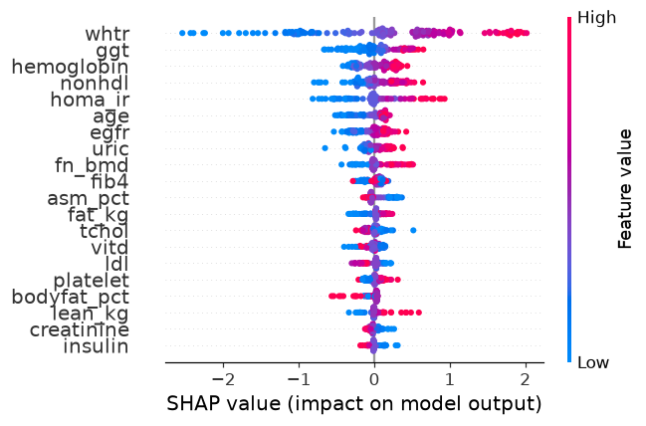

Partial dependence (PDP)
