Machine Learning Prediction Model Report
Outcome: High body fat (M>=25/F>=35%) · NHANES · 3 models compared · tuning, full metrics, threshold, SHAP, PDP
[ML] outcome = high_bodyfat

Data summary
Item | Value
N | 6000
Outcome prevalence (%) | 70.6
Features | 47
Models compared | 3
Train/test | 4200/1800 (70/30 stratified)
Auto-excluded leakage | None

Hyperparameter search space
Model | Search space
LogisticRegression | {'C': [0.01, 0.1, 1, 10], 'penalty': ['l1', 'l2']}
HistGradientBoosting | {'learning_rate': [0.03, 0.1], 'max_iter': [200, 400], 'max_depth': [3, 6, None]}
XGBoost | {'n_estimators': [300, 500], 'max_depth': [3, 5], 'learning_rate': [0.03, 0.1], 'subsample': [0.8, 1.0]}

Tuning results — best parameters and CV auROC
model | CV_auROC | best_params
LogisticRegression | 0.8132 | {'penalty': 'l1', 'C': 1}
HistGradientBoosting | 0.8136 | {'max_iter': 400, 'max_depth': 3, 'learning_rate': 0.03}
XGBoost | 0.8162 | {'subsample': 0.8, 'n_estimators': 500, 'max_depth': 3, 'learning_rate': 0.03}

Full performance metrics (test set)
model | TP | TN | FP | FN | sensitivity | specificity | PPV | NPV | accuracy | balanced_accuracy | f1 | MCC | kappa | auROC | auPRC | logloss | brier | combined
XGBoost | 1150 | 257 | 272 | 121 | 0.9048 | 0.4858 | 0.8087 | 0.6799 | 0.7817 | 0.6953 | 0.8541 | 0.4369 | 0.4261 | 0.8202 | 0.9089 | 0.4575 | 0.1489 | 0.8646
LogisticRegression | 1141 | 257 | 272 | 130 | 0.8977 | 0.4858 | 0.8075 | 0.6641 | 0.7767 | 0.6918 | 0.8502 | 0.4253 | 0.4161 | 0.8186 | 0.9063 | 0.4658 | 0.1504 | 0.8624
HistGradientBoosting | 1149 | 249 | 280 | 122 | 0.904 | 0.4707 | 0.8041 | 0.6712 | 0.7767 | 0.6874 | 0.8511 | 0.422 | 0.4105 | 0.8153 | 0.9054 | 0.4633 | 0.1507 | 0.8604

ROC · Precision-Recall
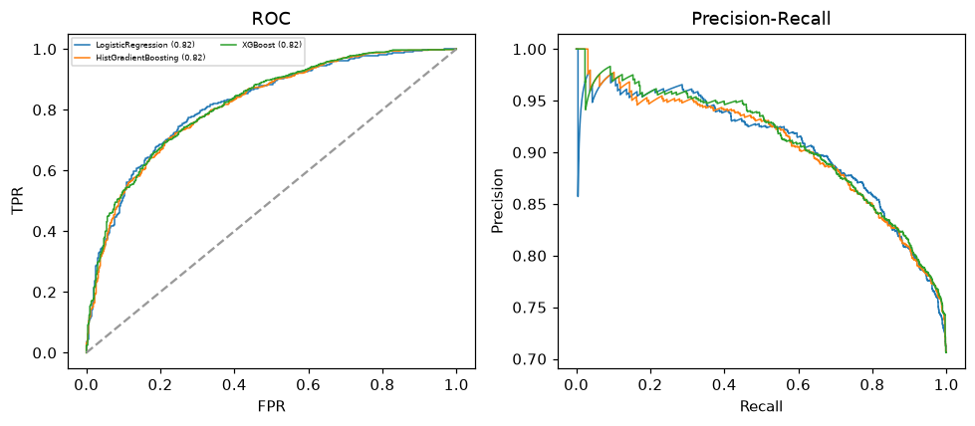

Selected final model — XGBoost (combined=0.8646)
Among 3 candidate models, XGBoost achieved the highest combined score, with an area under the receiver operating characteristic curve of 0.8202 and area under the precision-recall curve of 0.9089.

Threshold analysis (0.1-0.9)
threshold | TP | TN | FP | FN | sensitivity | specificity | PPV | NPV | f1 | accuracy
0.1 | 1268.0 | 25.0 | 504.0 | 3.0 | 0.998 | 0.047 | 0.716 | 0.893 | 0.833 | 0.718
0.2 | 1267.0 | 83.0 | 446.0 | 4.0 | 0.997 | 0.157 | 0.74 | 0.954 | 0.849 | 0.75
0.3 | 1243.0 | 149.0 | 380.0 | 28.0 | 0.978 | 0.282 | 0.766 | 0.842 | 0.859 | 0.773
0.4 | 1199.0 | 202.0 | 327.0 | 72.0 | 0.943 | 0.382 | 0.786 | 0.737 | 0.857 | 0.778
0.5 | 1150.0 | 257.0 | 272.0 | 121.0 | 0.905 | 0.486 | 0.809 | 0.68 | 0.854 | 0.782
0.6 | 1072.0 | 317.0 | 212.0 | 199.0 | 0.843 | 0.599 | 0.835 | 0.614 | 0.839 | 0.772
0.7 | 954.0 | 382.0 | 147.0 | 317.0 | 0.751 | 0.722 | 0.866 | 0.546 | 0.804 | 0.742
0.8 | 784.0 | 446.0 | 83.0 | 487.0 | 0.617 | 0.843 | 0.904 | 0.478 | 0.733 | 0.683
0.9 | 506.0 | 502.0 | 27.0 | 765.0 | 0.398 | 0.949 | 0.949 | 0.396 | 0.561 | 0.56

Calibration
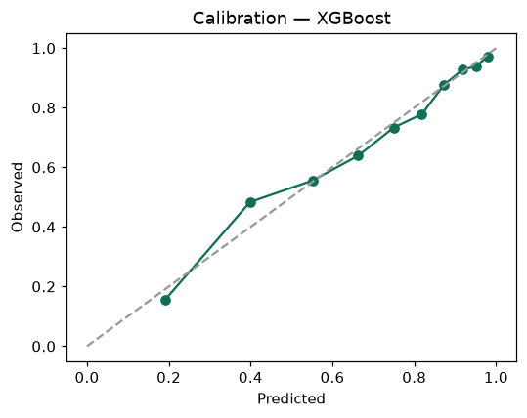

SHAP feature contributions
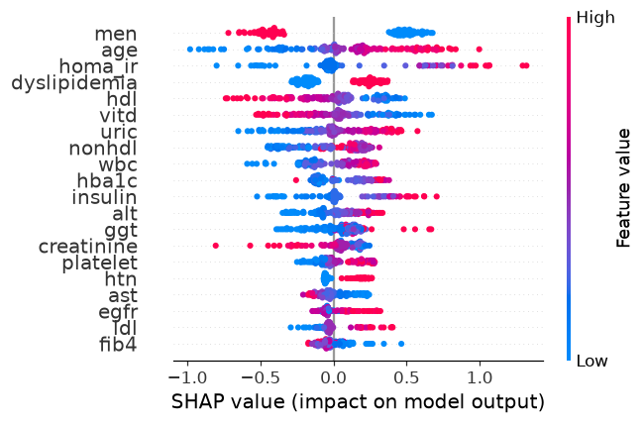

Partial dependence (PDP)
