Machine Learning Prediction Model Report
Outcome: High non-HDL cholesterol (>=190) · NHANES · 3 models compared · tuning, full metrics, threshold, SHAP, PDP
[ML] outcome = high_nonhdl

Data summary
Item | Value
N | 6000
Outcome prevalence (%) | 12.0
Features | 54
Models compared | 3
Train/test | 4200/1800 (70/30 stratified)
Auto-excluded leakage | None

Hyperparameter search space
Model | Search space
LogisticRegression | {'C': [0.01, 0.1, 1, 10], 'penalty': ['l1', 'l2']}
HistGradientBoosting | {'learning_rate': [0.03, 0.1], 'max_iter': [200, 400], 'max_depth': [3, 6, None]}
XGBoost | {'n_estimators': [300, 500], 'max_depth': [3, 5], 'learning_rate': [0.03, 0.1], 'subsample': [0.8, 1.0]}

Tuning results — best parameters and CV auROC
model | CV_auROC | best_params
LogisticRegression | 0.7137 | {'penalty': 'l2', 'C': 0.01}
HistGradientBoosting | 0.724 | {'max_iter': 200, 'max_depth': 6, 'learning_rate': 0.03}
XGBoost | 0.7364 | {'subsample': 0.8, 'n_estimators': 300, 'max_depth': 5, 'learning_rate': 0.03}

Full performance metrics (test set)
model | TP | TN | FP | FN | sensitivity | specificity | PPV | NPV | accuracy | balanced_accuracy | f1 | MCC | kappa | auROC | auPRC | logloss | brier | combined
XGBoost | 8 | 1569 | 16 | 207 | 0.0372 | 0.9899 | 0.3333 | 0.8834 | 0.8761 | 0.5136 | 0.0669 | 0.0767 | 0.044 | 0.7648 | 0.2962 | 0.3221 | 0.0953 | 0.5305
LogisticRegression | 12 | 1578 | 7 | 203 | 0.0558 | 0.9956 | 0.6316 | 0.886 | 0.8833 | 0.5257 | 0.1026 | 0.1631 | 0.0848 | 0.7438 | 0.2982 | 0.3365 | 0.0974 | 0.521
HistGradientBoosting | 7 | 1578 | 7 | 208 | 0.0326 | 0.9956 | 0.5 | 0.8835 | 0.8806 | 0.5141 | 0.0611 | 0.1039 | 0.0472 | 0.7473 | 0.2885 | 0.326 | 0.0961 | 0.5179

ROC · Precision-Recall
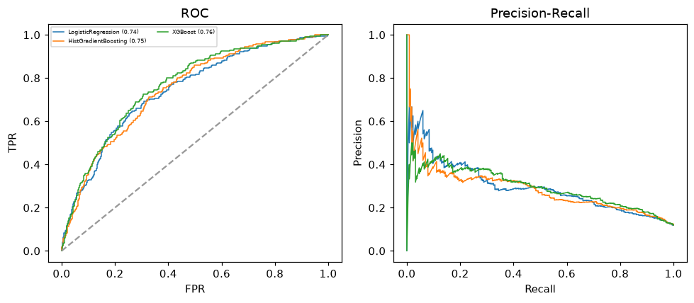

Selected final model — XGBoost (combined=0.5305)
Among 3 candidate models, XGBoost achieved the highest combined score, with an area under the receiver operating characteristic curve of 0.7648 and area under the precision-recall curve of 0.2962.

Threshold analysis (0.1-0.9)
threshold | TP | TN | FP | FN | sensitivity | specificity | PPV | NPV | f1 | accuracy
0.1 | 156.0 | 1101.0 | 484.0 | 59.0 | 0.726 | 0.695 | 0.244 | 0.949 | 0.365 | 0.698
0.2 | 81.0 | 1420.0 | 165.0 | 134.0 | 0.377 | 0.896 | 0.329 | 0.914 | 0.351 | 0.834
0.3 | 47.0 | 1510.0 | 75.0 | 168.0 | 0.219 | 0.953 | 0.385 | 0.9 | 0.279 | 0.865
0.4 | 27.0 | 1552.0 | 33.0 | 188.0 | 0.126 | 0.979 | 0.45 | 0.892 | 0.196 | 0.877
0.5 | 8.0 | 1569.0 | 16.0 | 207.0 | 0.037 | 0.99 | 0.333 | 0.883 | 0.067 | 0.876
0.6 | 6.0 | 1578.0 | 7.0 | 209.0 | 0.028 | 0.996 | 0.462 | 0.883 | 0.053 | 0.88
0.7 | 0.0 | 1582.0 | 3.0 | 215.0 | 0.0 | 0.998 | 0.0 | 0.88 | 0.0 | 0.879
0.8 | 0.0 | 1584.0 | 1.0 | 215.0 | 0.0 | 0.999 | 0.0 | 0.88 | 0.0 | 0.88
0.9 | 0.0 | 1585.0 | 0.0 | 215.0 | 0.0 | 1.0 | nan | 0.881 | 0.0 | 0.881

Calibration
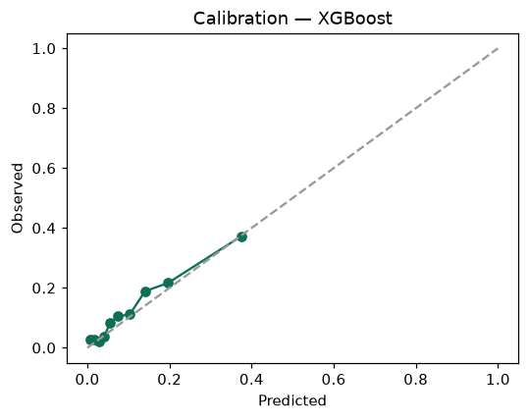

SHAP feature contributions
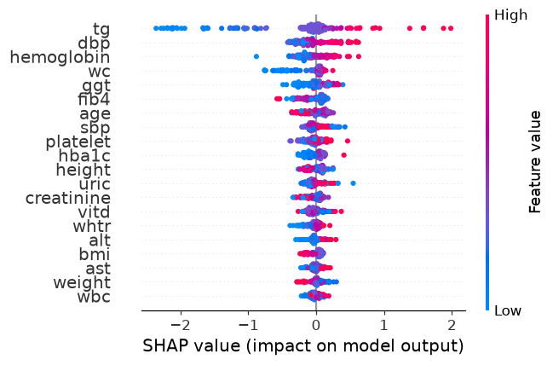

Partial dependence (PDP)
