Machine Learning Prediction Model Report
Outcome: Hypertension · NHANES · 3 models compared · tuning, full metrics, threshold, SHAP, PDP
[ML] outcome = htn

Data summary
Item | Value
N | 6000
Outcome prevalence (%) | 42.6
Features | 60
Models compared | 3
Train/test | 4200/1800 (70/30 stratified)
Auto-excluded leakage | None

Hyperparameter search space
Model | Search space
LogisticRegression | {'C': [0.01, 0.1, 1, 10], 'penalty': ['l1', 'l2']}
HistGradientBoosting | {'learning_rate': [0.03, 0.1], 'max_iter': [200, 400], 'max_depth': [3, 6, None]}
XGBoost | {'n_estimators': [300, 500], 'max_depth': [3, 5], 'learning_rate': [0.03, 0.1], 'subsample': [0.8, 1.0]}

Tuning results — best parameters and CV auROC
model | CV_auROC | best_params
LogisticRegression | 0.8461 | {'penalty': 'l1', 'C': 0.1}
HistGradientBoosting | 0.8454 | {'max_iter': 200, 'max_depth': 6, 'learning_rate': 0.03}
XGBoost | 0.8472 | {'subsample': 1.0, 'n_estimators': 300, 'max_depth': 3, 'learning_rate': 0.03}

Full performance metrics (test set)
model | TP | TN | FP | FN | sensitivity | specificity | PPV | NPV | accuracy | balanced_accuracy | f1 | MCC | kappa | auROC | auPRC | logloss | brier | combined
XGBoost | 573 | 824 | 208 | 195 | 0.7461 | 0.7984 | 0.7337 | 0.8086 | 0.7761 | 0.7723 | 0.7398 | 0.5434 | 0.5434 | 0.86 | 0.8039 | 0.4602 | 0.1511 | 0.8319
LogisticRegression | 559 | 852 | 180 | 209 | 0.7279 | 0.8256 | 0.7564 | 0.803 | 0.7839 | 0.7767 | 0.7419 | 0.5564 | 0.5561 | 0.8587 | 0.799 | 0.4644 | 0.152 | 0.8289
HistGradientBoosting | 575 | 821 | 211 | 193 | 0.7487 | 0.7955 | 0.7316 | 0.8097 | 0.7756 | 0.7721 | 0.74 | 0.5427 | 0.5426 | 0.8548 | 0.7996 | 0.4653 | 0.1538 | 0.8272

ROC · Precision-Recall
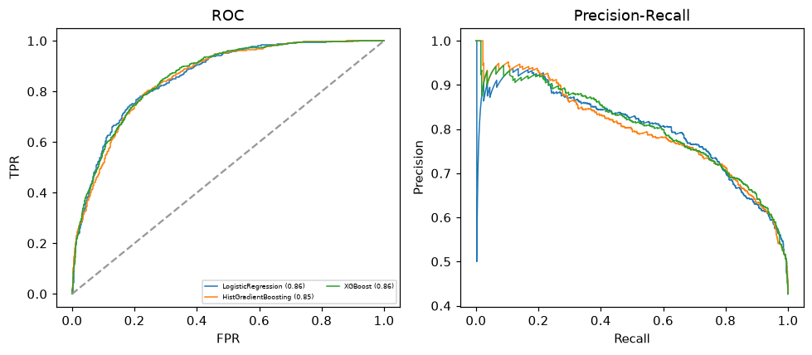

Selected final model — XGBoost (combined=0.8319)
Among 3 candidate models, XGBoost achieved the highest combined score, with an area under the receiver operating characteristic curve of 0.86 and area under the precision-recall curve of 0.8039.

Threshold analysis (0.1-0.9)
threshold | TP | TN | FP | FN | sensitivity | specificity | PPV | NPV | f1 | accuracy
0.1 | 756.0 | 348.0 | 684.0 | 12.0 | 0.984 | 0.337 | 0.525 | 0.967 | 0.685 | 0.613
0.2 | 735.0 | 521.0 | 511.0 | 33.0 | 0.957 | 0.505 | 0.59 | 0.94 | 0.73 | 0.698
0.3 | 697.0 | 643.0 | 389.0 | 71.0 | 0.908 | 0.623 | 0.642 | 0.901 | 0.752 | 0.744
0.4 | 637.0 | 744.0 | 288.0 | 131.0 | 0.829 | 0.721 | 0.689 | 0.85 | 0.753 | 0.767
0.5 | 573.0 | 824.0 | 208.0 | 195.0 | 0.746 | 0.798 | 0.734 | 0.809 | 0.74 | 0.776
0.6 | 493.0 | 888.0 | 144.0 | 275.0 | 0.642 | 0.86 | 0.774 | 0.764 | 0.702 | 0.767
0.7 | 375.0 | 951.0 | 81.0 | 393.0 | 0.488 | 0.922 | 0.822 | 0.708 | 0.613 | 0.737
0.8 | 205.0 | 1007.0 | 25.0 | 563.0 | 0.267 | 0.976 | 0.891 | 0.641 | 0.411 | 0.673
0.9 | 25.0 | 1030.0 | 2.0 | 743.0 | 0.033 | 0.998 | 0.926 | 0.581 | 0.063 | 0.586

Calibration
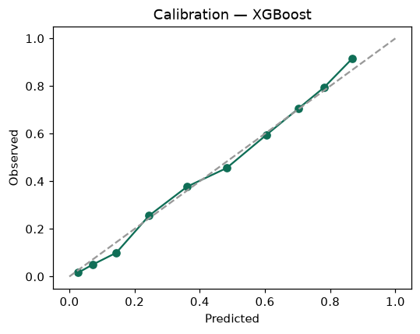

SHAP feature contributions
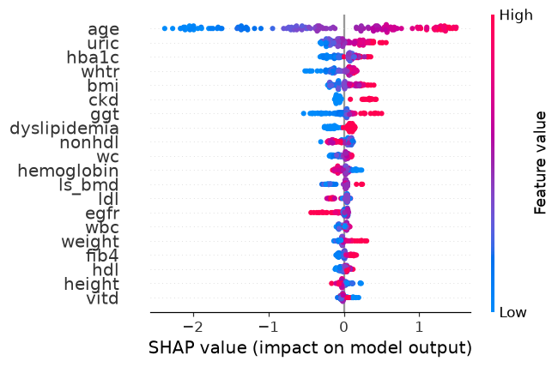

Partial dependence (PDP)
