Machine Learning Prediction Model Report
Outcome: Insulin resistance (HOMA-IR>=2.5) · NHANES · 3 models compared · tuning, full metrics, threshold, SHAP, PDP
[ML] outcome = insulin_resistance

Data summary
Item | Value
N | 6000
Outcome prevalence (%) | 49.9
Features | 56
Models compared | 3
Train/test | 4200/1800 (70/30 stratified)
Auto-excluded leakage | None

Hyperparameter search space
Model | Search space
LogisticRegression | {'C': [0.01, 0.1, 1, 10], 'penalty': ['l1', 'l2']}
HistGradientBoosting | {'learning_rate': [0.03, 0.1], 'max_iter': [200, 400], 'max_depth': [3, 6, None]}
XGBoost | {'n_estimators': [300, 500], 'max_depth': [3, 5], 'learning_rate': [0.03, 0.1], 'subsample': [0.8, 1.0]}

Tuning results — best parameters and CV auROC
model | CV_auROC | best_params
LogisticRegression | 0.844 | {'penalty': 'l1', 'C': 0.1}
HistGradientBoosting | 0.8442 | {'max_iter': 400, 'max_depth': 3, 'learning_rate': 0.03}
XGBoost | 0.8464 | {'subsample': 0.8, 'n_estimators': 500, 'max_depth': 3, 'learning_rate': 0.03}

Full performance metrics (test set)
model | TP | TN | FP | FN | sensitivity | specificity | PPV | NPV | accuracy | balanced_accuracy | f1 | MCC | kappa | auROC | auPRC | logloss | brier | combined
XGBoost | 691 | 679 | 224 | 206 | 0.7703 | 0.7519 | 0.7552 | 0.7672 | 0.7611 | 0.7611 | 0.7627 | 0.5224 | 0.5222 | 0.8434 | 0.8392 | 0.491 | 0.1617 | 0.8413
LogisticRegression | 680 | 683 | 220 | 217 | 0.7581 | 0.7564 | 0.7556 | 0.7589 | 0.7572 | 0.7572 | 0.7568 | 0.5144 | 0.5144 | 0.8404 | 0.8393 | 0.4932 | 0.1629 | 0.8399
HistGradientBoosting | 687 | 677 | 226 | 210 | 0.7659 | 0.7497 | 0.7525 | 0.7632 | 0.7578 | 0.7578 | 0.7591 | 0.5157 | 0.5156 | 0.8402 | 0.8343 | 0.4953 | 0.1631 | 0.8372

ROC · Precision-Recall
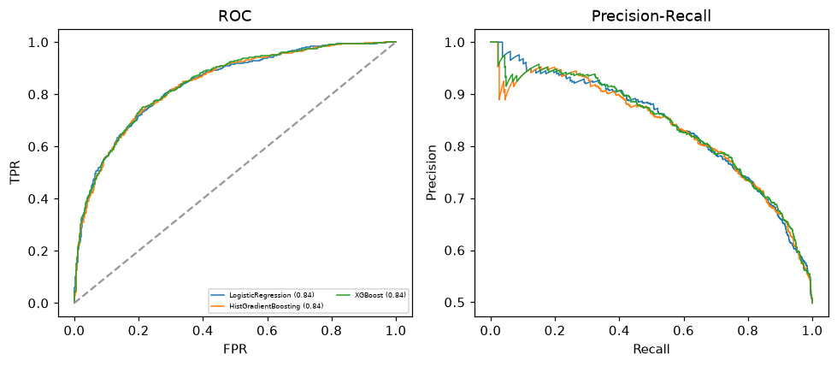

Selected final model — XGBoost (combined=0.8413)
Among 3 candidate models, XGBoost achieved the highest combined score, with an area under the receiver operating characteristic curve of 0.8434 and area under the precision-recall curve of 0.8392.

Threshold analysis (0.1-0.9)
threshold | TP | TN | FP | FN | sensitivity | specificity | PPV | NPV | f1 | accuracy
0.1 | 886.0 | 193.0 | 710.0 | 11.0 | 0.988 | 0.214 | 0.555 | 0.946 | 0.711 | 0.599
0.2 | 847.0 | 396.0 | 507.0 | 50.0 | 0.944 | 0.439 | 0.626 | 0.888 | 0.753 | 0.691
0.3 | 802.0 | 519.0 | 384.0 | 95.0 | 0.894 | 0.575 | 0.676 | 0.845 | 0.77 | 0.734
0.4 | 748.0 | 606.0 | 297.0 | 149.0 | 0.834 | 0.671 | 0.716 | 0.803 | 0.77 | 0.752
0.5 | 691.0 | 679.0 | 224.0 | 206.0 | 0.77 | 0.752 | 0.755 | 0.767 | 0.763 | 0.761
0.6 | 613.0 | 746.0 | 157.0 | 284.0 | 0.683 | 0.826 | 0.796 | 0.724 | 0.735 | 0.755
0.7 | 520.0 | 799.0 | 104.0 | 377.0 | 0.58 | 0.885 | 0.833 | 0.679 | 0.684 | 0.733
0.8 | 400.0 | 851.0 | 52.0 | 497.0 | 0.446 | 0.942 | 0.885 | 0.631 | 0.593 | 0.695
0.9 | 224.0 | 888.0 | 15.0 | 673.0 | 0.25 | 0.983 | 0.937 | 0.569 | 0.394 | 0.618

Calibration
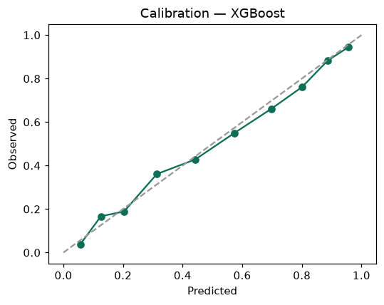

SHAP feature contributions
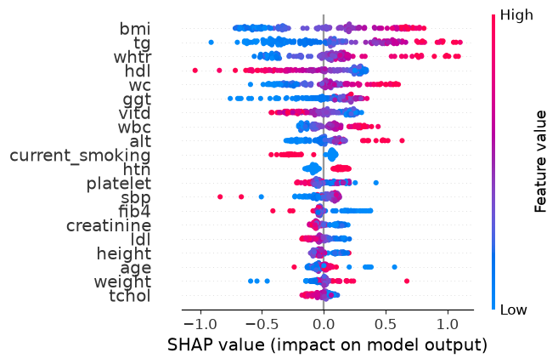

Partial dependence (PDP)
