Machine Learning Prediction Model Report
Outcome: Low HDL cholesterol · NHANES · 3 models compared · tuning, full metrics, threshold, SHAP, PDP
[ML] outcome = low_hdl

Data summary
Item | Value
N | 6000
Outcome prevalence (%) | 29.8
Features | 54
Models compared | 3
Train/test | 4200/1800 (70/30 stratified)
Auto-excluded leakage | None

Hyperparameter search space
Model | Search space
LogisticRegression | {'C': [0.01, 0.1, 1, 10], 'penalty': ['l1', 'l2']}
HistGradientBoosting | {'learning_rate': [0.03, 0.1], 'max_iter': [200, 400], 'max_depth': [3, 6, None]}
XGBoost | {'n_estimators': [300, 500], 'max_depth': [3, 5], 'learning_rate': [0.03, 0.1], 'subsample': [0.8, 1.0]}

Tuning results — best parameters and CV auROC
model | CV_auROC | best_params
LogisticRegression | 0.7316 | {'penalty': 'l2', 'C': 0.1}
HistGradientBoosting | 0.7353 | {'max_iter': 400, 'max_depth': 3, 'learning_rate': 0.03}
XGBoost | 0.7397 | {'subsample': 0.8, 'n_estimators': 300, 'max_depth': 5, 'learning_rate': 0.03}

Full performance metrics (test set)
model | TP | TN | FP | FN | sensitivity | specificity | PPV | NPV | accuracy | balanced_accuracy | f1 | MCC | kappa | auROC | auPRC | logloss | brier | combined
XGBoost | 198 | 1137 | 127 | 338 | 0.3694 | 0.8995 | 0.6092 | 0.7708 | 0.7417 | 0.6345 | 0.4599 | 0.3197 | 0.3033 | 0.7589 | 0.591 | 0.5132 | 0.1709 | 0.675
HistGradientBoosting | 175 | 1157 | 107 | 361 | 0.3265 | 0.9153 | 0.6206 | 0.7622 | 0.74 | 0.6209 | 0.4279 | 0.3042 | 0.2801 | 0.7554 | 0.5752 | 0.5163 | 0.1725 | 0.6653
LogisticRegression | 160 | 1151 | 113 | 376 | 0.2985 | 0.9106 | 0.5861 | 0.7538 | 0.7283 | 0.6046 | 0.3956 | 0.2666 | 0.2435 | 0.7465 | 0.5413 | 0.5275 | 0.1772 | 0.6439

ROC · Precision-Recall
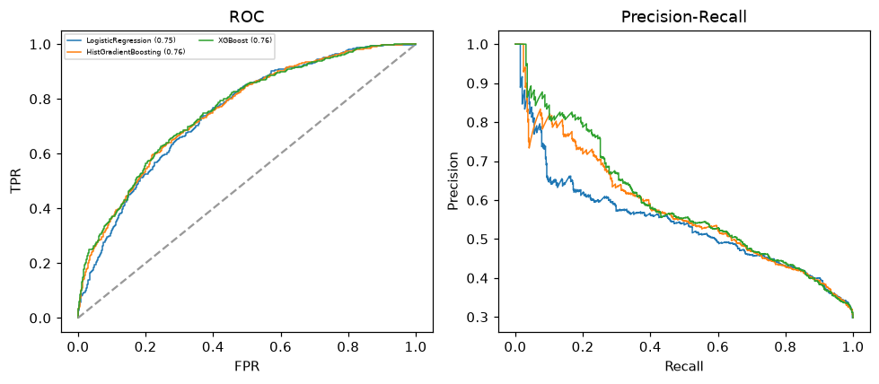

Selected final model — XGBoost (combined=0.675)
Among 3 candidate models, XGBoost achieved the highest combined score, with an area under the receiver operating characteristic curve of 0.7589 and area under the precision-recall curve of 0.591.

Threshold analysis (0.1-0.9)
threshold | TP | TN | FP | FN | sensitivity | specificity | PPV | NPV | f1 | accuracy
0.1 | 510.0 | 311.0 | 953.0 | 26.0 | 0.951 | 0.246 | 0.349 | 0.923 | 0.51 | 0.456
0.2 | 455.0 | 632.0 | 632.0 | 81.0 | 0.849 | 0.5 | 0.419 | 0.886 | 0.561 | 0.604
0.3 | 364.0 | 880.0 | 384.0 | 172.0 | 0.679 | 0.696 | 0.487 | 0.837 | 0.567 | 0.691
0.4 | 274.0 | 1042.0 | 222.0 | 262.0 | 0.511 | 0.824 | 0.552 | 0.799 | 0.531 | 0.731
0.5 | 198.0 | 1137.0 | 127.0 | 338.0 | 0.369 | 0.9 | 0.609 | 0.771 | 0.46 | 0.742
0.6 | 127.0 | 1225.0 | 39.0 | 409.0 | 0.237 | 0.969 | 0.765 | 0.75 | 0.362 | 0.751
0.7 | 54.0 | 1251.0 | 13.0 | 482.0 | 0.101 | 0.99 | 0.806 | 0.722 | 0.179 | 0.725
0.8 | 22.0 | 1261.0 | 3.0 | 514.0 | 0.041 | 0.998 | 0.88 | 0.71 | 0.078 | 0.713
0.9 | 5.0 | 1264.0 | 0.0 | 531.0 | 0.009 | 1.0 | 1.0 | 0.704 | 0.018 | 0.705

Calibration
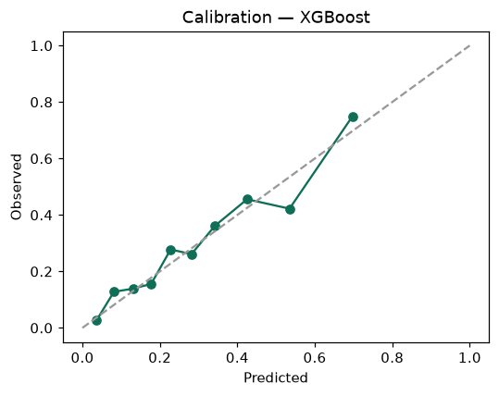

SHAP feature contributions
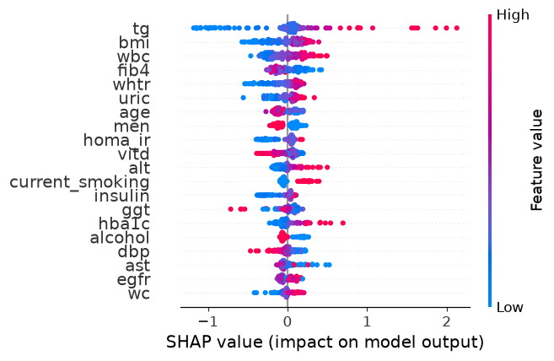

Partial dependence (PDP)
