Machine Learning Prediction Model Report
Outcome: Low muscle mass (low ASMI, AWGS cut) · NHANES · 3 models compared · tuning, full metrics, threshold, SHAP, PDP
[ML] outcome = sarcopenia

Data summary
Item | Value
N | 6000
Outcome prevalence (%) | 3.6
Features | 47
Models compared | 3
Train/test | 4200/1800 (70/30 stratified)
Auto-excluded leakage | None

Hyperparameter search space
Model | Search space
LogisticRegression | {'C': [0.01, 0.1, 1, 10], 'penalty': ['l1', 'l2']}
HistGradientBoosting | {'learning_rate': [0.03, 0.1], 'max_iter': [200, 400], 'max_depth': [3, 6, None]}
XGBoost | {'n_estimators': [300, 500], 'max_depth': [3, 5], 'learning_rate': [0.03, 0.1], 'subsample': [0.8, 1.0]}

Tuning results — best parameters and CV auROC
model | CV_auROC | best_params
LogisticRegression | 0.7305 | {'penalty': 'l1', 'C': 0.1}
HistGradientBoosting | 0.7237 | {'max_iter': 200, 'max_depth': None, 'learning_rate': 0.03}
XGBoost | 0.7415 | {'subsample': 0.8, 'n_estimators': 300, 'max_depth': 5, 'learning_rate': 0.03}

Full performance metrics (test set)
model | TP | TN | FP | FN | sensitivity | specificity | PPV | NPV | accuracy | balanced_accuracy | f1 | MCC | kappa | auROC | auPRC | logloss | brier | combined
XGBoost | 0 | 1735 | 1 | 64 | 0.0 | 0.9994 | 0.0 | 0.9644 | 0.9639 | 0.4997 | 0.0 | -0.0045 | -0.0011 | 0.7583 | 0.1354 | 0.1415 | 0.033 | 0.4469
LogisticRegression | 0 | 1736 | 0 | 64 | 0.0 | 1.0 | nan | 0.9644 | 0.9644 | 0.5 | 0.0 | 0.0 | 0.0 | 0.7572 | 0.1323 | 0.1384 | 0.0328 | 0.4447
HistGradientBoosting | 0 | 1734 | 2 | 64 | 0.0 | 0.9988 | 0.0 | 0.9644 | 0.9633 | 0.4994 | 0.0 | -0.0064 | -0.0022 | 0.7177 | 0.0962 | 0.1637 | 0.0343 | 0.4069

ROC · Precision-Recall
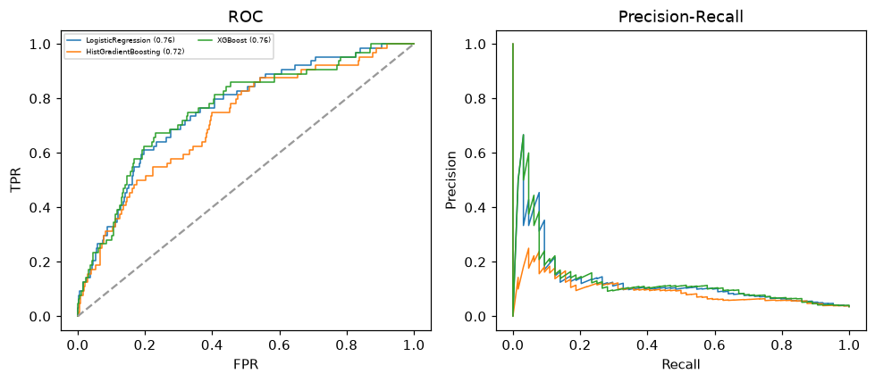

Selected final model — XGBoost (combined=0.4469)
Among 3 candidate models, XGBoost achieved the highest combined score, with an area under the receiver operating characteristic curve of 0.7583 and area under the precision-recall curve of 0.1354.

Threshold analysis (0.1-0.9)
threshold | TP | TN | FP | FN | sensitivity | specificity | PPV | NPV | f1 | accuracy
0.1 | 15.0 | 1652.0 | 84.0 | 49.0 | 0.234 | 0.952 | 0.152 | 0.971 | 0.184 | 0.926
0.2 | 5.0 | 1717.0 | 19.0 | 59.0 | 0.078 | 0.989 | 0.208 | 0.967 | 0.114 | 0.957
0.3 | 4.0 | 1731.0 | 5.0 | 60.0 | 0.062 | 0.997 | 0.444 | 0.966 | 0.11 | 0.964
0.4 | 2.0 | 1734.0 | 2.0 | 62.0 | 0.031 | 0.999 | 0.5 | 0.965 | 0.059 | 0.964
0.5 | 0.0 | 1735.0 | 1.0 | 64.0 | 0.0 | 0.999 | 0.0 | 0.964 | 0.0 | 0.964
0.6 | 0.0 | 1736.0 | 0.0 | 64.0 | 0.0 | 1.0 | nan | 0.964 | 0.0 | 0.964
0.7 | 0.0 | 1736.0 | 0.0 | 64.0 | 0.0 | 1.0 | nan | 0.964 | 0.0 | 0.964
0.8 | 0.0 | 1736.0 | 0.0 | 64.0 | 0.0 | 1.0 | nan | 0.964 | 0.0 | 0.964
0.9 | 0.0 | 1736.0 | 0.0 | 64.0 | 0.0 | 1.0 | nan | 0.964 | 0.0 | 0.964

Calibration
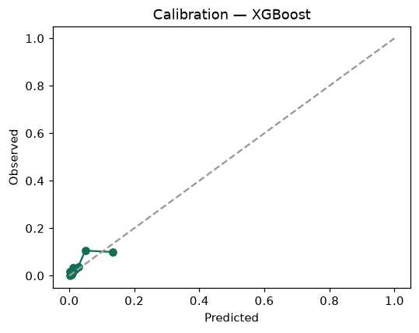

SHAP feature contributions
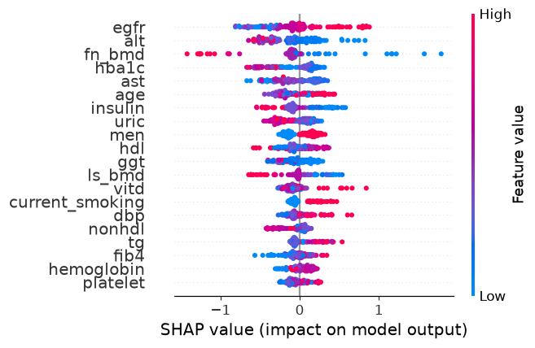

Partial dependence (PDP)
