Machine Learning Prediction Model Report
Outcome: Metabolic syndrome · NHANES · 3 models compared · tuning, full metrics, threshold, SHAP, PDP
[ML] outcome = mets

Data summary
Item | Value
N | 6000
Outcome prevalence (%) | 39.9
Features | 43
Models compared | 3
Train/test | 4200/1800 (70/30 stratified)
Auto-excluded leakage | None

Hyperparameter search space
Model | Search space
LogisticRegression | {'C': [0.01, 0.1, 1, 10], 'penalty': ['l1', 'l2']}
HistGradientBoosting | {'learning_rate': [0.03, 0.1], 'max_iter': [200, 400], 'max_depth': [3, 6, None]}
XGBoost | {'n_estimators': [300, 500], 'max_depth': [3, 5], 'learning_rate': [0.03, 0.1], 'subsample': [0.8, 1.0]}

Tuning results — best parameters and CV auROC
model | CV_auROC | best_params
LogisticRegression | 0.8729 | {'penalty': 'l2', 'C': 0.1}
HistGradientBoosting | 0.8772 | {'max_iter': 400, 'max_depth': 3, 'learning_rate': 0.03}
XGBoost | 0.8778 | {'subsample': 0.8, 'n_estimators': 500, 'max_depth': 3, 'learning_rate': 0.03}

Full performance metrics (test set)
model | TP | TN | FP | FN | sensitivity | specificity | PPV | NPV | accuracy | balanced_accuracy | f1 | MCC | kappa | auROC | auPRC | logloss | brier | combined
XGBoost | 510 | 912 | 170 | 208 | 0.7103 | 0.8429 | 0.75 | 0.8143 | 0.79 | 0.7766 | 0.7296 | 0.5587 | 0.5582 | 0.878 | 0.8272 | 0.4259 | 0.1391 | 0.8526
HistGradientBoosting | 509 | 921 | 161 | 209 | 0.7089 | 0.8512 | 0.7597 | 0.815 | 0.7944 | 0.7801 | 0.7334 | 0.5674 | 0.5665 | 0.8748 | 0.8251 | 0.4305 | 0.1407 | 0.8499
LogisticRegression | 495 | 927 | 155 | 223 | 0.6894 | 0.8567 | 0.7615 | 0.8061 | 0.79 | 0.7731 | 0.7237 | 0.5568 | 0.555 | 0.8731 | 0.8226 | 0.4325 | 0.1416 | 0.8479

ROC · Precision-Recall
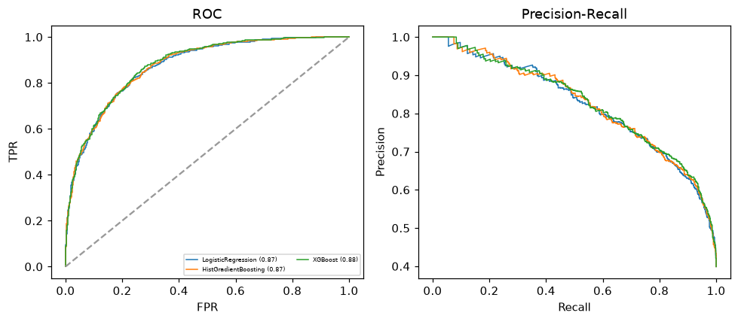

Selected final model — XGBoost (combined=0.8526)
Among 3 candidate models, XGBoost achieved the highest combined score, with an area under the receiver operating characteristic curve of 0.878 and area under the precision-recall curve of 0.8272.

Threshold analysis (0.1-0.9)
threshold | TP | TN | FP | FN | sensitivity | specificity | PPV | NPV | f1 | accuracy
0.1 | 697.0 | 499.0 | 583.0 | 21.0 | 0.971 | 0.461 | 0.545 | 0.96 | 0.698 | 0.664
0.2 | 670.0 | 665.0 | 417.0 | 48.0 | 0.933 | 0.615 | 0.616 | 0.933 | 0.742 | 0.742
0.3 | 630.0 | 767.0 | 315.0 | 88.0 | 0.877 | 0.709 | 0.667 | 0.897 | 0.758 | 0.776
0.4 | 566.0 | 851.0 | 231.0 | 152.0 | 0.788 | 0.787 | 0.71 | 0.848 | 0.747 | 0.787
0.5 | 510.0 | 912.0 | 170.0 | 208.0 | 0.71 | 0.843 | 0.75 | 0.814 | 0.73 | 0.79
0.6 | 444.0 | 970.0 | 112.0 | 274.0 | 0.618 | 0.896 | 0.799 | 0.78 | 0.697 | 0.786
0.7 | 377.0 | 1019.0 | 63.0 | 341.0 | 0.525 | 0.942 | 0.857 | 0.749 | 0.651 | 0.776
0.8 | 289.0 | 1045.0 | 37.0 | 429.0 | 0.403 | 0.966 | 0.887 | 0.709 | 0.554 | 0.741
0.9 | 148.0 | 1072.0 | 10.0 | 570.0 | 0.206 | 0.991 | 0.937 | 0.653 | 0.338 | 0.678

Calibration
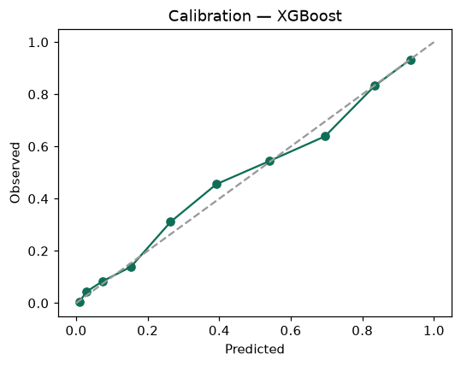

SHAP feature contributions
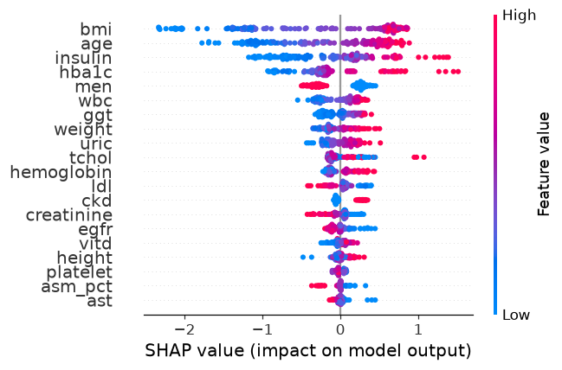

Partial dependence (PDP)
