Machine Learning Prediction Model Report
Outcome: Obesity (KSSO >=25 / WHO >=30, country-specific) · NHANES · 3 models compared · tuning, full metrics, threshold, SHAP, PDP
[ML] outcome = obesity

Data summary
Item | Value
N | 6000
Outcome prevalence (%) | 38.1
Features | 47
Models compared | 3
Train/test | 4200/1800 (70/30 stratified)
Auto-excluded leakage | None

Hyperparameter search space
Model | Search space
LogisticRegression | {'C': [0.01, 0.1, 1, 10], 'penalty': ['l1', 'l2']}
HistGradientBoosting | {'learning_rate': [0.03, 0.1], 'max_iter': [200, 400], 'max_depth': [3, 6, None]}
XGBoost | {'n_estimators': [300, 500], 'max_depth': [3, 5], 'learning_rate': [0.03, 0.1], 'subsample': [0.8, 1.0]}

Tuning results — best parameters and CV auROC
model | CV_auROC | best_params
LogisticRegression | 0.7779 | {'penalty': 'l2', 'C': 0.1}
HistGradientBoosting | 0.7967 | {'max_iter': 400, 'max_depth': 3, 'learning_rate': 0.03}
XGBoost | 0.8024 | {'subsample': 0.8, 'n_estimators': 500, 'max_depth': 3, 'learning_rate': 0.03}

Full performance metrics (test set)
model | TP | TN | FP | FN | sensitivity | specificity | PPV | NPV | accuracy | balanced_accuracy | f1 | MCC | kappa | auROC | auPRC | logloss | brier | combined
XGBoost | 368 | 937 | 177 | 318 | 0.5364 | 0.8411 | 0.6752 | 0.7466 | 0.725 | 0.6888 | 0.5979 | 0.3991 | 0.3931 | 0.7912 | 0.6902 | 0.5322 | 0.1792 | 0.7407
HistGradientBoosting | 354 | 946 | 168 | 332 | 0.516 | 0.8492 | 0.6782 | 0.7402 | 0.7222 | 0.6826 | 0.5861 | 0.3909 | 0.3828 | 0.7854 | 0.683 | 0.5379 | 0.1814 | 0.7342
LogisticRegression | 338 | 949 | 165 | 348 | 0.4927 | 0.8519 | 0.672 | 0.7317 | 0.715 | 0.6723 | 0.5685 | 0.373 | 0.3632 | 0.7648 | 0.6532 | 0.5668 | 0.1896 | 0.709

ROC · Precision-Recall
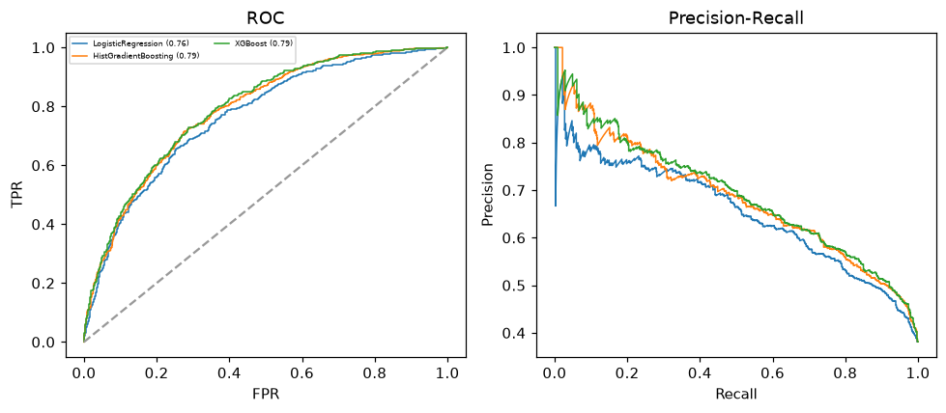

Selected final model — XGBoost (combined=0.7407)
Among 3 candidate models, XGBoost achieved the highest combined score, with an area under the receiver operating characteristic curve of 0.7912 and area under the precision-recall curve of 0.6902.

Threshold analysis (0.1-0.9)
threshold | TP | TN | FP | FN | sensitivity | specificity | PPV | NPV | f1 | accuracy
0.1 | 672.0 | 255.0 | 859.0 | 14.0 | 0.98 | 0.229 | 0.439 | 0.948 | 0.606 | 0.515
0.2 | 630.0 | 501.0 | 613.0 | 56.0 | 0.918 | 0.45 | 0.507 | 0.899 | 0.653 | 0.628
0.3 | 550.0 | 692.0 | 422.0 | 136.0 | 0.802 | 0.621 | 0.566 | 0.836 | 0.663 | 0.69
0.4 | 464.0 | 835.0 | 279.0 | 222.0 | 0.676 | 0.75 | 0.624 | 0.79 | 0.649 | 0.722
0.5 | 368.0 | 937.0 | 177.0 | 318.0 | 0.536 | 0.841 | 0.675 | 0.747 | 0.598 | 0.725
0.6 | 283.0 | 1013.0 | 101.0 | 403.0 | 0.413 | 0.909 | 0.737 | 0.715 | 0.529 | 0.72
0.7 | 193.0 | 1060.0 | 54.0 | 493.0 | 0.281 | 0.952 | 0.781 | 0.683 | 0.414 | 0.696
0.8 | 115.0 | 1093.0 | 21.0 | 571.0 | 0.168 | 0.981 | 0.846 | 0.657 | 0.28 | 0.671
0.9 | 42.0 | 1111.0 | 3.0 | 644.0 | 0.061 | 0.997 | 0.933 | 0.633 | 0.115 | 0.641

Calibration
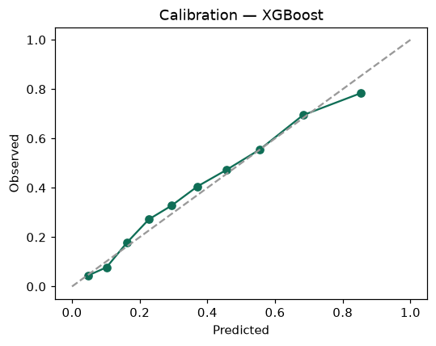

SHAP feature contributions
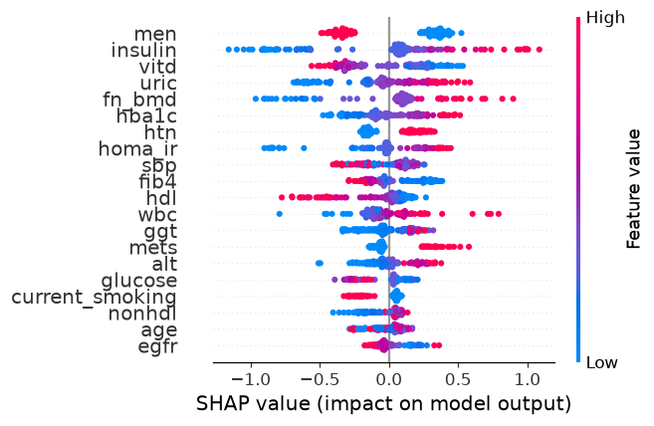

Partial dependence (PDP)
