Machine Learning Prediction Model Report
Outcome: Osteoporosis (T-score<=-2.5, age>=50) · NHANES · 3 models compared · tuning, full metrics, threshold, SHAP, PDP
[ML] outcome = osteoporosis

Data summary
Item | Value
N | 6000
Outcome prevalence (%) | 9.0
Features | 54
Models compared | 3
Train/test | 4200/1800 (70/30 stratified)
Auto-excluded leakage | None

Hyperparameter search space
Model | Search space
LogisticRegression | {'C': [0.01, 0.1, 1, 10], 'penalty': ['l1', 'l2']}
HistGradientBoosting | {'learning_rate': [0.03, 0.1], 'max_iter': [200, 400], 'max_depth': [3, 6, None]}
XGBoost | {'n_estimators': [300, 500], 'max_depth': [3, 5], 'learning_rate': [0.03, 0.1], 'subsample': [0.8, 1.0]}

Tuning results — best parameters and CV auROC
model | CV_auROC | best_params
LogisticRegression | 0.8282 | {'penalty': 'l1', 'C': 0.1}
HistGradientBoosting | 0.8023 | {'max_iter': 200, 'max_depth': 6, 'learning_rate': 0.03}
XGBoost | 0.811 | {'subsample': 1.0, 'n_estimators': 300, 'max_depth': 3, 'learning_rate': 0.03}

Full performance metrics (test set)
model | TP | TN | FP | FN | sensitivity | specificity | PPV | NPV | accuracy | balanced_accuracy | f1 | MCC | kappa | auROC | auPRC | logloss | brier | combined
XGBoost | 18 | 1621 | 17 | 144 | 0.1111 | 0.9896 | 0.5143 | 0.9184 | 0.9106 | 0.5504 | 0.1827 | 0.2088 | 0.1557 | 0.8101 | 0.3491 | 0.246 | 0.07 | 0.5796
LogisticRegression | 9 | 1626 | 12 | 153 | 0.0556 | 0.9927 | 0.4286 | 0.914 | 0.9083 | 0.5241 | 0.0984 | 0.1285 | 0.0793 | 0.824 | 0.3346 | 0.2425 | 0.0696 | 0.5793
HistGradientBoosting | 20 | 1617 | 21 | 142 | 0.1235 | 0.9872 | 0.4878 | 0.9193 | 0.9094 | 0.5553 | 0.197 | 0.2122 | 0.1668 | 0.8116 | 0.3317 | 0.2498 | 0.071 | 0.5716

ROC · Precision-Recall
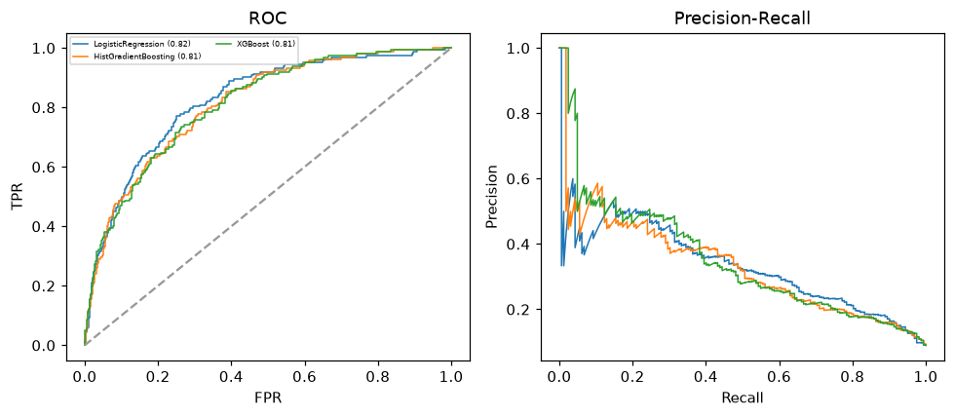

Selected final model — XGBoost (combined=0.5796)
Among 3 candidate models, XGBoost achieved the highest combined score, with an area under the receiver operating characteristic curve of 0.8101 and area under the precision-recall curve of 0.3491.

Threshold analysis (0.1-0.9)
threshold | TP | TN | FP | FN | sensitivity | specificity | PPV | NPV | f1 | accuracy
0.1 | 108.0 | 1252.0 | 386.0 | 54.0 | 0.667 | 0.764 | 0.219 | 0.959 | 0.329 | 0.756
0.2 | 78.0 | 1466.0 | 172.0 | 84.0 | 0.481 | 0.895 | 0.312 | 0.946 | 0.379 | 0.858
0.3 | 55.0 | 1567.0 | 71.0 | 107.0 | 0.34 | 0.957 | 0.437 | 0.936 | 0.382 | 0.901
0.4 | 32.0 | 1605.0 | 33.0 | 130.0 | 0.198 | 0.98 | 0.492 | 0.925 | 0.282 | 0.909
0.5 | 18.0 | 1621.0 | 17.0 | 144.0 | 0.111 | 0.99 | 0.514 | 0.918 | 0.183 | 0.911
0.6 | 8.0 | 1633.0 | 5.0 | 154.0 | 0.049 | 0.997 | 0.615 | 0.914 | 0.091 | 0.912
0.7 | 3.0 | 1638.0 | 0.0 | 159.0 | 0.019 | 1.0 | 1.0 | 0.912 | 0.036 | 0.912
0.8 | 0.0 | 1638.0 | 0.0 | 162.0 | 0.0 | 1.0 | nan | 0.91 | 0.0 | 0.91
0.9 | 0.0 | 1638.0 | 0.0 | 162.0 | 0.0 | 1.0 | nan | 0.91 | 0.0 | 0.91

Calibration
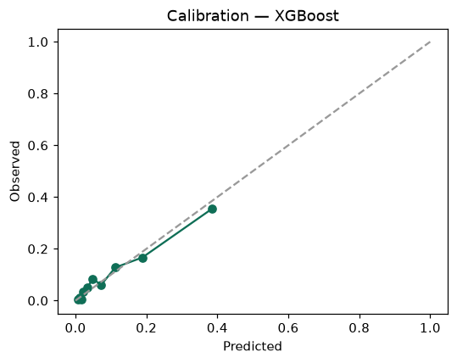

SHAP feature contributions
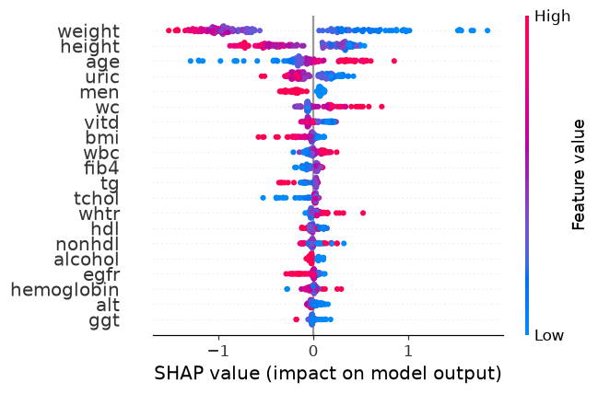

Partial dependence (PDP)
