Machine Learning Prediction Model Report
Outcome: Vitamin D deficiency (<20 ng/mL) · NHANES · 3 models compared · tuning, full metrics, threshold, SHAP, PDP
[ML] outcome = vitd_deficiency

Data summary
Item | Value
N | 6000
Outcome prevalence (%) | 31.0
Features | 62
Models compared | 3
Train/test | 4200/1800 (70/30 stratified)
Auto-excluded leakage | None

Hyperparameter search space
Model | Search space
LogisticRegression | {'C': [0.01, 0.1, 1, 10], 'penalty': ['l1', 'l2']}
HistGradientBoosting | {'learning_rate': [0.03, 0.1], 'max_iter': [200, 400], 'max_depth': [3, 6, None]}
XGBoost | {'n_estimators': [300, 500], 'max_depth': [3, 5], 'learning_rate': [0.03, 0.1], 'subsample': [0.8, 1.0]}

Tuning results — best parameters and CV auROC
model | CV_auROC | best_params
LogisticRegression | 0.6961 | {'penalty': 'l1', 'C': 0.1}
HistGradientBoosting | 0.6892 | {'max_iter': 200, 'max_depth': 6, 'learning_rate': 0.03}
XGBoost | 0.6977 | {'subsample': 0.8, 'n_estimators': 500, 'max_depth': 3, 'learning_rate': 0.03}

Full performance metrics (test set)
model | TP | TN | FP | FN | sensitivity | specificity | PPV | NPV | accuracy | balanced_accuracy | f1 | MCC | kappa | auROC | auPRC | logloss | brier | combined
XGBoost | 123 | 1132 | 109 | 436 | 0.22 | 0.9122 | 0.5302 | 0.7219 | 0.6972 | 0.5661 | 0.311 | 0.1826 | 0.1575 | 0.6744 | 0.4678 | 0.5812 | 0.1987 | 0.5711
LogisticRegression | 102 | 1149 | 92 | 457 | 0.1825 | 0.9259 | 0.5258 | 0.7154 | 0.695 | 0.5542 | 0.2709 | 0.1617 | 0.132 | 0.6718 | 0.4632 | 0.583 | 0.1986 | 0.5675
HistGradientBoosting | 131 | 1117 | 124 | 428 | 0.2343 | 0.9001 | 0.5137 | 0.723 | 0.6933 | 0.5672 | 0.3219 | 0.1784 | 0.158 | 0.6684 | 0.4532 | 0.5867 | 0.2009 | 0.5608

ROC · Precision-Recall
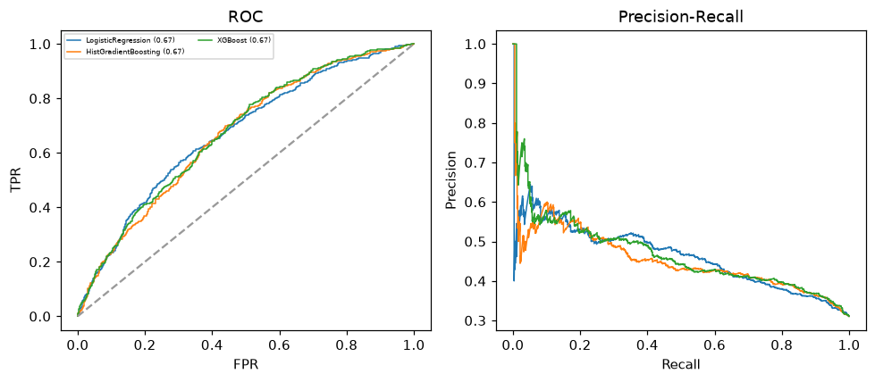

Selected final model — XGBoost (combined=0.5711)
Among 3 candidate models, XGBoost achieved the highest combined score, with an area under the receiver operating characteristic curve of 0.6744 and area under the precision-recall curve of 0.4678.

Threshold analysis (0.1-0.9)
threshold | TP | TN | FP | FN | sensitivity | specificity | PPV | NPV | f1 | accuracy
0.1 | 548.0 | 89.0 | 1152.0 | 11.0 | 0.98 | 0.072 | 0.322 | 0.89 | 0.485 | 0.354
0.2 | 481.0 | 457.0 | 784.0 | 78.0 | 0.86 | 0.368 | 0.38 | 0.854 | 0.527 | 0.521
0.3 | 336.0 | 793.0 | 448.0 | 223.0 | 0.601 | 0.639 | 0.429 | 0.781 | 0.5 | 0.627
0.4 | 224.0 | 1007.0 | 234.0 | 335.0 | 0.401 | 0.811 | 0.489 | 0.75 | 0.441 | 0.684
0.5 | 123.0 | 1132.0 | 109.0 | 436.0 | 0.22 | 0.912 | 0.53 | 0.722 | 0.311 | 0.697
0.6 | 62.0 | 1190.0 | 51.0 | 497.0 | 0.111 | 0.959 | 0.549 | 0.705 | 0.185 | 0.696
0.7 | 21.0 | 1232.0 | 9.0 | 538.0 | 0.038 | 0.993 | 0.7 | 0.696 | 0.071 | 0.696
0.8 | 6.0 | 1241.0 | 0.0 | 553.0 | 0.011 | 1.0 | 1.0 | 0.692 | 0.021 | 0.693
0.9 | 0.0 | 1241.0 | 0.0 | 559.0 | 0.0 | 1.0 | nan | 0.689 | 0.0 | 0.689

Calibration
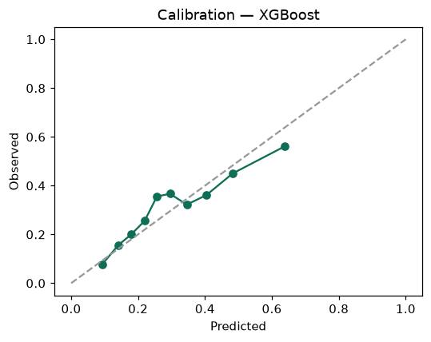

SHAP feature contributions
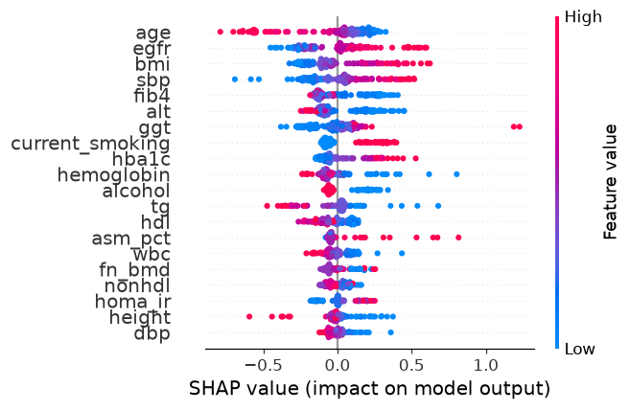

Partial dependence (PDP)
