Incidence/Prevalence Trend Report
Abdominal obesity · NHANES · 2005-2021 · survey-weighted

Figure. Incidence/prevalence trend
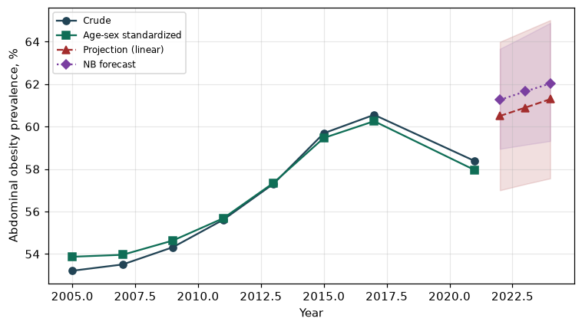

Counts by period
period | count
2005 | 2519
2007 | 3051
2009 | 3271
2011 | 2671
2013 | 2990
2015 | 3015
2017 | 2981
2021 | 3542

Crude and age-sex standardized rate (%)
year | crude | standardized
2005.00 | 53.21 | 53.87
2007.00 | 53.51 | 53.96
2009.00 | 54.32 | 54.64
2011.00 | 55.61 | 55.68
2013.00 | 57.31 | 57.35
2015.00 | 59.69 | 59.47
2017.00 | 60.55 | 60.26
2021.00 | 58.38 | 57.95

Projection (linear, standardized rate)
year | forecast | lo95 | hi95
2022.00 | 60.50 | 57.00 | 63.99
2023.00 | 60.89 | 57.29 | 64.50
2024.00 | 61.29 | 57.56 | 65.01

Stratified trend by sex (%)
year | men | women
2005.00 | 45.37 | 60.43
2007.00 | 43.60 | 62.73
2009.00 | 43.56 | 64.48
2011.00 | 44.32 | 66.32
2013.00 | 46.13 | 67.84
2015.00 | 48.28 | 70.40
2017.00 | 51.42 | 69.17
2021.00 | 48.05 | 68.30

Joinpoint regression — segment APC (%) with bootstrap 95% CI
segment | period | APC(%) | lo95 | hi95
1 | 2005-2015 | 1.00 | 0.50 | 1.48
2 | 2015-2021 | -0.51 | -0.97 | 0.66

Negative binomial (NB) forecast (%)
year | NB_forecast | lo95 | hi95
2022.00 | 61.26 | 58.95 | 63.66
2023.00 | 61.65 | 59.14 | 64.26
2024.00 | 62.03 | 59.32 | 64.88

Interpretation
The age-sex standardized prevalence of Abdominal obesity showed an annual percent change of -0.51% (95% CI -0.97 to 0.66) in the latest segment.

