Incidence/Prevalence Trend Report
Advanced liver fibrosis (FIB-4>2.67) · NHANES · 2005-2021 · survey-weighted

Figure. Incidence/prevalence trend
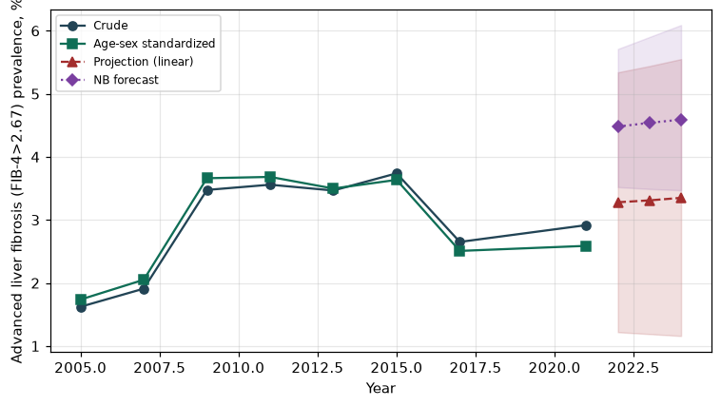

Counts by period
period | count
2005 | 122
2007 | 172
2009 | 276
2011 | 215
2013 | 231
2015 | 235
2017 | 188
2021 | 207

Crude and age-sex standardized rate (%)
year | crude | standardized
2005.00 | 1.62 | 1.74
2007.00 | 1.91 | 2.05
2009.00 | 3.48 | 3.66
2011.00 | 3.56 | 3.68
2013.00 | 3.47 | 3.50
2015.00 | 3.74 | 3.64
2017.00 | 2.65 | 2.51
2021.00 | 2.92 | 2.59

Projection (linear, standardized rate)
year | forecast | lo95 | hi95
2022.00 | 3.28 | 1.22 | 5.34
2023.00 | 3.31 | 1.19 | 5.44
2024.00 | 3.35 | 1.16 | 5.55

Stratified trend by sex (%)
year | men | women
2005.00 | 2.22 | 1.07
2007.00 | 2.47 | 1.39
2009.00 | 4.23 | 2.76
2011.00 | 4.20 | 2.95
2013.00 | 3.85 | 3.11
2015.00 | 3.70 | 3.78
2017.00 | 3.48 | 1.88
2021.00 | 3.37 | 2.49

Joinpoint regression — segment APC (%) with bootstrap 95% CI
segment | period | APC(%) | lo95 | hi95
1 | 2005-2009 | 20.49 | 8.65 | 33.61
2 | 2009-2021 | -3.46 | -6.33 | -0.20

Negative binomial (NB) forecast (%)
year | NB_forecast | lo95 | hi95
2022.00 | 4.48 | 3.52 | 5.71
2023.00 | 4.54 | 3.49 | 5.90
2024.00 | 4.59 | 3.47 | 6.09

Interpretation
The age-sex standardized prevalence of Advanced liver fibrosis (FIB-4>2.67) showed an annual percent change of -3.46% (95% CI -6.33 to -0.2) in the latest segment.

