Incidence/Prevalence Trend Report
Anemia (WHO) · NHANES · 2005-2021 · survey-weighted

Figure. Incidence/prevalence trend
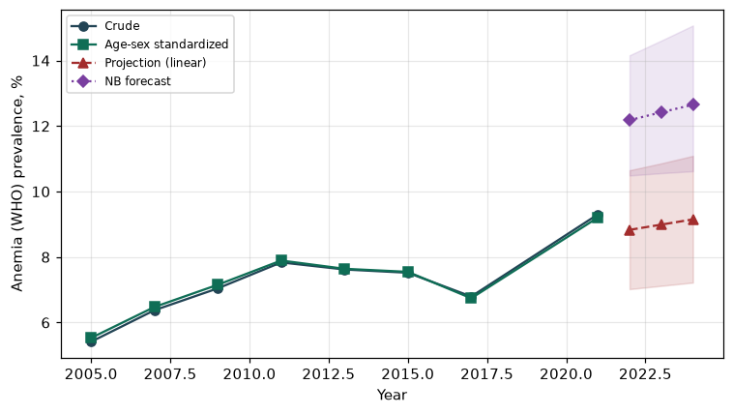

Counts by period
period | count
2005 | 358
2007 | 467
2009 | 527
2011 | 610
2013 | 563
2015 | 607
2017 | 533
2021 | 623

Crude and age-sex standardized rate (%)
year | crude | standardized
2005.00 | 5.41 | 5.53
2007.00 | 6.38 | 6.48
2009.00 | 7.04 | 7.15
2011.00 | 7.84 | 7.89
2013.00 | 7.62 | 7.64
2015.00 | 7.52 | 7.55
2017.00 | 6.79 | 6.74
2021.00 | 9.30 | 9.21

Projection (linear, standardized rate)
year | forecast | lo95 | hi95
2022.00 | 8.83 | 7.02 | 10.65
2023.00 | 8.99 | 7.12 | 10.86
2024.00 | 9.15 | 7.22 | 11.09

Stratified trend by sex (%)
year | men | women
2005.00 | 3.77 | 6.92
2007.00 | 3.83 | 8.73
2009.00 | 4.34 | 9.56
2011.00 | 5.20 | 10.26
2013.00 | 4.87 | 10.16
2015.00 | 4.84 | 10.01
2017.00 | 4.42 | 8.99
2021.00 | 5.75 | 12.62

Joinpoint regression — segment APC (%) with bootstrap 95% CI
segment | period | APC(%) | lo95 | hi95
1 | 2005-2009 | 6.65 | 5.11 | 8.21
2 | 2009-2021 | 1.23 | -2.65 | 2.87

Negative binomial (NB) forecast (%)
year | NB_forecast | lo95 | hi95
2022.00 | 12.18 | 10.49 | 14.16
2023.00 | 12.42 | 10.56 | 14.61
2024.00 | 12.65 | 10.62 | 15.07

Interpretation
The age-sex standardized prevalence of Anemia (WHO) showed an annual percent change of 1.23% (95% CI -2.65 to 2.87) in the latest segment.

