Incidence/Prevalence Trend Report
Atherogenic dyslipidemia (high TG + low HDL) · NHANES · 2005-2021 · survey-weighted

Figure. Incidence/prevalence trend
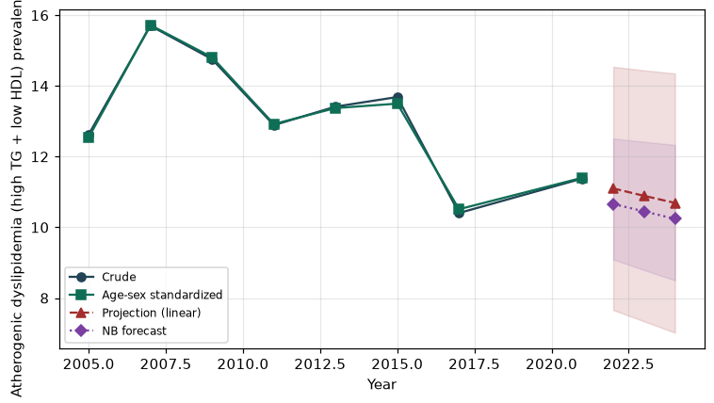

Counts by period
period | count
2005 | 260
2007 | 430
2009 | 428
2011 | 305
2013 | 326
2015 | 293
2017 | 263
2021 | 330

Crude and age-sex standardized rate (%)
year | crude | standardized
2005.00 | 12.63 | 12.55
2007.00 | 15.70 | 15.72
2009.00 | 14.75 | 14.81
2011.00 | 12.89 | 12.92
2013.00 | 13.41 | 13.37
2015.00 | 13.69 | 13.50
2017.00 | 10.40 | 10.51
2021.00 | 11.38 | 11.40

Projection (linear, standardized rate)
year | forecast | lo95 | hi95
2022.00 | 11.10 | 7.66 | 14.54
2023.00 | 10.89 | 7.34 | 14.44
2024.00 | 10.69 | 7.02 | 14.35

Stratified trend by sex (%)
year | men | women
2005.00 | 14.81 | 10.51
2007.00 | 17.48 | 14.04
2009.00 | 15.59 | 14.02
2011.00 | 14.09 | 11.75
2013.00 | 14.81 | 12.09
2015.00 | 15.00 | 12.45
2017.00 | 11.55 | 9.29
2021.00 | 11.05 | 11.68

Joinpoint regression — segment APC (%) with bootstrap 95% CI
segment | period | APC(%) | lo95 | hi95
1 | 2005-2007 | 11.94 | 11.94 | 11.94
2 | 2007-2021 | -2.47 | -3.95 | -1.35

Negative binomial (NB) forecast (%)
year | NB_forecast | lo95 | hi95
2022.00 | 10.66 | 9.09 | 12.51
2023.00 | 10.45 | 8.79 | 12.42
2024.00 | 10.24 | 8.50 | 12.33

Interpretation
The age-sex standardized prevalence of Atherogenic dyslipidemia (high TG + low HDL) showed an annual percent change of -2.47% (95% CI -3.95 to -1.35) in the latest segment.

