Incidence/Prevalence Trend Report
Central obesity (WHtR>=0.5) · NHANES · 2005-2021 · survey-weighted

Figure. Incidence/prevalence trend
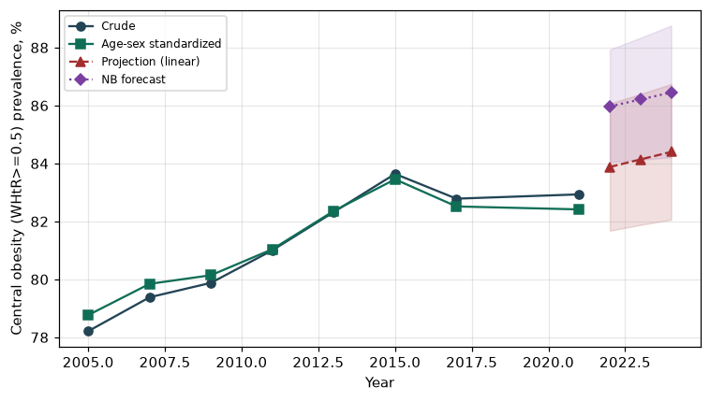

Counts by period
period | count
2005 | 3680
2007 | 4484
2009 | 4735
2011 | 4044
2013 | 4366
2015 | 4365
2017 | 4202
2021 | 4927

Crude and age-sex standardized rate (%)
year | crude | standardized
2005.00 | 78.21 | 78.77
2007.00 | 79.38 | 79.84
2009.00 | 79.88 | 80.14
2011.00 | 81.00 | 81.04
2013.00 | 82.32 | 82.36
2015.00 | 83.64 | 83.45
2017.00 | 82.79 | 82.52
2021.00 | 82.93 | 82.41

Projection (linear, standardized rate)
year | forecast | lo95 | hi95
2022.00 | 83.88 | 81.68 | 86.07
2023.00 | 84.14 | 81.88 | 86.40
2024.00 | 84.40 | 82.06 | 86.74

Stratified trend by sex (%)
year | men | women
2005.00 | 80.54 | 76.07
2007.00 | 80.03 | 78.78
2009.00 | 80.47 | 79.33
2011.00 | 80.16 | 81.80
2013.00 | 81.95 | 82.67
2015.00 | 82.53 | 84.68
2017.00 | 83.07 | 82.52
2021.00 | 83.05 | 82.82

Joinpoint regression — segment APC (%) with bootstrap 95% CI
segment | period | APC(%) | lo95 | hi95
1 | 2005-2015 | 0.56 | 0.43 | 0.70
2 | 2015-2021 | -0.18 | -0.56 | -0.03

Negative binomial (NB) forecast (%)
year | NB_forecast | lo95 | hi95
2022.00 | 85.97 | 84.05 | 87.93
2023.00 | 86.21 | 84.13 | 88.34
2024.00 | 86.45 | 84.21 | 88.76

Interpretation
The age-sex standardized prevalence of Central obesity (WHtR>=0.5) showed an annual percent change of -0.18% (95% CI -0.56 to -0.03) in the latest segment.

