Incidence/Prevalence Trend Report
Chronic kidney disease (KDIGO: eGFR<60 or ACR>=30) · NHANES · 2005-2021 · survey-weighted

Figure. Incidence/prevalence trend
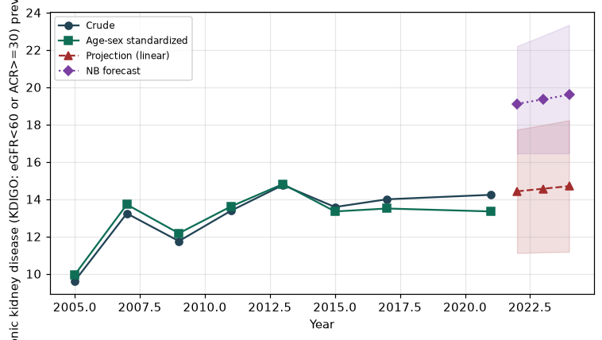

Counts by period
period | count
2005 | 583
2007 | 1049
2009 | 947
2011 | 918
2013 | 954
2015 | 915
2017 | 1003
2021 | 1055

Crude and age-sex standardized rate (%)
year | crude | standardized
2005.00 | 9.62 | 9.95
2007.00 | 13.24 | 13.71
2009.00 | 11.75 | 12.17
2011.00 | 13.38 | 13.61
2013.00 | 14.76 | 14.81
2015.00 | 13.58 | 13.34
2017.00 | 13.99 | 13.50
2021.00 | 14.23 | 13.34

Projection (linear, standardized rate)
year | forecast | lo95 | hi95
2022.00 | 14.42 | 11.11 | 17.73
2023.00 | 14.56 | 11.15 | 17.97
2024.00 | 14.70 | 11.18 | 18.23

Stratified trend by sex (%)
year | men | women
2005.00 | 8.48 | 10.68
2007.00 | 11.26 | 15.07
2009.00 | 10.58 | 12.84
2011.00 | 12.41 | 14.27
2013.00 | 12.45 | 16.90
2015.00 | 12.10 | 14.95
2017.00 | 12.94 | 14.97
2021.00 | 13.59 | 14.84

Joinpoint regression — segment APC (%) with bootstrap 95% CI
segment | period | APC(%) | lo95 | hi95
1 | 2005-2007 | 17.38 | 17.38 | 17.38
2 | 2007-2021 | 0.14 | -0.79 | 1.52

Negative binomial (NB) forecast (%)
year | NB_forecast | lo95 | hi95
2022.00 | 19.11 | 16.45 | 22.20
2023.00 | 19.35 | 16.46 | 22.76
2024.00 | 19.60 | 16.46 | 23.34

Interpretation
The age-sex standardized prevalence of Chronic kidney disease (KDIGO: eGFR<60 or ACR>=30) showed an annual percent change of 0.14% (95% CI -0.79 to 1.52) in the latest segment.

