Incidence/Prevalence Trend Report
Diabetes mellitus · NHANES · 2005-2021 · survey-weighted

Figure. Incidence/prevalence trend
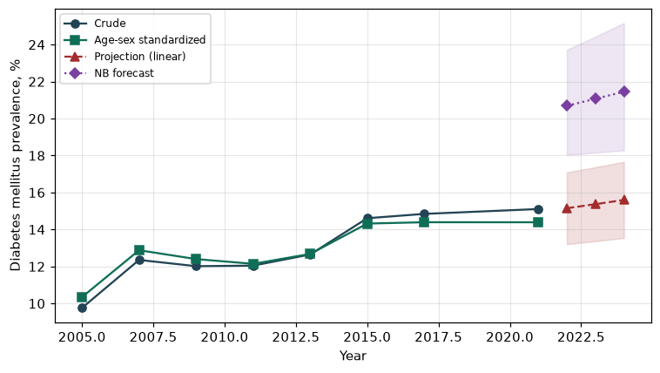

Counts by period
period | count
2005 | 593
2007 | 962
2009 | 954
2011 | 869
2013 | 878
2015 | 987
2017 | 1066
2021 | 1068

Crude and age-sex standardized rate (%)
year | crude | standardized
2005.00 | 9.76 | 10.35
2007.00 | 12.36 | 12.88
2009.00 | 12.02 | 12.40
2011.00 | 12.05 | 12.14
2013.00 | 12.65 | 12.68
2015.00 | 14.61 | 14.32
2017.00 | 14.85 | 14.39
2021.00 | 15.11 | 14.39

Projection (linear, standardized rate)
year | forecast | lo95 | hi95
2022.00 | 15.15 | 13.21 | 17.09
2023.00 | 15.37 | 13.37 | 17.37
2024.00 | 15.60 | 13.54 | 17.66

Stratified trend by sex (%)
year | men | women
2005.00 | 9.67 | 9.84
2007.00 | 13.15 | 11.62
2009.00 | 13.20 | 10.92
2011.00 | 13.17 | 11.02
2013.00 | 13.81 | 11.58
2015.00 | 16.47 | 12.88
2017.00 | 16.47 | 13.35
2021.00 | 16.46 | 13.84

Joinpoint regression — segment APC (%) with bootstrap 95% CI
segment | period | APC(%) | lo95 | hi95
1 | 2005-2007 | 11.57 | 11.57 | 11.57
2 | 2007-2021 | 1.26 | 0.56 | 2.56

Negative binomial (NB) forecast (%)
year | NB_forecast | lo95 | hi95
2022.00 | 20.69 | 18.04 | 23.72
2023.00 | 21.07 | 18.16 | 24.43
2024.00 | 21.45 | 18.28 | 25.17

Interpretation
The age-sex standardized prevalence of Diabetes mellitus showed an annual percent change of 1.26% (95% CI 0.56 to 2.56) in the latest segment.

