Incidence/Prevalence Trend Report
Dyslipidemia (KSoLA composite) · NHANES · 2005-2021 · survey-weighted

Figure. Incidence/prevalence trend
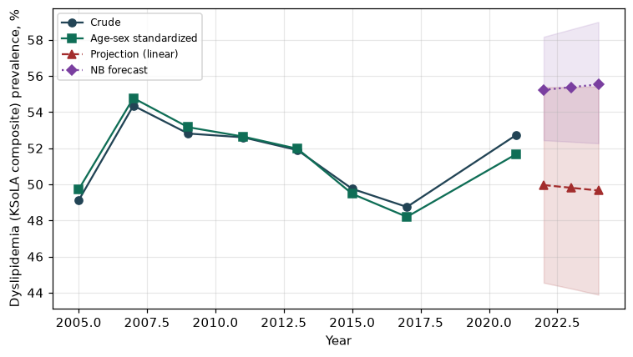

Counts by period
period | count
2005 | 2260
2007 | 3029
2009 | 3166
2011 | 2681
2013 | 2861
2015 | 2732
2017 | 2663
2021 | 3203

Crude and age-sex standardized rate (%)
year | crude | standardized
2005.00 | 49.11 | 49.72
2007.00 | 54.36 | 54.78
2009.00 | 52.81 | 53.16
2011.00 | 52.60 | 52.65
2013.00 | 51.89 | 51.97
2015.00 | 49.75 | 49.47
2017.00 | 48.75 | 48.20
2021.00 | 52.74 | 51.68

Projection (linear, standardized rate)
year | forecast | lo95 | hi95
2022.00 | 49.96 | 44.55 | 55.38
2023.00 | 49.81 | 44.23 | 55.39
2024.00 | 49.66 | 43.89 | 55.42

Stratified trend by sex (%)
year | men | women
2005.00 | 49.08 | 49.15
2007.00 | 53.97 | 54.72
2009.00 | 52.81 | 52.82
2011.00 | 50.41 | 54.64
2013.00 | 51.50 | 52.26
2015.00 | 50.56 | 48.99
2017.00 | 47.69 | 49.74
2021.00 | 50.70 | 54.64

Joinpoint regression — segment APC (%) with bootstrap 95% CI
segment | period | APC(%) | lo95 | hi95
1 | 2005-2007 | 4.96 | 4.96 | 4.96
2 | 2007-2021 | -0.62 | -1.34 | -0.12

Negative binomial (NB) forecast (%)
year | NB_forecast | lo95 | hi95
2022.00 | 55.23 | 52.44 | 58.17
2023.00 | 55.38 | 52.36 | 58.58
2024.00 | 55.53 | 52.27 | 58.99

Interpretation
The age-sex standardized prevalence of Dyslipidemia (KSoLA composite) showed an annual percent change of -0.62% (95% CI -1.34 to -0.12) in the latest segment.

