Incidence/Prevalence Trend Report
Elevated ALT (>40 IU/L) · NHANES · 2005-2021 · survey-weighted

Figure. Incidence/prevalence trend
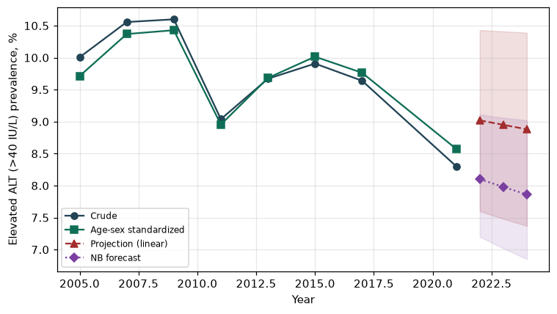

Counts by period
period | count
2005 | 419
2007 | 548
2009 | 585
2011 | 427
2013 | 523
2015 | 524
2017 | 430
2021 | 402

Crude and age-sex standardized rate (%)
year | crude | standardized
2005.00 | 10.01 | 9.71
2007.00 | 10.56 | 10.37
2009.00 | 10.60 | 10.43
2011.00 | 9.04 | 8.95
2013.00 | 9.67 | 9.68
2015.00 | 9.91 | 10.02
2017.00 | 9.64 | 9.76
2021.00 | 8.30 | 8.57

Projection (linear, standardized rate)
year | forecast | lo95 | hi95
2022.00 | 9.02 | 7.60 | 10.43
2023.00 | 8.95 | 7.48 | 10.41
2024.00 | 8.88 | 7.37 | 10.39

Stratified trend by sex (%)
year | men | women
2005.00 | 15.29 | 5.14
2007.00 | 16.85 | 4.68
2009.00 | 16.07 | 5.45
2011.00 | 13.37 | 4.99
2013.00 | 14.71 | 4.97
2015.00 | 15.07 | 5.10
2017.00 | 14.54 | 5.09
2021.00 | 12.56 | 4.29

Joinpoint regression — segment APC (%) with bootstrap 95% CI
segment | period | APC(%) | lo95 | hi95
1 | 2005-2015 | -0.29 | -2.24 | 1.79
2 | 2015-2021 | -2.65 | -3.20 | -1.26

Negative binomial (NB) forecast (%)
year | NB_forecast | lo95 | hi95
2022.00 | 8.10 | 7.20 | 9.11
2023.00 | 7.98 | 7.02 | 9.06
2024.00 | 7.86 | 6.85 | 9.02

Interpretation
The age-sex standardized prevalence of Elevated ALT (>40 IU/L) showed an annual percent change of -2.65% (95% CI -3.2 to -1.26) in the latest segment.

