Incidence/Prevalence Trend Report
Elevated AST (>40 IU/L) · NHANES · 2005-2021 · survey-weighted

Figure. Incidence/prevalence trend
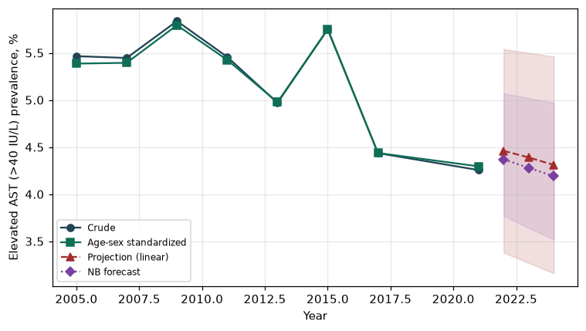

Counts by period
period | count
2005 | 240
2007 | 333
2009 | 362
2011 | 262
2013 | 291
2015 | 308
2017 | 218
2021 | 224

Crude and age-sex standardized rate (%)
year | crude | standardized
2005.00 | 5.47 | 5.39
2007.00 | 5.45 | 5.39
2009.00 | 5.84 | 5.79
2011.00 | 5.46 | 5.43
2013.00 | 4.97 | 4.98
2015.00 | 5.75 | 5.75
2017.00 | 4.44 | 4.44
2021.00 | 4.26 | 4.30

Projection (linear, standardized rate)
year | forecast | lo95 | hi95
2022.00 | 4.46 | 3.38 | 5.54
2023.00 | 4.39 | 3.27 | 5.50
2024.00 | 4.31 | 3.16 | 5.46

Stratified trend by sex (%)
year | men | women
2005.00 | 7.87 | 3.25
2007.00 | 7.39 | 3.63
2009.00 | 7.48 | 4.30
2011.00 | 6.70 | 4.30
2013.00 | 6.16 | 3.86
2015.00 | 7.84 | 3.80
2017.00 | 6.48 | 2.53
2021.00 | 5.32 | 3.26

Joinpoint regression — segment APC (%) with bootstrap 95% CI
segment | period | APC(%) | lo95 | hi95
1 | 2005-2009 | 1.84 | 0.07 | 3.64
2 | 2009-2021 | -2.42 | -3.64 | 0.07

Negative binomial (NB) forecast (%)
year | NB_forecast | lo95 | hi95
2022.00 | 4.37 | 3.77 | 5.07
2023.00 | 4.28 | 3.64 | 5.02
2024.00 | 4.19 | 3.52 | 4.97

Interpretation
The age-sex standardized prevalence of Elevated AST (>40 IU/L) showed an annual percent change of -2.42% (95% CI -3.64 to 0.07) in the latest segment.

