Incidence/Prevalence Trend Report
High body fat (M>=25/F>=35%) · NHANES · 2005-2017 · survey-weighted

Figure. Incidence/prevalence trend
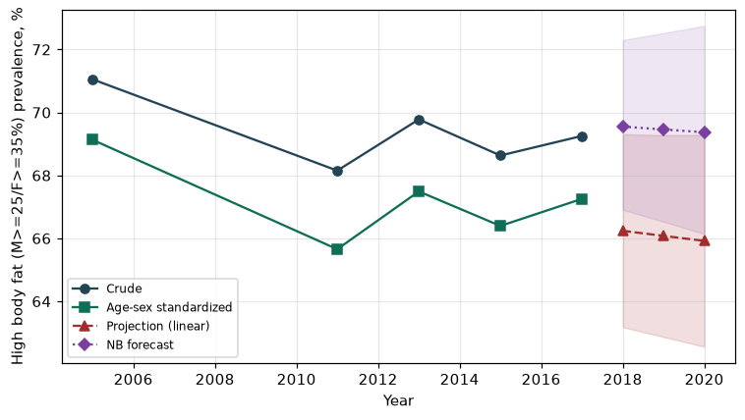

Counts by period
period | count
2005 | 2584
2011 | 1814
2013 | 2174
2015 | 1960
2017 | 1603

Crude and age-sex standardized rate (%)
year | crude | standardized
2005.00 | 71.05 | 69.13
2011.00 | 68.15 | 65.66
2013.00 | 69.78 | 67.49
2015.00 | 68.63 | 66.40
2017.00 | 69.25 | 67.26

Projection (linear, standardized rate)
year | forecast | lo95 | hi95
2018.00 | 66.24 | 63.18 | 69.31
2019.00 | 66.08 | 62.87 | 69.28
2020.00 | 65.92 | 62.56 | 69.28

Stratified trend by sex (%)
year | men | women
2005.00 | 67.67 | 74.45
2011.00 | 63.25 | 73.37
2013.00 | 67.06 | 72.60
2015.00 | 62.84 | 74.26
2017.00 | 66.18 | 72.23

Joinpoint regression — segment APC (%) with bootstrap 95% CI
segment | period | APC(%) | lo95 | hi95
1 | 2005-2011 | -0.86 | -0.86 | -0.86
2 | 2011-2017 | 0.28 | -0.81 | 1.39

Negative binomial (NB) forecast (%)
year | NB_forecast | lo95 | hi95
2018.00 | 69.55 | 66.91 | 72.30
2019.00 | 69.46 | 66.53 | 72.52
2020.00 | 69.37 | 66.14 | 72.75

Interpretation
The age-sex standardized prevalence of High body fat (M>=25/F>=35%) showed an annual percent change of 0.28% (95% CI -0.81 to 1.39) in the latest segment.

