Incidence/Prevalence Trend Report
High LDL cholesterol (>=160) · NHANES · 2005-2021 · survey-weighted

Figure. Incidence/prevalence trend
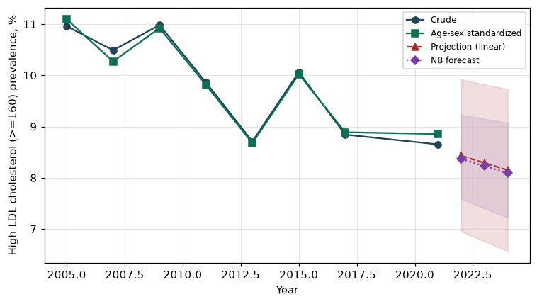

Counts by period
period | count
2005 | 228
2007 | 282
2009 | 291
2011 | 236
2013 | 220
2015 | 223
2017 | 209
2021 | 265

Crude and age-sex standardized rate (%)
year | crude | standardized
2005.00 | 10.96 | 11.09
2007.00 | 10.49 | 10.27
2009.00 | 10.98 | 10.92
2011.00 | 9.86 | 9.81
2013.00 | 8.71 | 8.68
2015.00 | 10.06 | 10.02
2017.00 | 8.84 | 8.89
2021.00 | 8.65 | 8.85

Projection (linear, standardized rate)
year | forecast | lo95 | hi95
2022.00 | 8.43 | 6.95 | 9.92
2023.00 | 8.29 | 6.76 | 9.82
2024.00 | 8.15 | 6.57 | 9.73

Stratified trend by sex (%)
year | men | women
2005.00 | 11.09 | 10.83
2007.00 | 10.87 | 10.14
2009.00 | 10.08 | 11.77
2011.00 | 9.52 | 10.18
2013.00 | 9.13 | 8.32
2015.00 | 10.27 | 9.87
2017.00 | 8.38 | 9.29
2021.00 | 8.41 | 8.87

Joinpoint regression — segment APC (%) with bootstrap 95% CI
segment | period | APC(%) | lo95 | hi95
1 | 2005-2011 | -1.52 | -5.21 | 3.12
2 | 2011-2021 | -0.75 | -2.04 | 1.49

Negative binomial (NB) forecast (%)
year | NB_forecast | lo95 | hi95
2022.00 | 8.37 | 7.59 | 9.23
2023.00 | 8.23 | 7.40 | 9.15
2024.00 | 8.09 | 7.22 | 9.07

Interpretation
The age-sex standardized prevalence of High LDL cholesterol (>=160) showed an annual percent change of -0.75% (95% CI -2.04 to 1.49) in the latest segment.

