Incidence/Prevalence Trend Report
High non-HDL cholesterol (>=190) · NHANES · 2005-2021 · survey-weighted

Figure. Incidence/prevalence trend
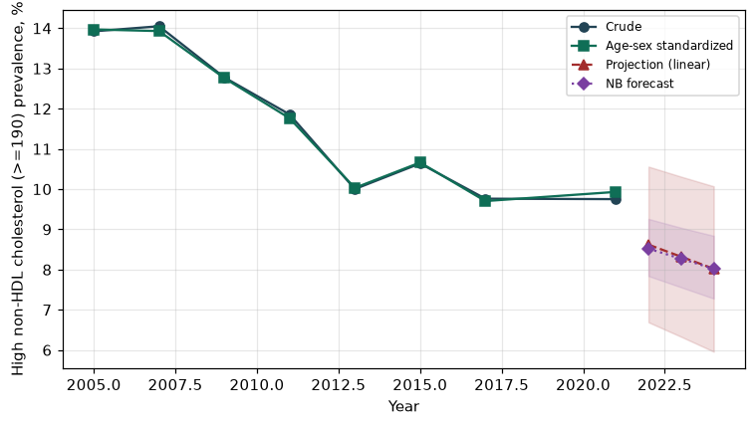

Counts by period
period | count
2005 | 618
2007 | 762
2009 | 738
2011 | 562
2013 | 537
2015 | 551
2017 | 480
2021 | 507

Crude and age-sex standardized rate (%)
year | crude | standardized
2005.00 | 13.92 | 13.97
2007.00 | 14.05 | 13.93
2009.00 | 12.78 | 12.76
2011.00 | 11.86 | 11.76
2013.00 | 10.00 | 10.03
2015.00 | 10.64 | 10.66
2017.00 | 9.76 | 9.70
2021.00 | 9.75 | 9.93

Projection (linear, standardized rate)
year | forecast | lo95 | hi95
2022.00 | 8.62 | 6.69 | 10.56
2023.00 | 8.32 | 6.33 | 10.31
2024.00 | 8.02 | 5.96 | 10.07

Stratified trend by sex (%)
year | men | women
2005.00 | 15.10 | 12.83
2007.00 | 16.21 | 12.04
2009.00 | 13.91 | 11.72
2011.00 | 13.15 | 10.66
2013.00 | 11.58 | 8.54
2015.00 | 12.17 | 9.21
2017.00 | 11.01 | 8.61
2021.00 | 11.17 | 8.41

Joinpoint regression — segment APC (%) with bootstrap 95% CI
segment | period | APC(%) | lo95 | hi95
1 | 2005-2013 | -4.07 | -6.07 | -2.24
2 | 2013-2021 | -0.44 | -4.60 | 3.10

Negative binomial (NB) forecast (%)
year | NB_forecast | lo95 | hi95
2022.00 | 8.52 | 7.84 | 9.26
2023.00 | 8.27 | 7.56 | 9.04
2024.00 | 8.02 | 7.28 | 8.84

Interpretation
The age-sex standardized prevalence of High non-HDL cholesterol (>=190) showed an annual percent change of -0.44% (95% CI -4.6 to 3.1) in the latest segment.

