Incidence/Prevalence Trend Report
Hypertension · NHANES · 2005-2021 · survey-weighted

Figure. Incidence/prevalence trend
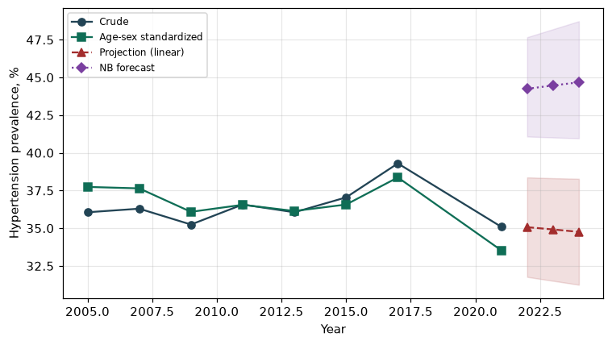

Counts by period
period | count
2005 | 1694
2007 | 2379
2009 | 2375
2011 | 2077
2013 | 2145
2015 | 2221
2017 | 2322
2021 | 2507

Crude and age-sex standardized rate (%)
year | crude | standardized
2005.00 | 36.06 | 37.74
2007.00 | 36.30 | 37.64
2009.00 | 35.25 | 36.09
2011.00 | 36.57 | 36.56
2013.00 | 36.06 | 36.14
2015.00 | 37.05 | 36.57
2017.00 | 39.30 | 38.37
2021.00 | 35.10 | 33.53

Projection (linear, standardized rate)
year | forecast | lo95 | hi95
2022.00 | 35.07 | 31.77 | 38.37
2023.00 | 34.92 | 31.51 | 38.32
2024.00 | 34.76 | 31.25 | 38.28

Stratified trend by sex (%)
year | men | women
2005.00 | 35.58 | 36.51
2007.00 | 35.91 | 36.66
2009.00 | 35.24 | 35.25
2011.00 | 36.38 | 36.76
2013.00 | 35.58 | 36.50
2015.00 | 37.02 | 37.07
2017.00 | 41.03 | 37.67
2021.00 | 34.95 | 35.23

Joinpoint regression — segment APC (%) with bootstrap 95% CI
segment | period | APC(%) | lo95 | hi95
1 | 2005-2015 | -0.38 | -0.80 | 0.17
2 | 2015-2021 | -1.71 | -3.31 | 2.43

Negative binomial (NB) forecast (%)
year | NB_forecast | lo95 | hi95
2022.00 | 44.25 | 41.08 | 47.67
2023.00 | 44.47 | 41.02 | 48.20
2024.00 | 44.68 | 40.96 | 48.73

Interpretation
The age-sex standardized prevalence of Hypertension showed an annual percent change of -1.71% (95% CI -3.31 to 2.43) in the latest segment.

